 **Git octocat logo.**

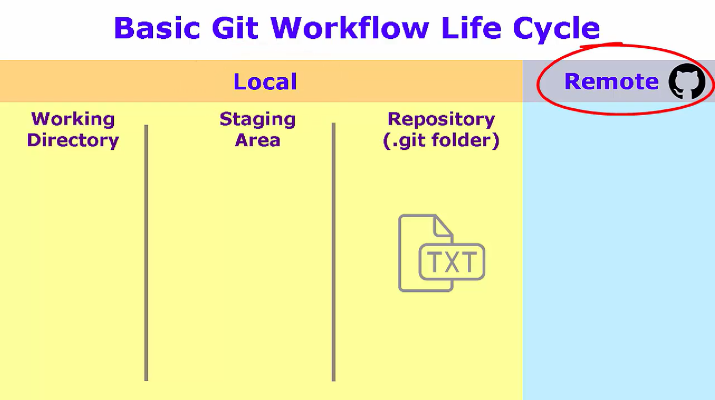

**DIFFERENT AREAS:**

* **Working Directory**
* **Staging area Local**
* **Repository (.git folder)**
* **Remote repo Remote**

**Git Configuration**

Check if email is set: git config user.email



Git config levels and files

3 configuration levels to operate on:

1. **--local**: By default, git config will write to a local level if no configuration option is passed. Local level configuration is applied to the context repository git config gets invoked in. Local configuration values are stored in a file that can be found in the repo's .git directory: .git/config
2. **--global**: Global level configuration is user-specific, meaning it is applied to an operating system user. Global configuration values are stored in a file that is located in a user's home directory. ~ /.gitconfig on unix systems and C:\Users\\.gitconfig on windows
3. **--system**: System-level configuration is applied across an entire machine. This covers all users on an operating system and all repos. The system level configuration file lives in a gitconfig file off the system root path. $(prefix)/etc/gitconfig on unix systems.

Thus the order of priority for configuration levels is: local, global, system. This means when looking for a configuration value, Git will start at the local level and bubble up to the system level.

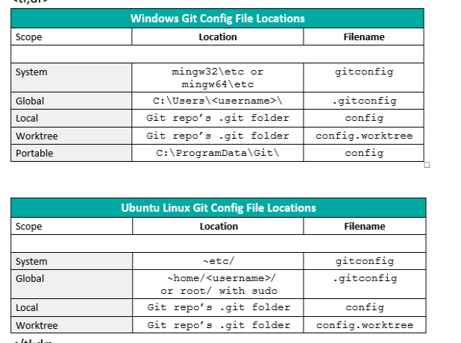

List all values of a specific git config file: git config --global --list --show-origin

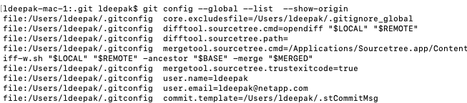

Get value of a key from a specific git config file: git config --global user.email



Writing a value to a key in a specific git config file: git config --global user.email “ldeepak@netapp.com”

**BASIC GIT WORKFLOW AND OPERATIONS:**

* **git config:** Setup the configuration for local, global and system. It’s better to use your personal git account for global config and your company specific account for local config.
* **git clone**: Use an already existing git repo.
* **git status:** Checks untracked files.

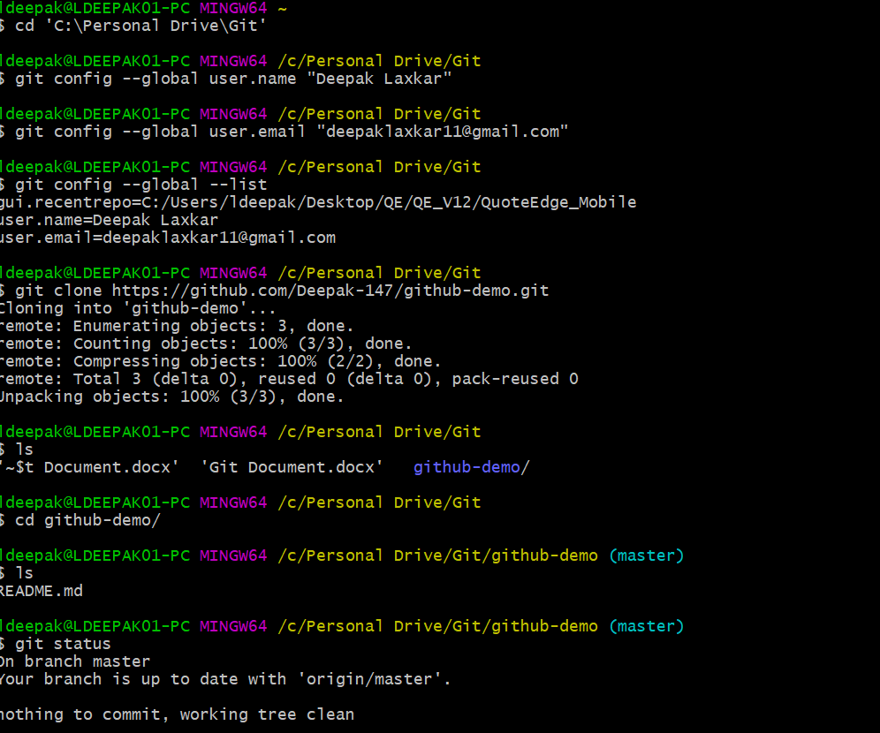

* **git add**: Add the files to the **Staging area**.
* Adding a new text file in the repo and checking the status for untracked files.

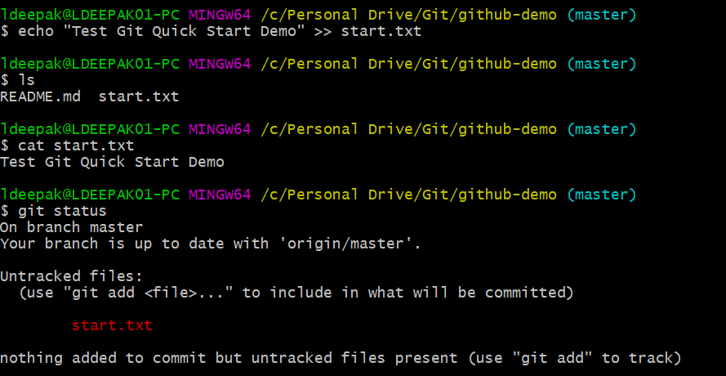

* **git commit**: Moving the files from **Staging area** to **Local repo**.
* Committing the new changes.

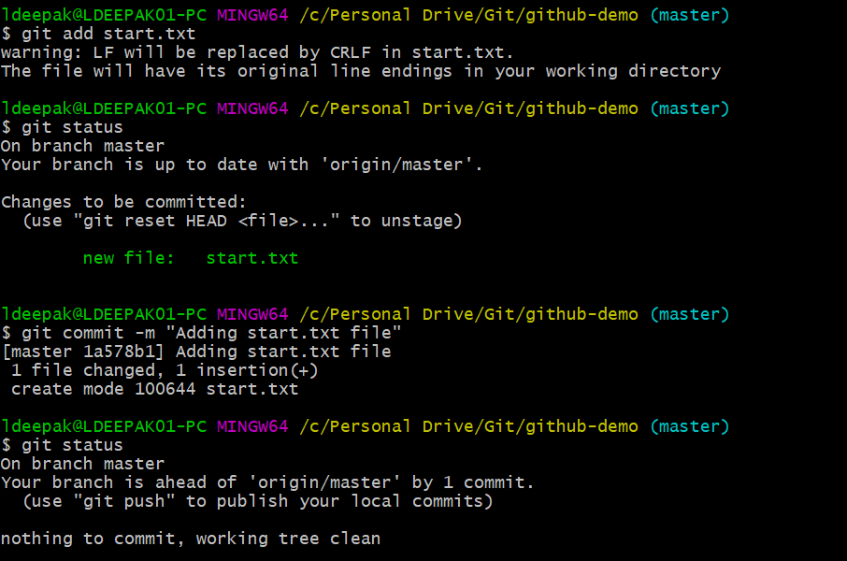

* **git push:** Moving from **Local repo** to **Remote repo.**

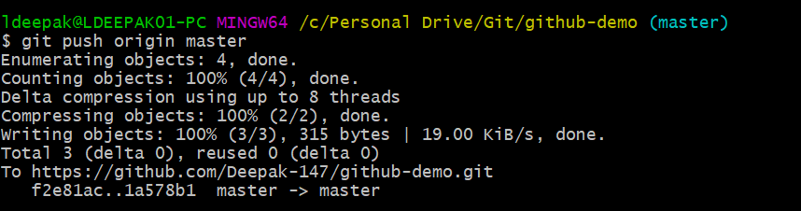

**TEXT EDITOR INTEGRATION**

* Download and install Notepad++ (or any text editor of choice).
* Add notepad++ executable to PATH environment variable.

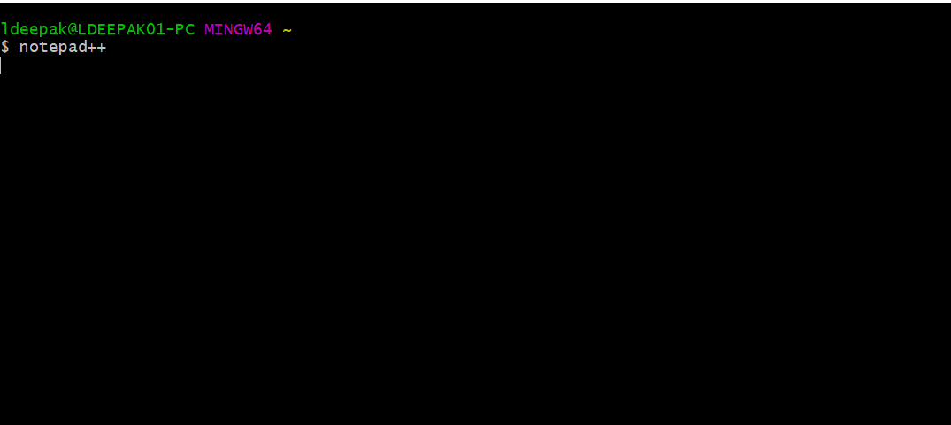

This should open notepad++ from git bash.

* Create and edit .bashrc_profile

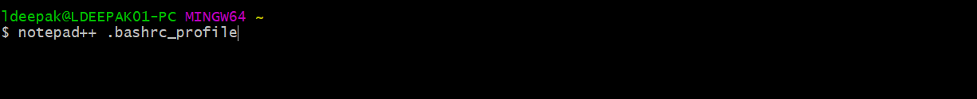

This opens .bashrc_profile if it exists, or creates a new file.

* Edit this file with below command.

**alias npp='notepad++.exe -multiInst -nosession'**

This command create an alias name for notepad++ as npp. Now we can directly open notepad++ with just this alias npp.

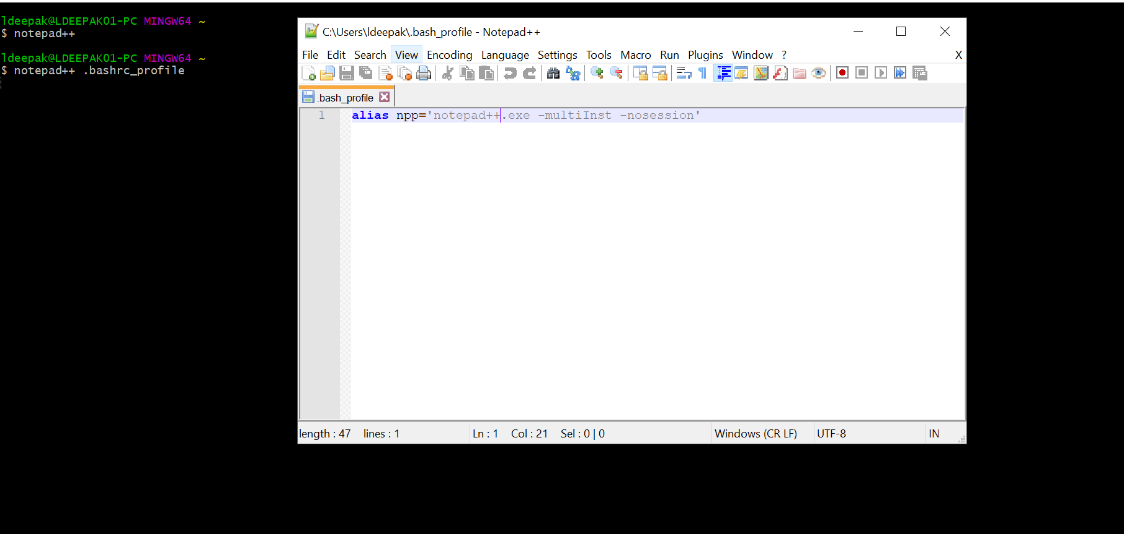

* Save the file and close the editor.

**Setup notepad++ as git’s default editor:**

* Check the current global configuration.

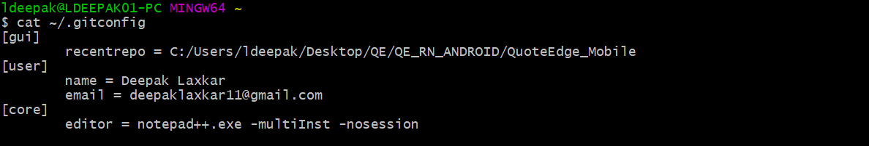

* Do below command

**git config --global core.editor “notepad++.exe -multiInst -nosession”**

* Now check for global configurations. It should show user settings and editor settings.

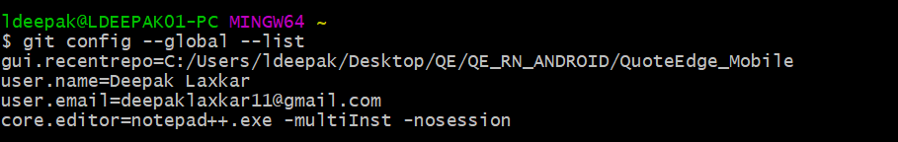

**CREATING A FRESH GIT REPO FROM SCRATCH**

* **git init**: Creating a fresh git repo.

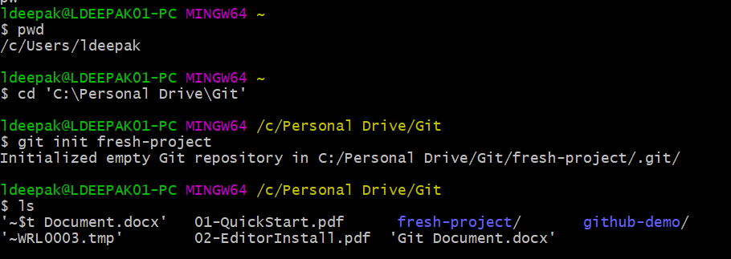

* **ls -al** also list your git files.

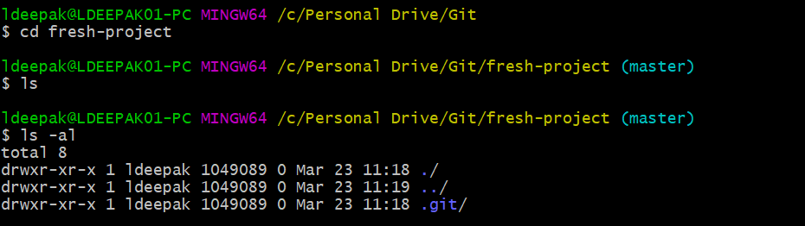

Copy some text from URL: <https://hipsum.co/>

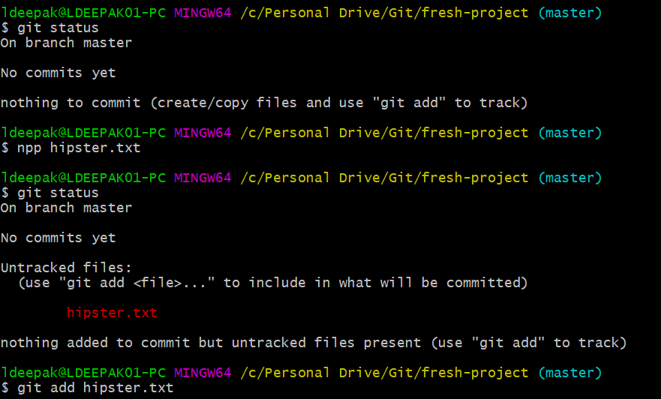

* **git commit** without any arguments opens configured text editor for providing multi-line commit message.

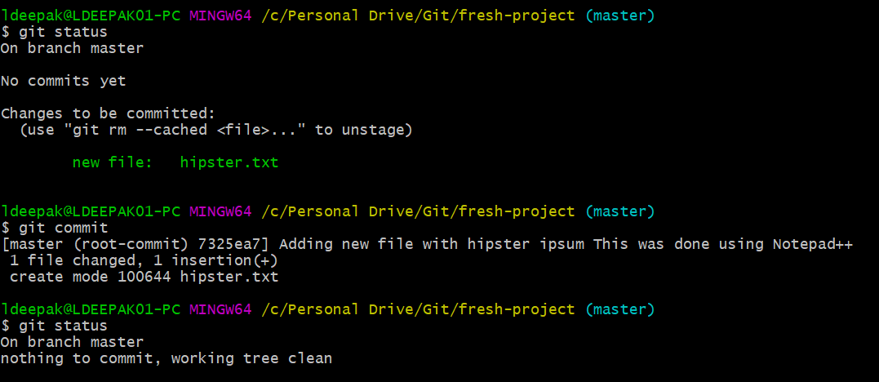

**ADDING GIT TO EXISTING PROJECT**

* Adding git to an existing project. Download a project from initializr and extract it. Cd to that extracted directory and do **git init**.
* Initializr url: <http://www.initializr.com/>

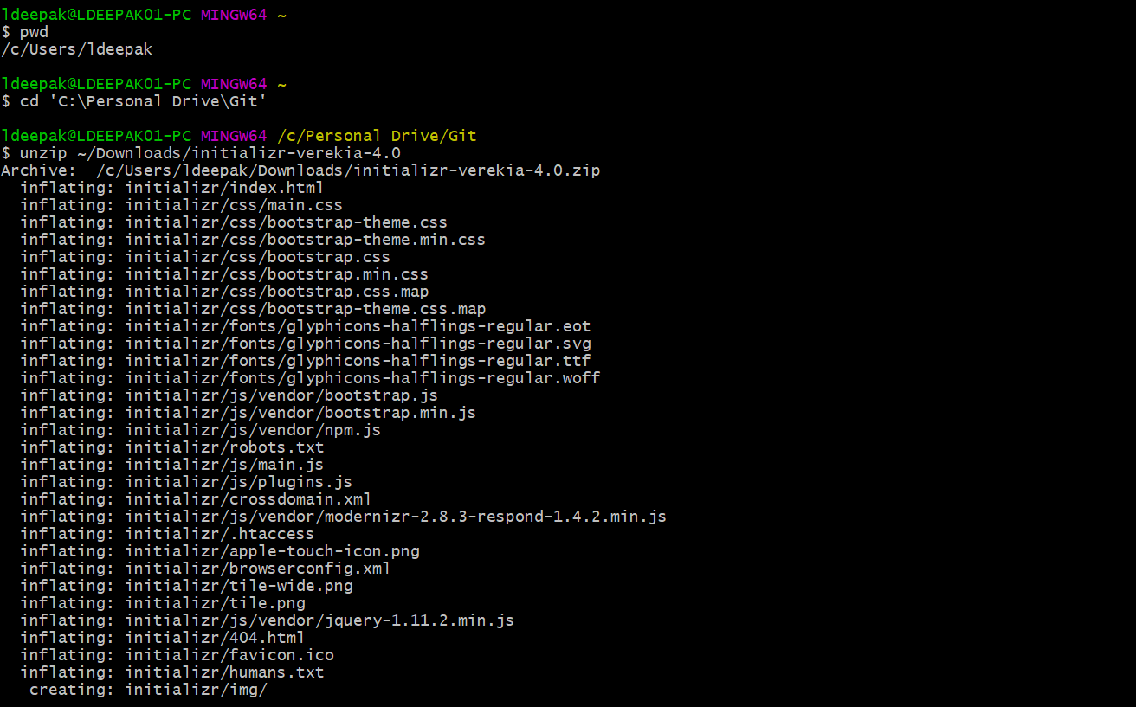

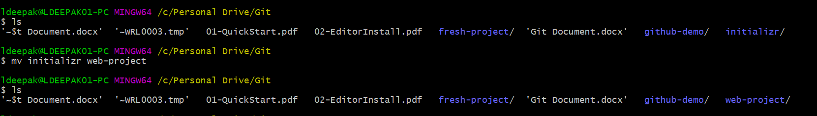





**JOINING AN ALREADY EXISTING GIT REPOSITORY**

* **Fork** an existing git repo from GitHub into your git account. Then clone that repo to work on it.
* Fork from here: <https://github.com/scm-ninja/starter-web>

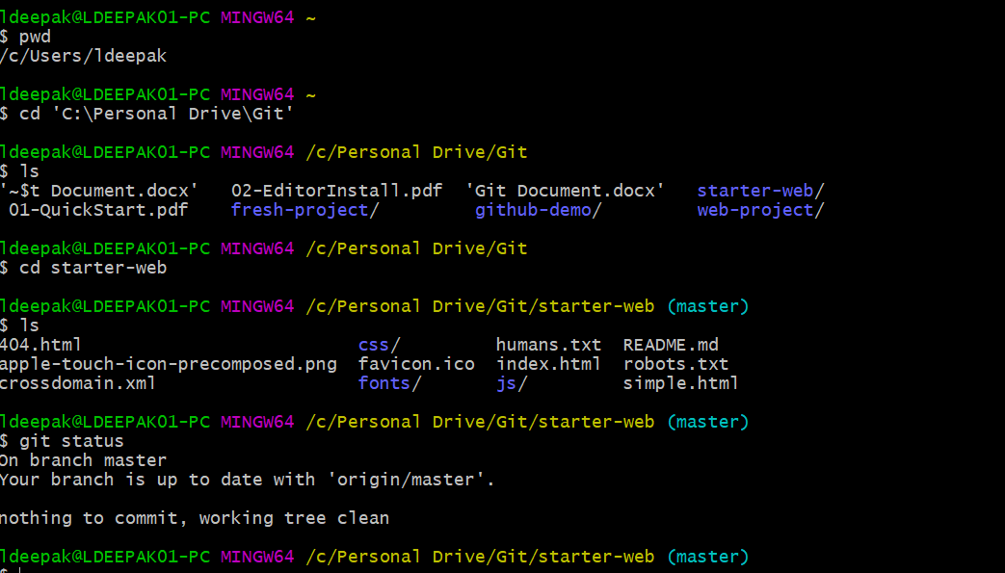

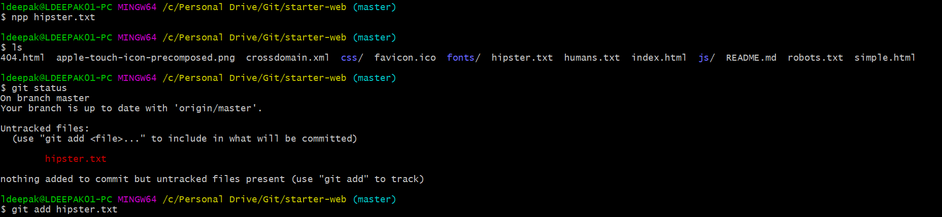

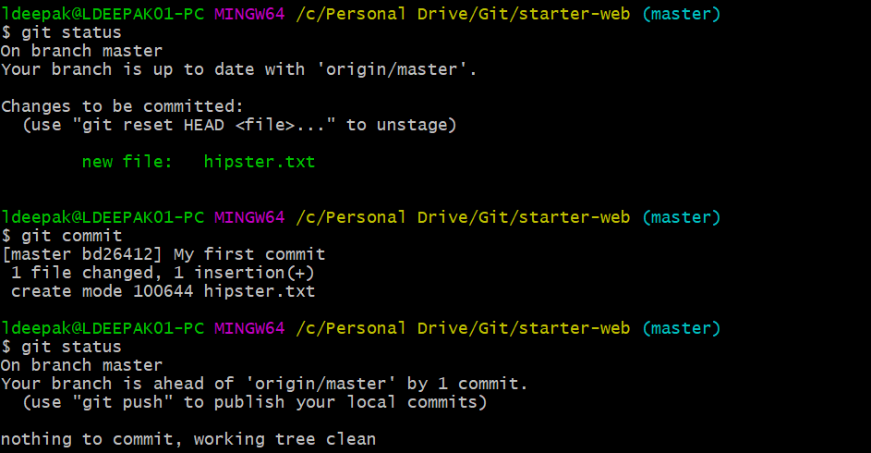

* **git pull**: Take all changes from the repo.
* Doing a **git pull** before a push is a best practice. Always do a pull before doing a push.

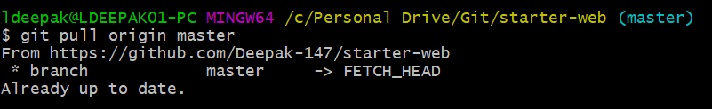

* Now do a **git push.**

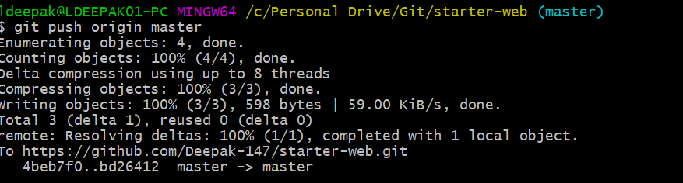

* **Origin:** It is the reference to the remote repo**.**
* **Master:** It is the branch that we are working on.

**TRACKING FILES**

* Add more changes to the already existing text file.

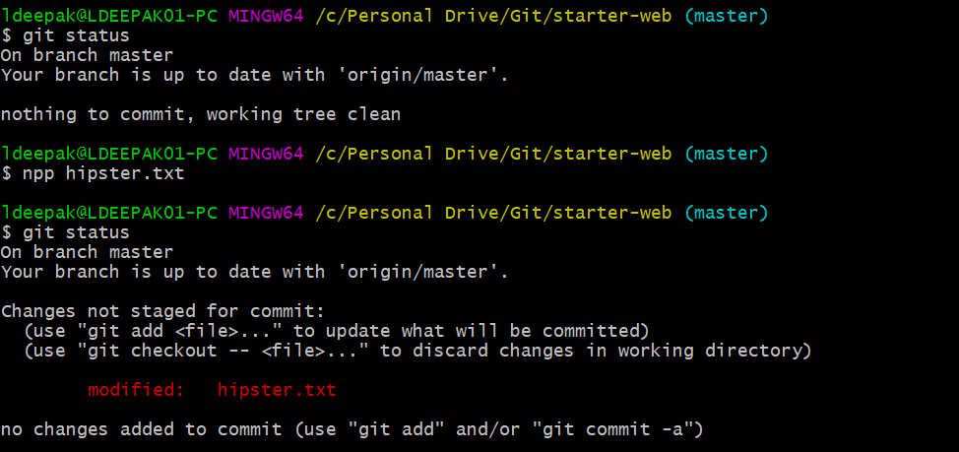

* **git commit -am “Message”:** Does two steps in one. It adds to stage and also commits with the message. This can be used only if git is already tracking this file. This command will add and commit all the modified files, **but not newly created files**.

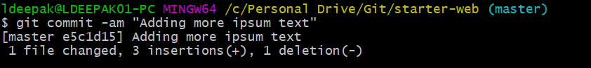

* How to find whether your file is being tracked by git or not?
* **git ls-files**: Gives list of all the files tracked by git.
* Create a new file and check for files tracked by git. It will not be in the list.

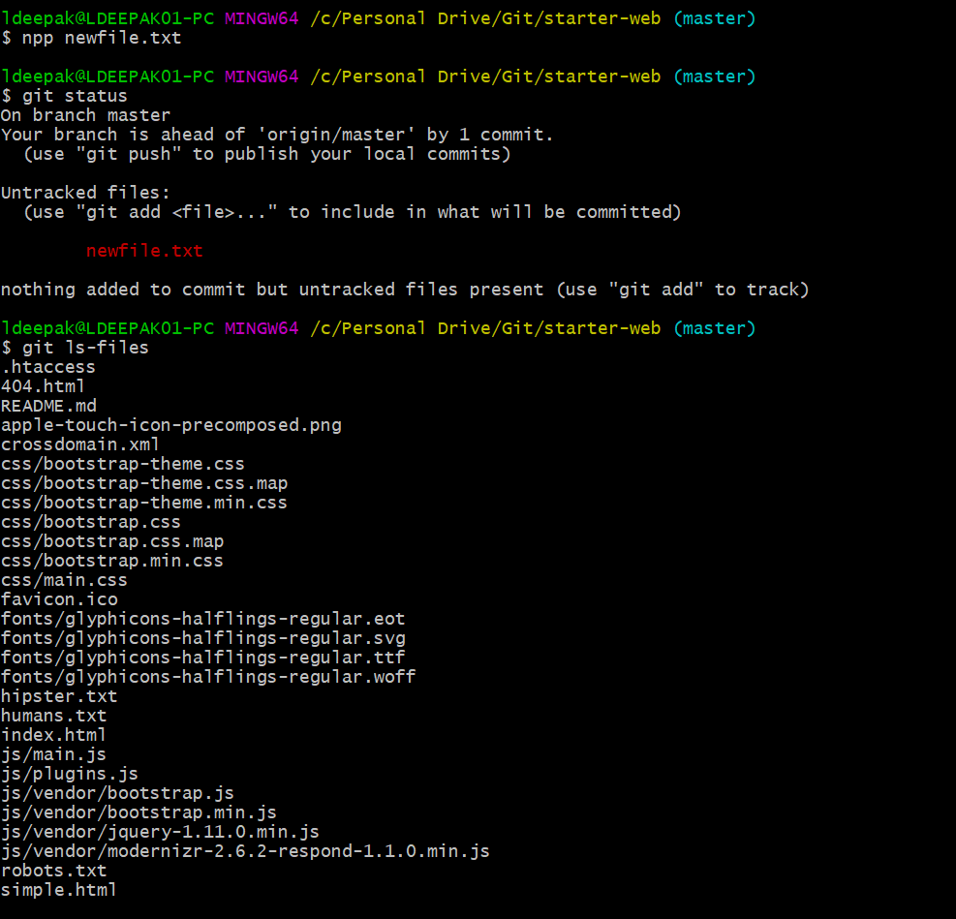

* Add this file to staging area, so that git can track it. Now if you list all the tracked files. This file will be present.

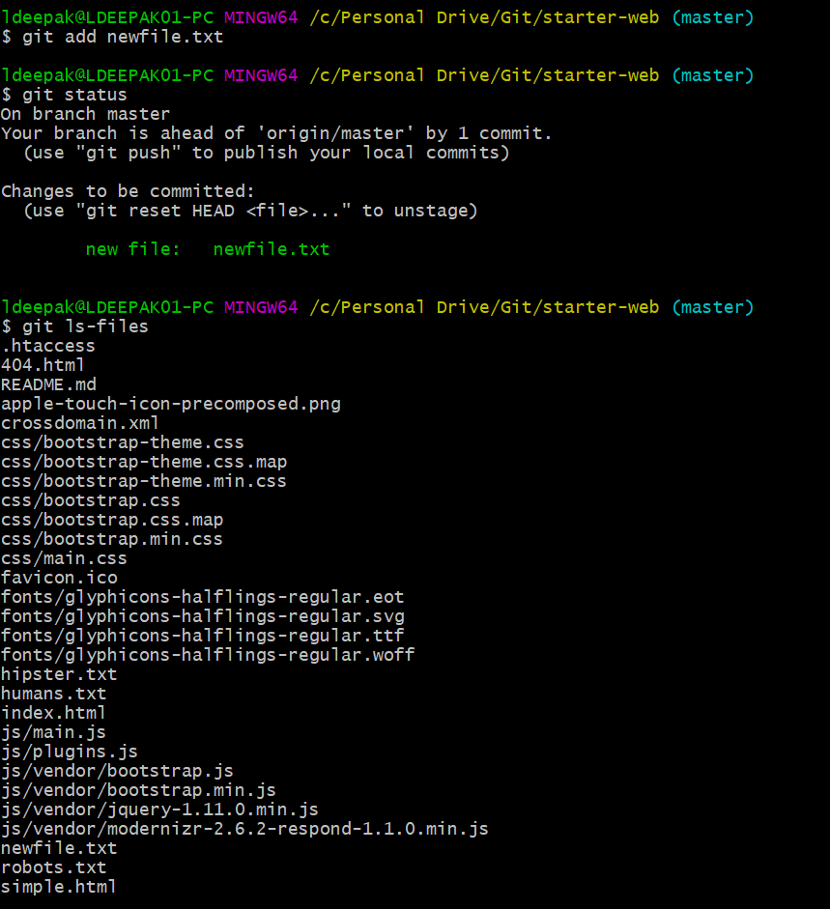

* Now edit the hipster.txt and do a git status.

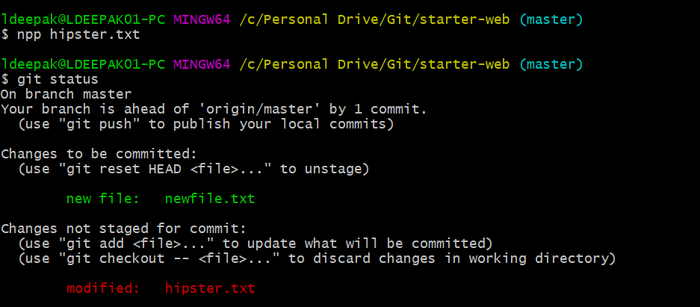

* Now do a commit and check the status, it will only take the staged file(newfile.txt), but not the modified file(hipster.txt).

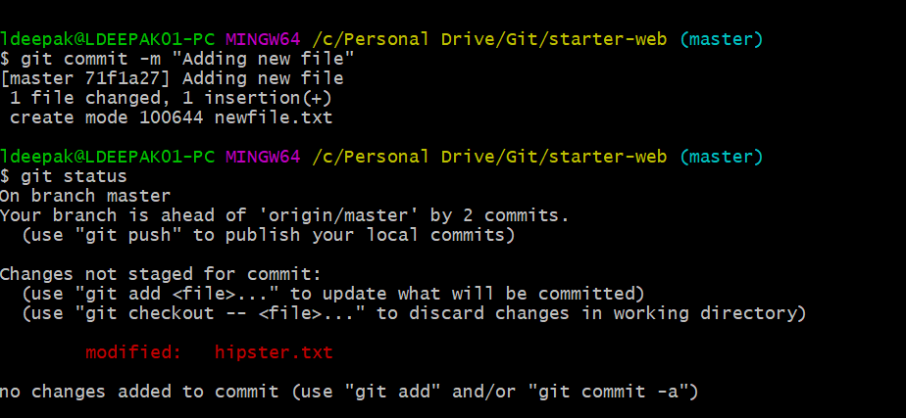

* Now add hipster.txt and check the status.

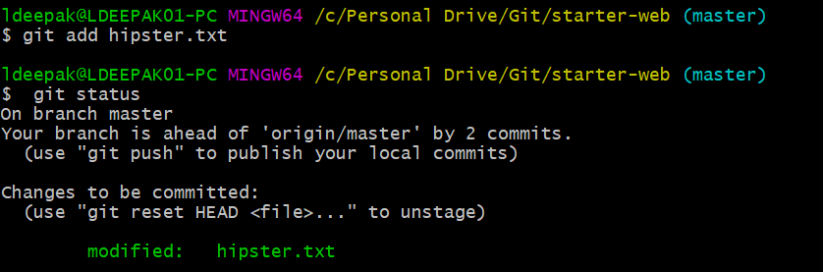

* Modify hipster.txt again and follow the procedure.

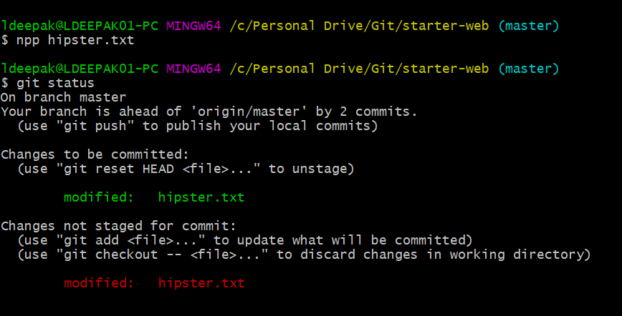

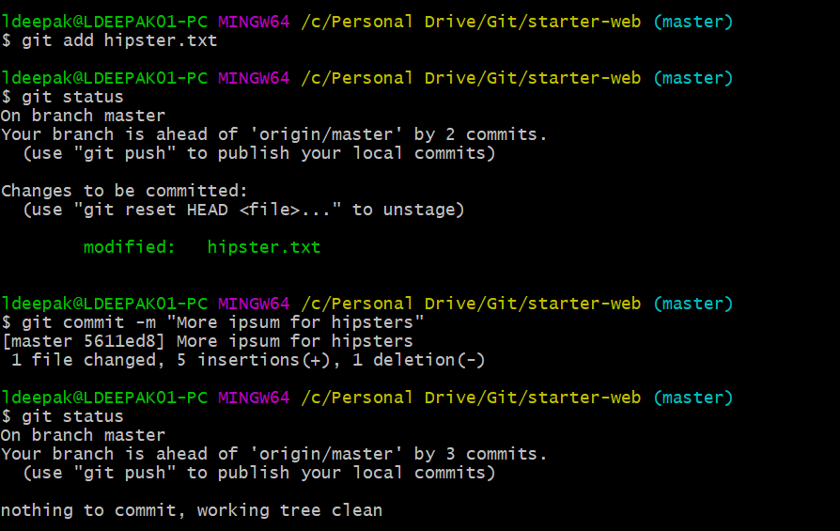

**ADDING FILES RECURSIVELY**

* Create a directory levels and add new files to it.

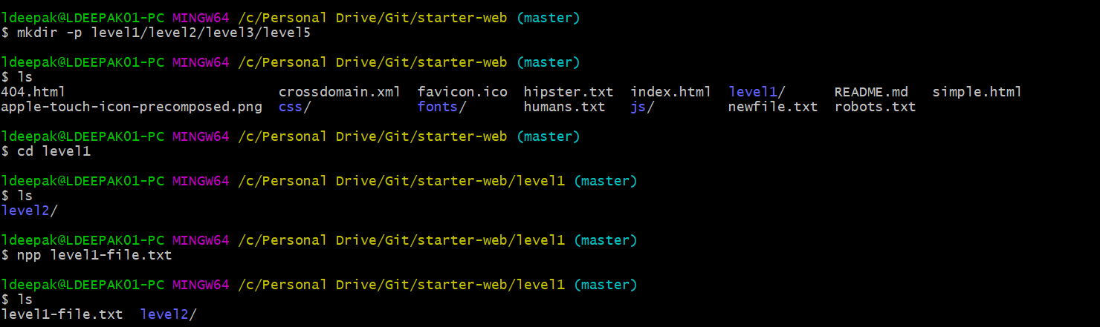

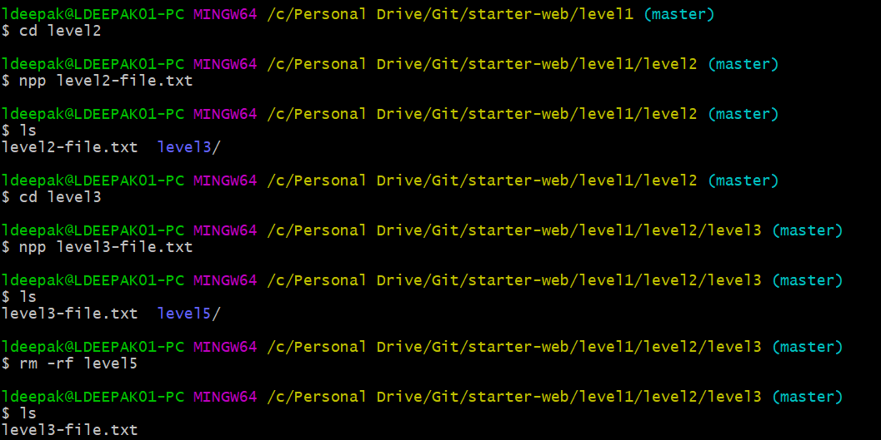

**git add** . : Adds files recursively.

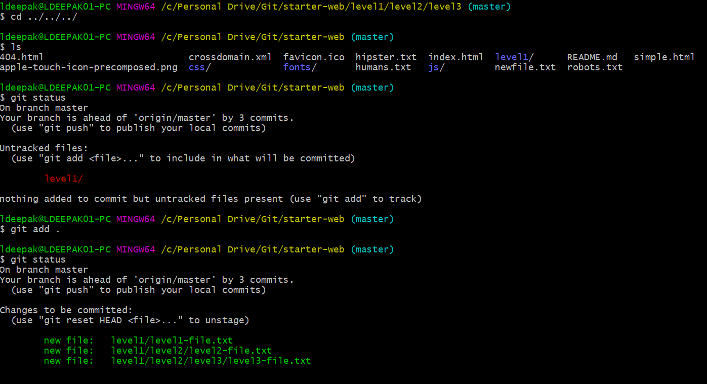

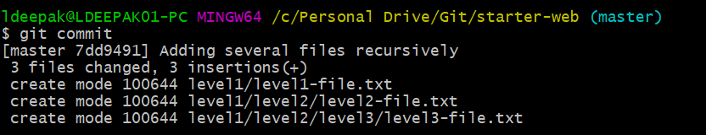

**BACKING OUT CHANGES**

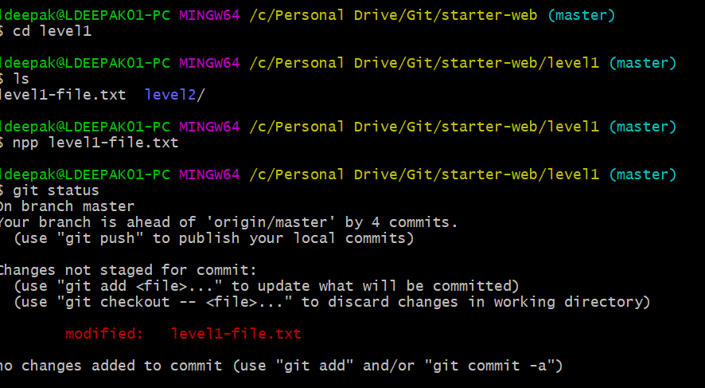

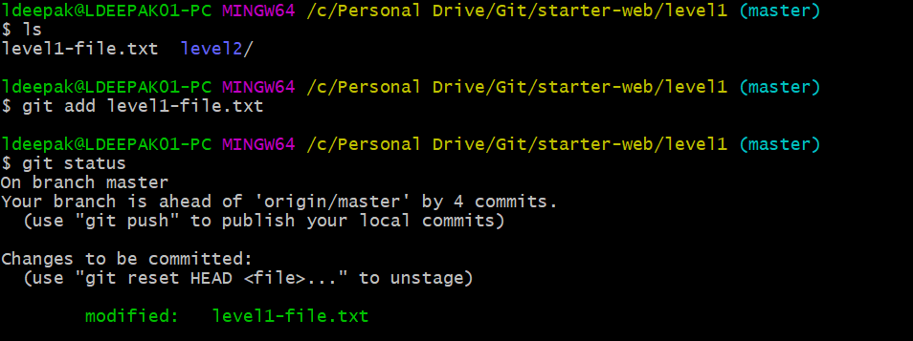

Suppose if you don’t want these changes. We can unstage these changes by doing a **git reset HEAD <*filename*>**

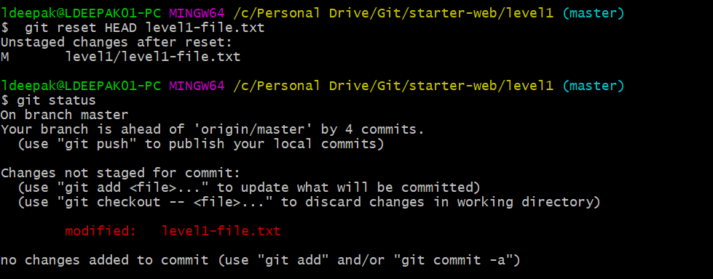

Now suppose if you don’t want these changes also, then we can do a

**git checkout -- <*filename*>.** This lets us at the place of last commit.

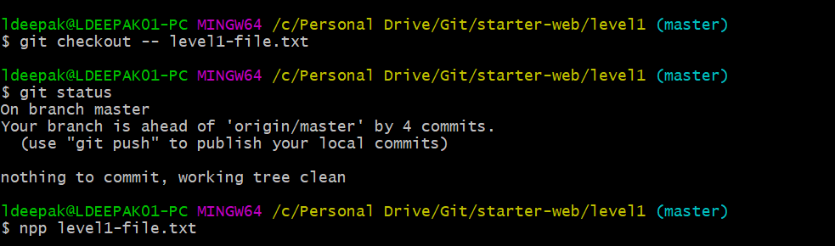

**RENAMING AND MOVING FILES**

Renaming level3-file.txt to level3.txt

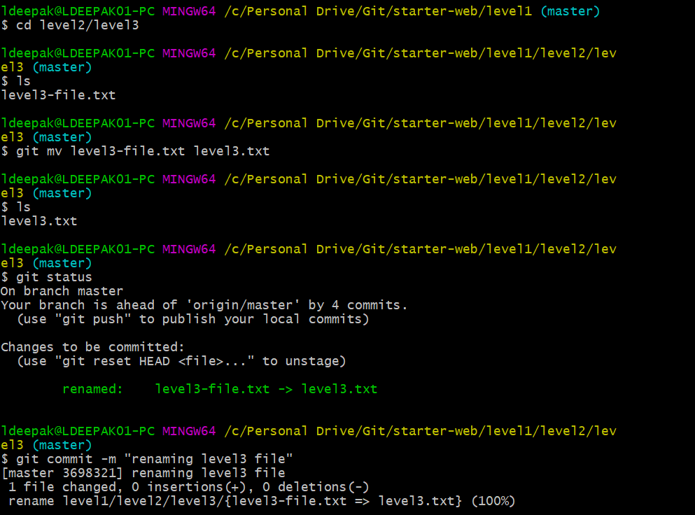

We can see that git stages the rename.

Renaming level2-file.txt to level2.txt

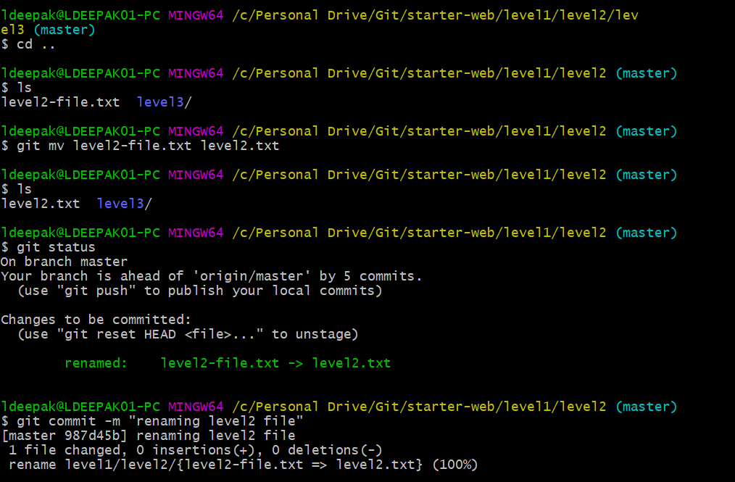

Renaming level2.txt to 2.txt

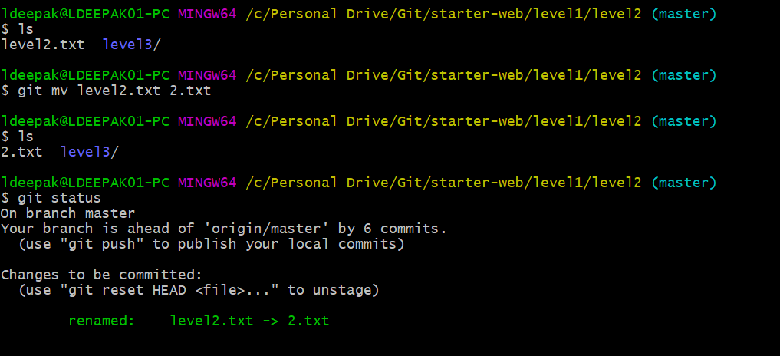

Now rename 2.txt to level2.txt

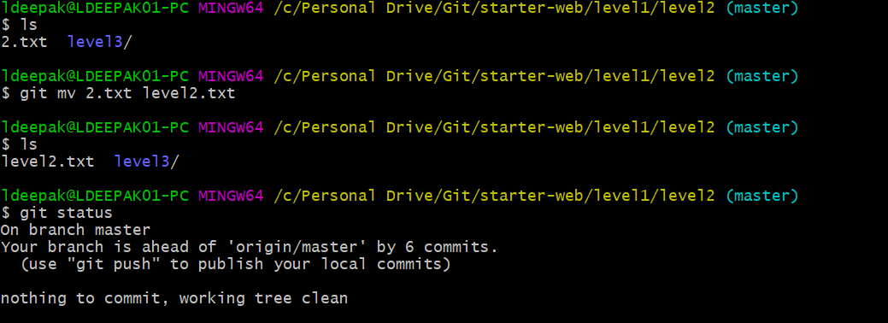

Now move the level2.txt up to level3

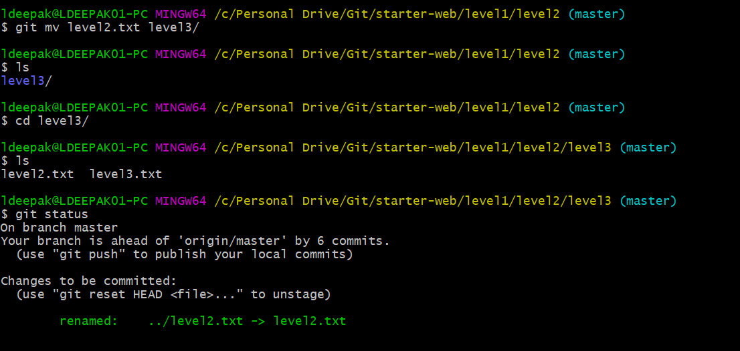

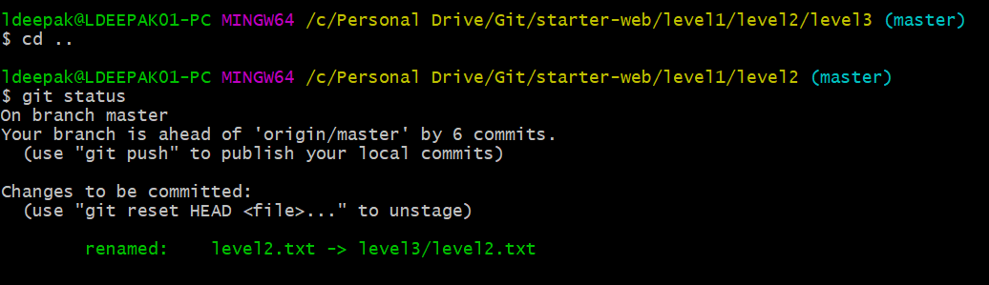

Do a commit

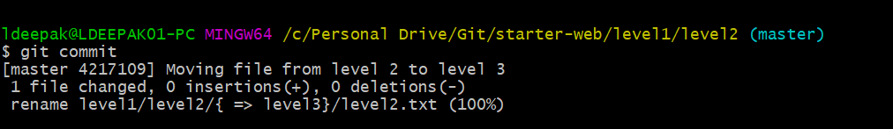

Now move level2.txt from level3 back to level2.

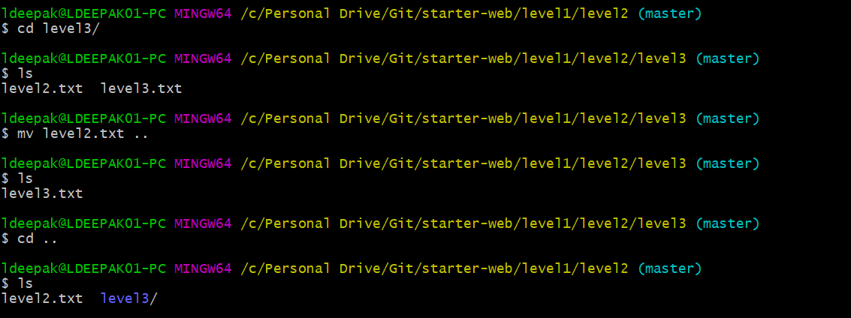

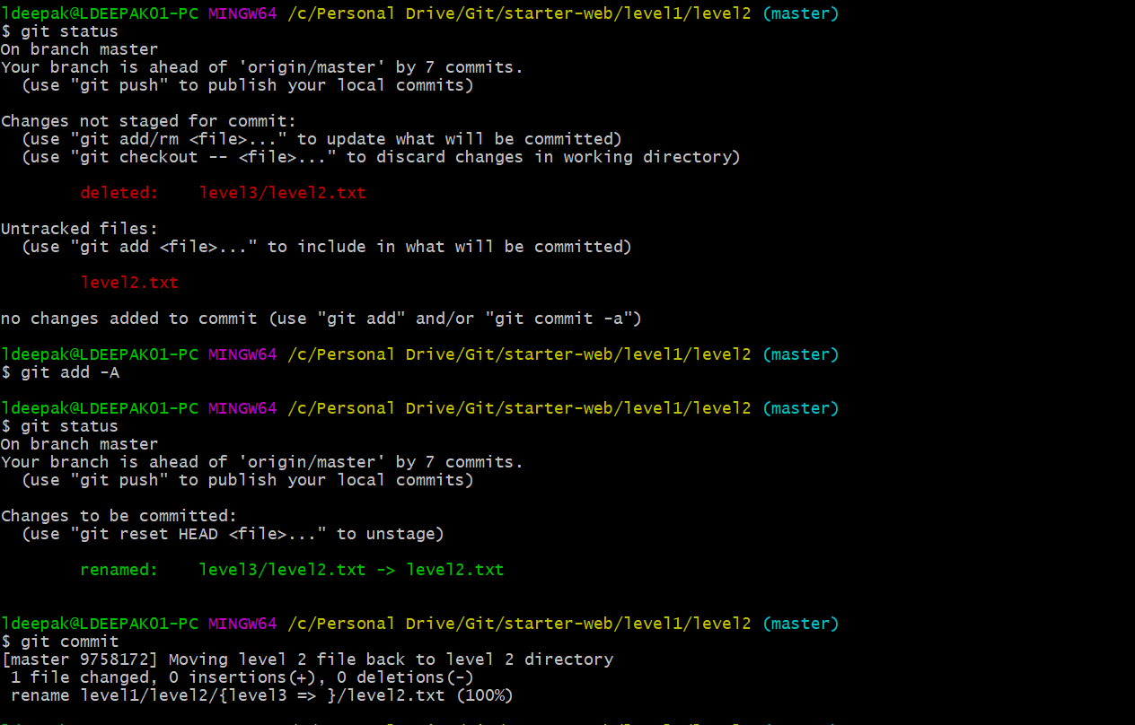

* git add -A stages **all changes**
* git add . stages new files and modifications, **without deletions**
* git add -u stages modifications and deletions, **without new files**

Change the name of level1-file.txt to level1.txt from file explorer.

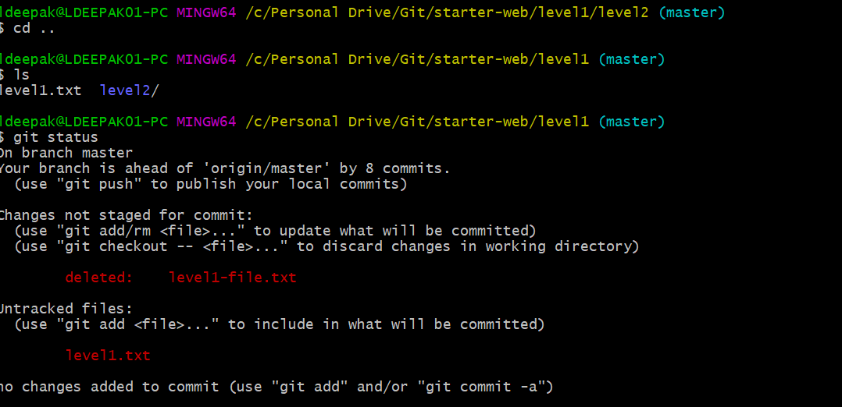

Git detects as two separate operations: a delete and then an add.

We can manually add the files if need be.

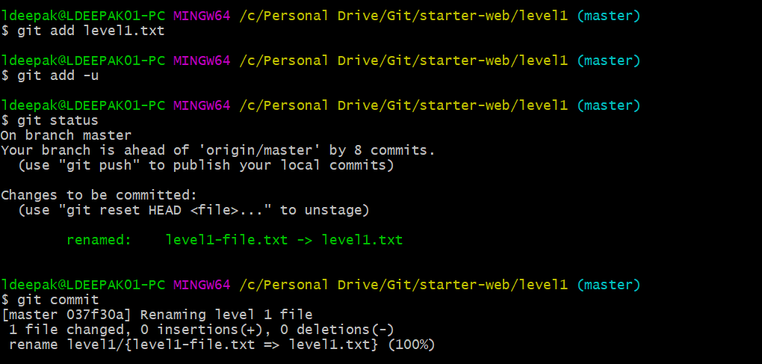

**DELETING FILES**

1. Delete a file not yet tracked by git.

Create a file doomed.txt with some text.

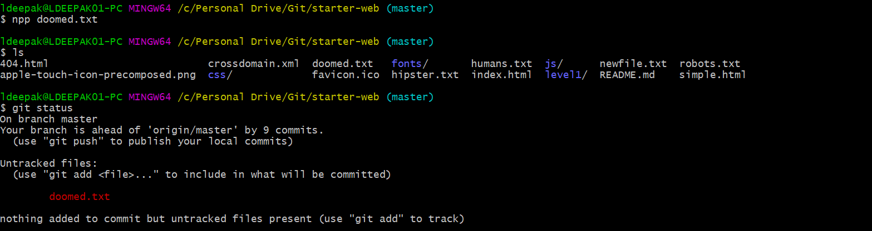

Remove the file using OS specific commands.

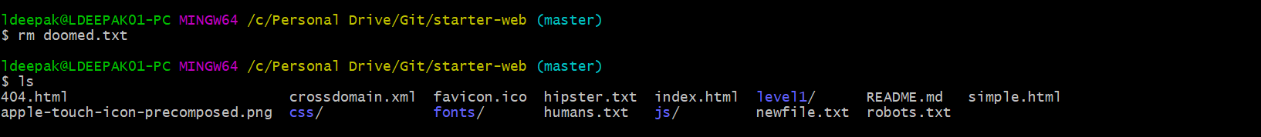

1. Delete a file that is being tracked by git. Using git rm command. Delete ‘newfile.txt’, which is being tracked by git.

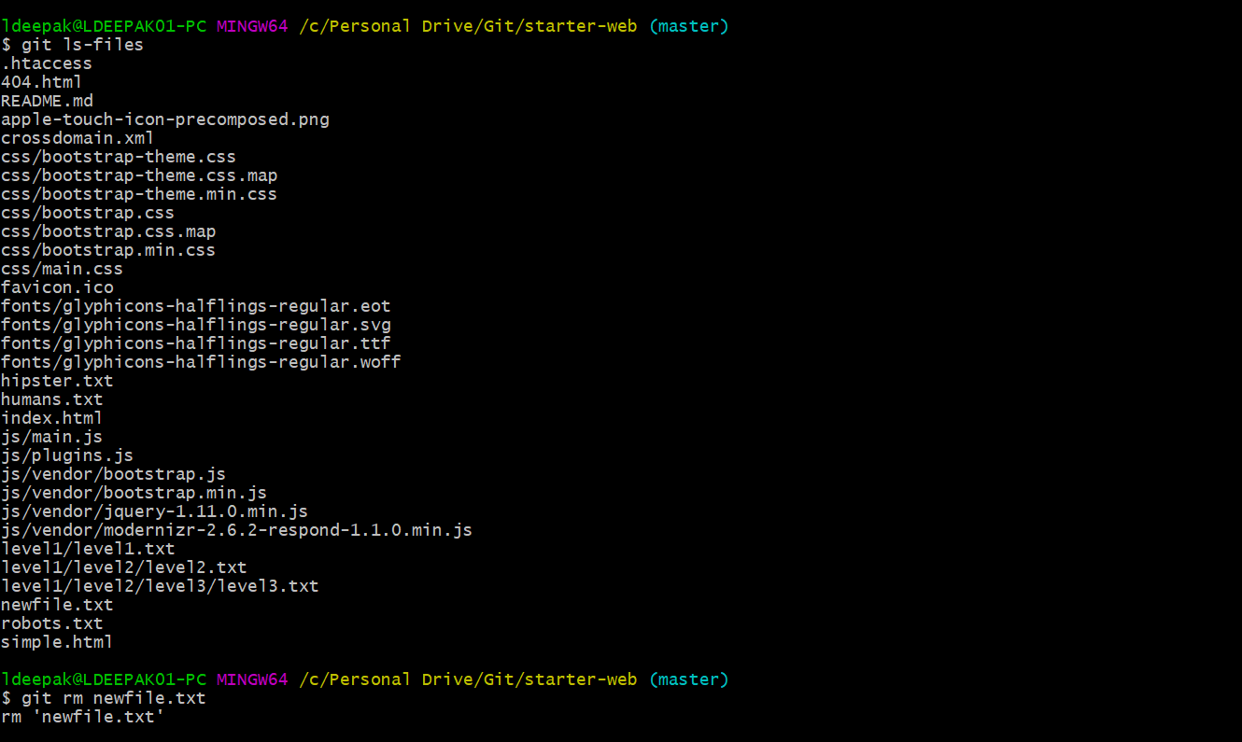

Git has staged the fact that deletion is going to take place.

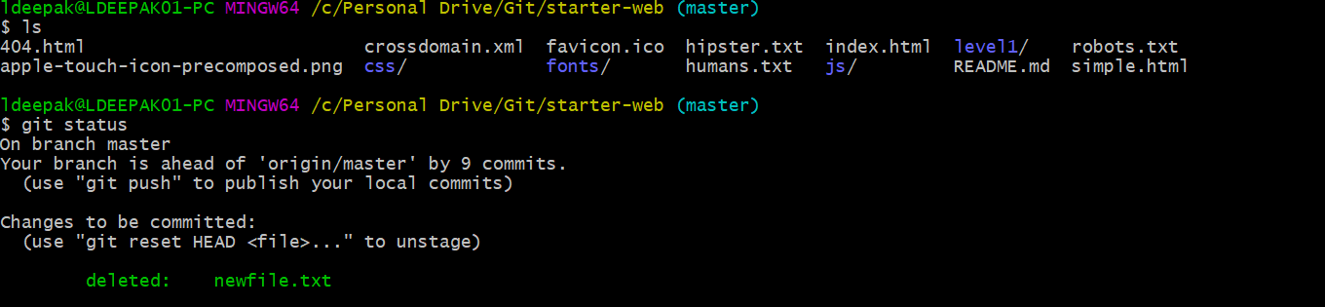

Do a commit.

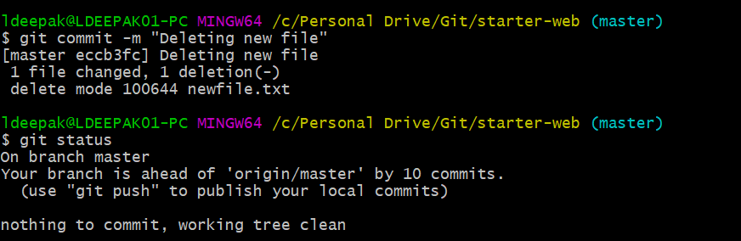

1. Backout a staged deletion.

Remove ‘hipster.txt’

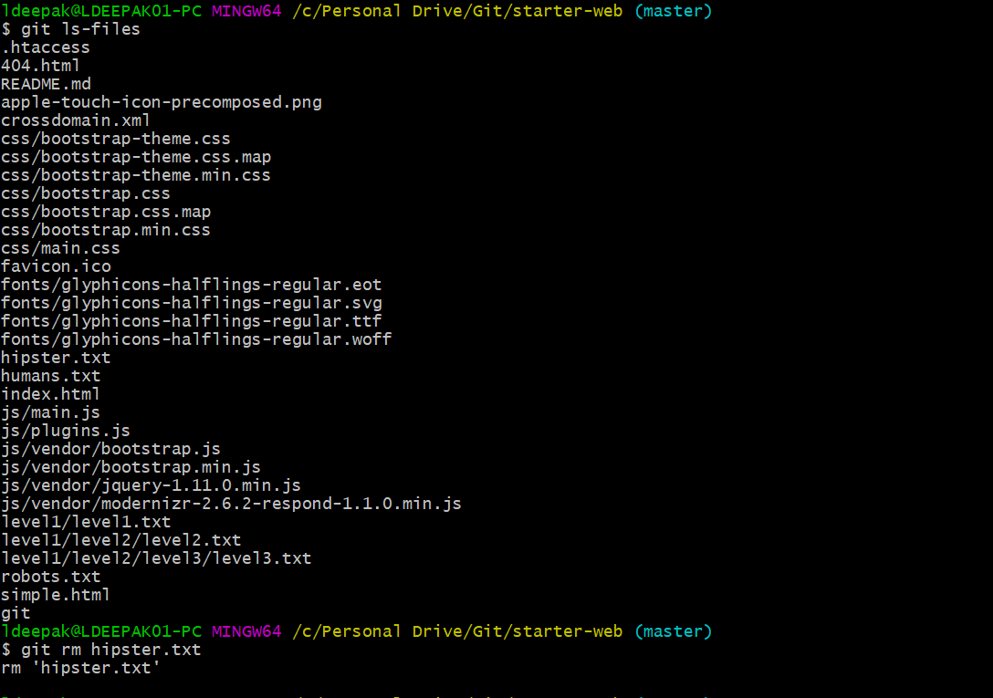

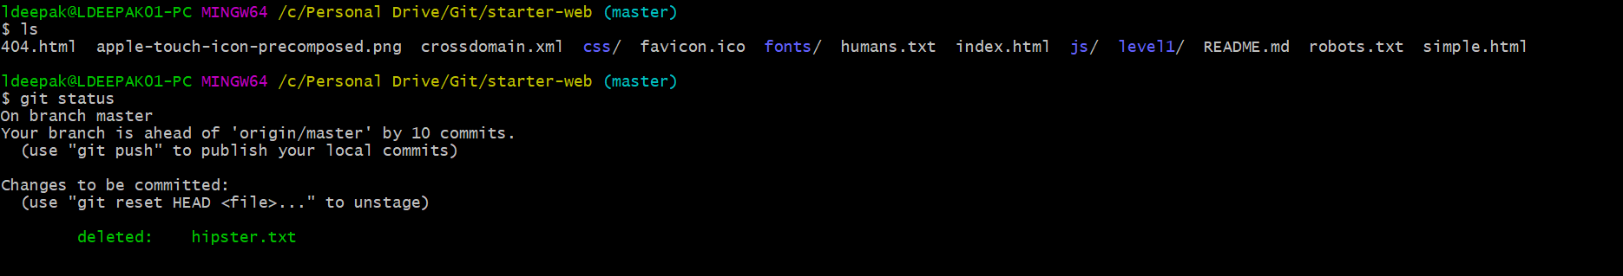

If we are not ready to delete this file. Let’s unstage it.

This shows that the file is being tracked, but is not present in our working directory.

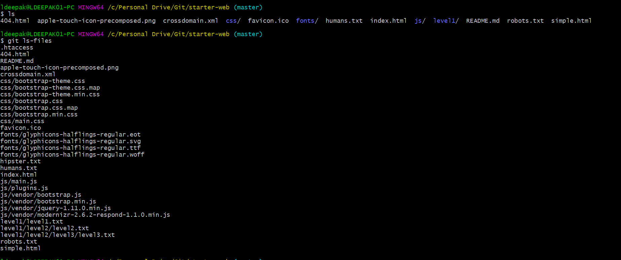

The file is just unstaged, but is not actually restored by the file system.

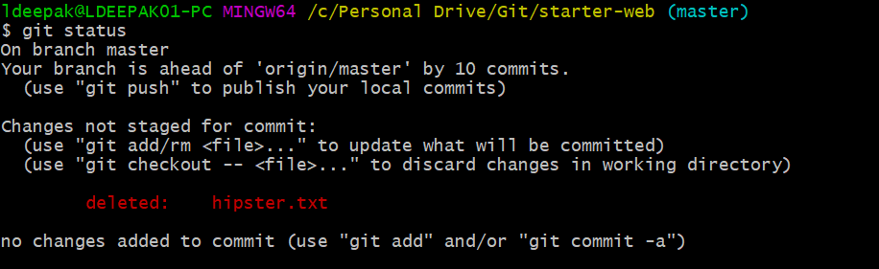

Lets do a checkout. Now we can see that the file in present in our working directory.

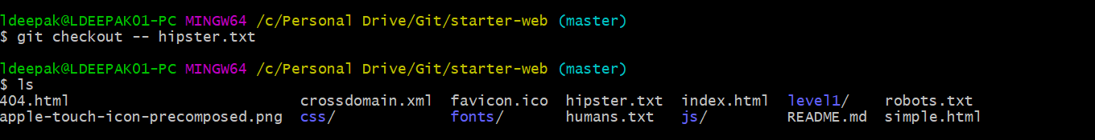

1. Delete a file which is being tracked by git. Do a manual delete in file system instead of using git rm command.

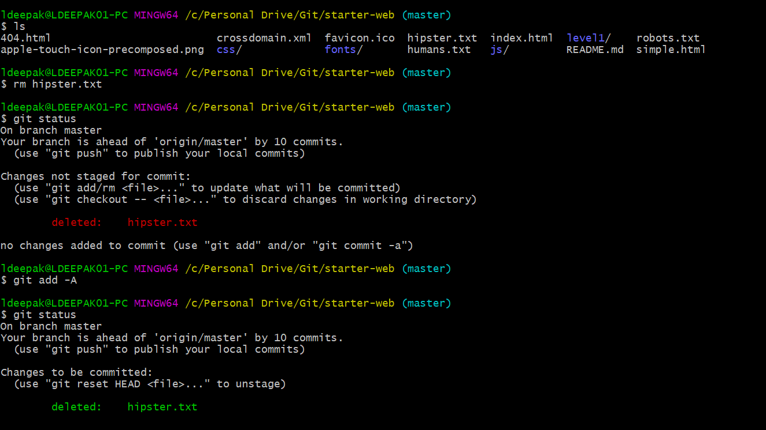

Do a commit.

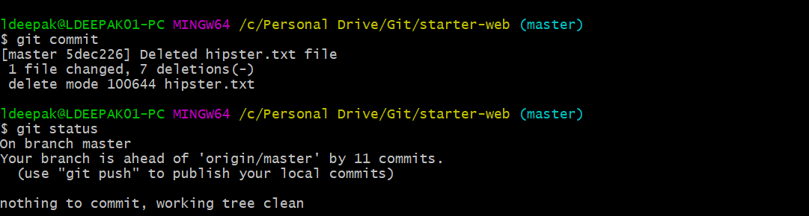

1. Deleting the folder structure recursively. Use rm -rf command.

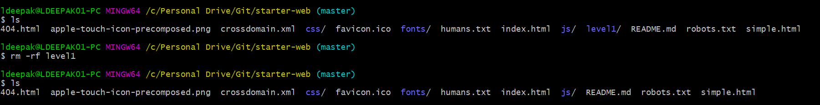

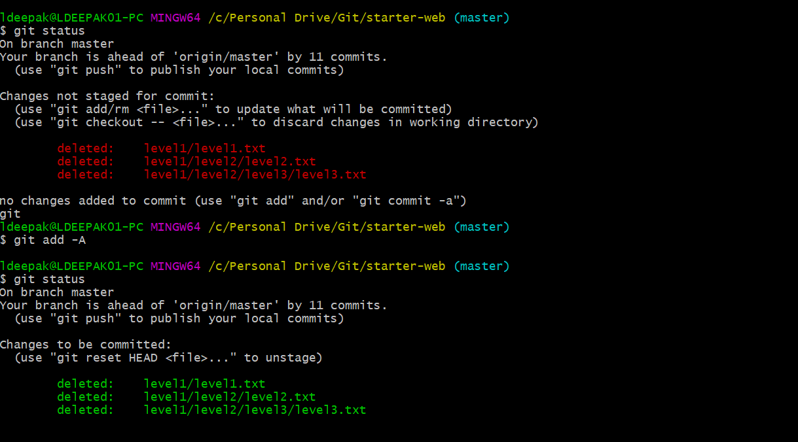

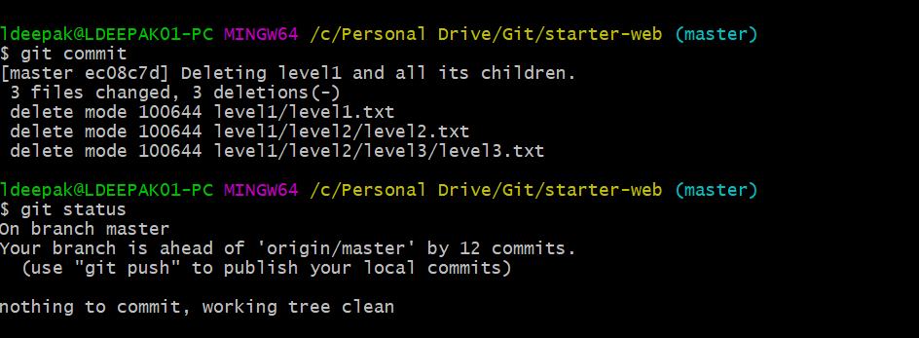

**SEEING GIT HISTORY**

Use **git help<command name>** to view the available options for a git command. Example: git help log, to see options available for log command in git.

Do a **git log**. This lists git commits in a reverse chronological order.

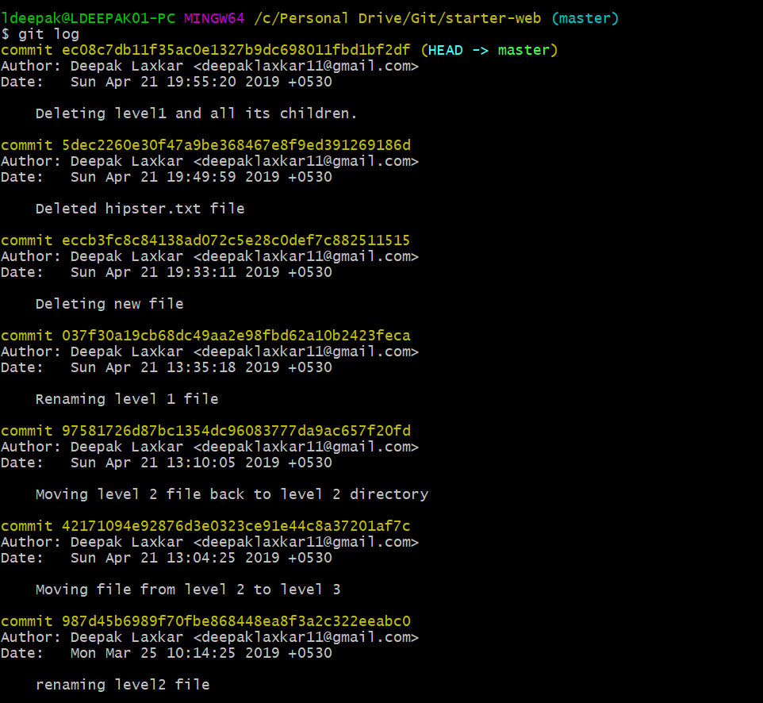

First line is the SHA-1 identifier to identify a commit.

Second line is the author’s name and email.

Third line is the date and time of the commit.

Fourth is the actual commit message.

We can use **git log --abbrev-commit.** This shortens the commit identifier.

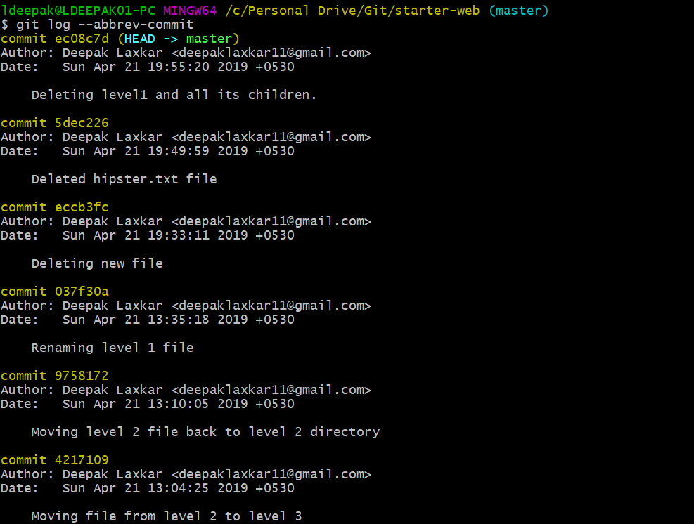

Do **git log --oneline --graph –decorate.**

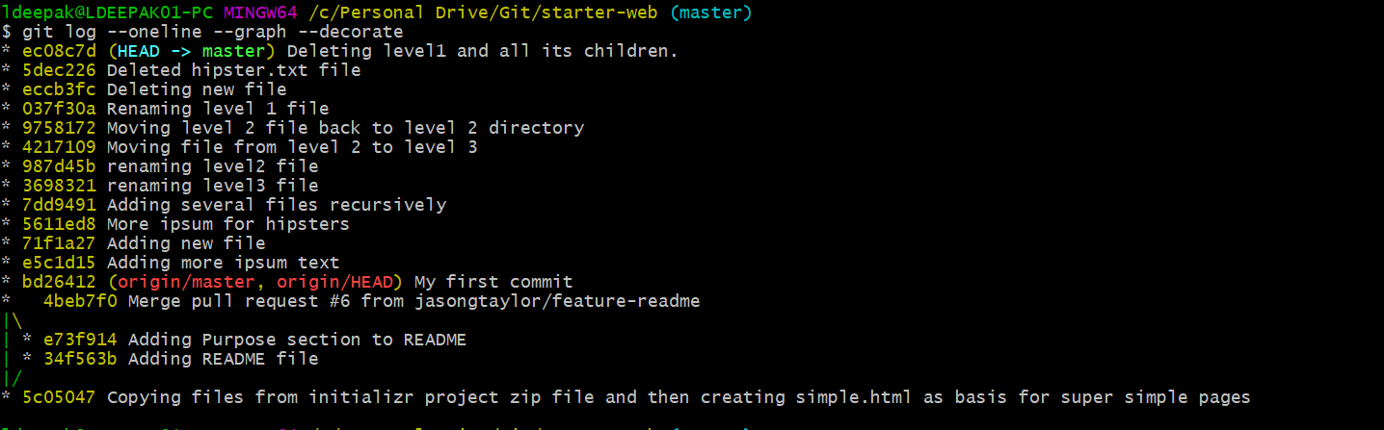

Do **git log --since "3 days ago".** This will show the commit that have happened in last 3 days.

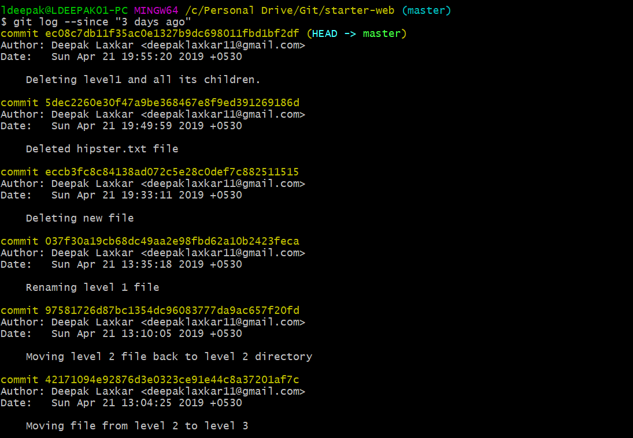

Look at the history of a specific file.

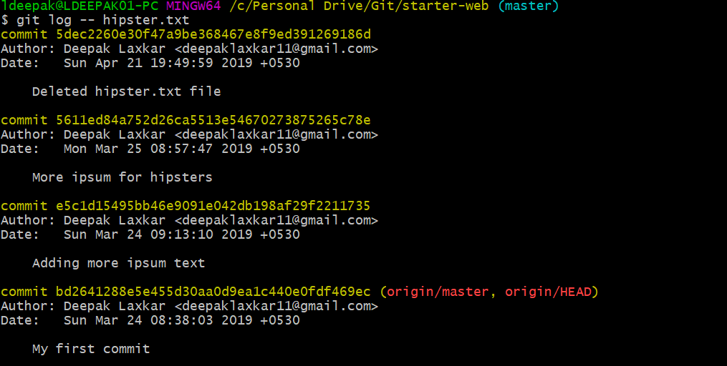

To show information about a commit. Use **git show <commit id>**

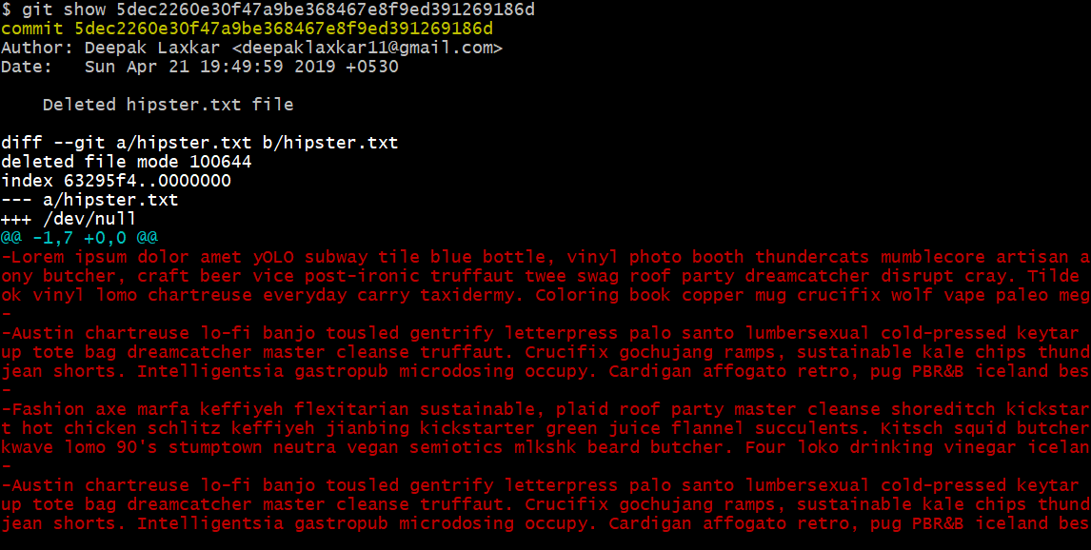

**EXCLUDE UNWANTED FILES FROM GIT REPO**

Create a new file ‘systemFile.txt’. We want that git ignores this file.

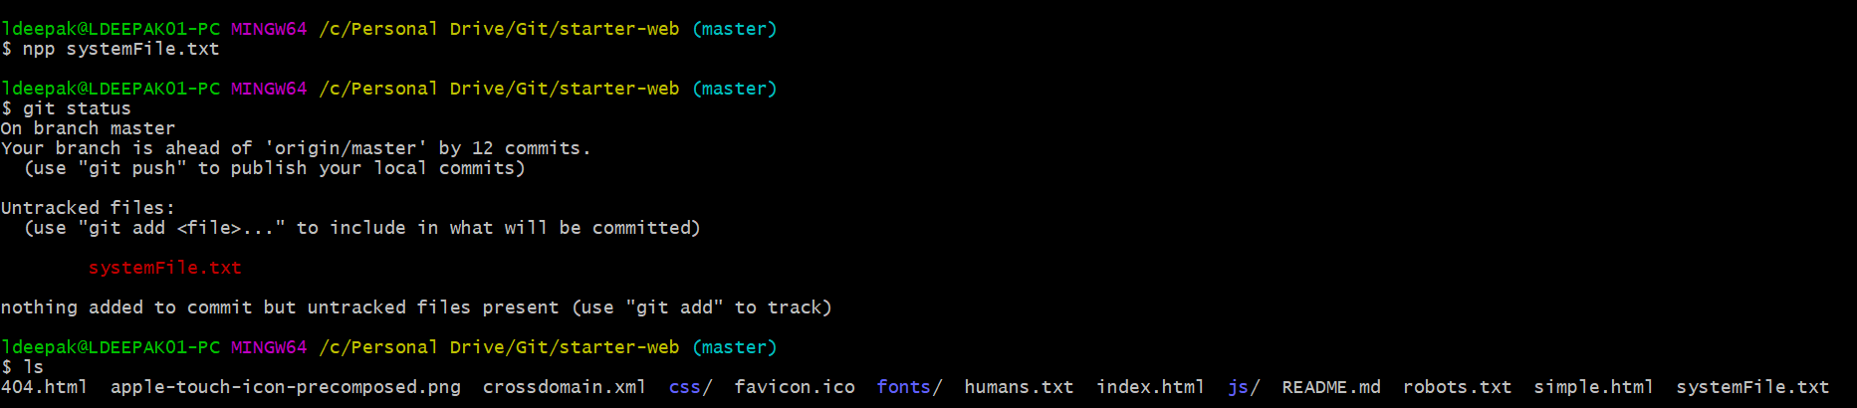

Check to see whether **.gitignore** file exists or not. Otherwise create it.

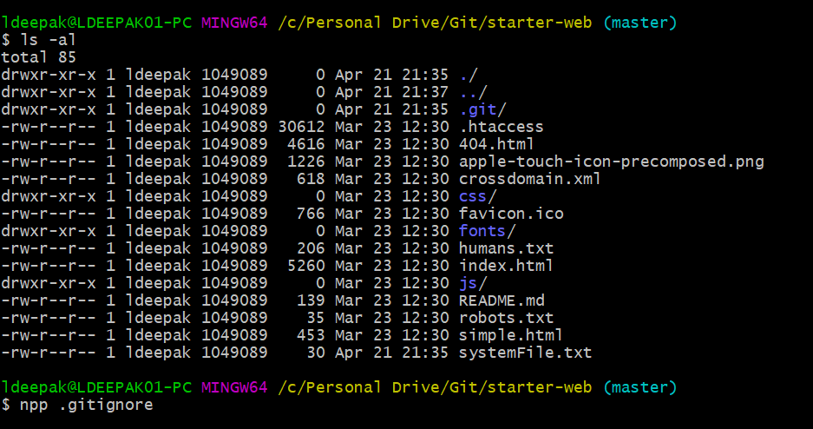

Add the file you want to exclude.

We can add one expression per line. It can be:

A specific file that you want to ignore: like simpleFile.txt

File pattern: *.ext

Folder: my-folder/

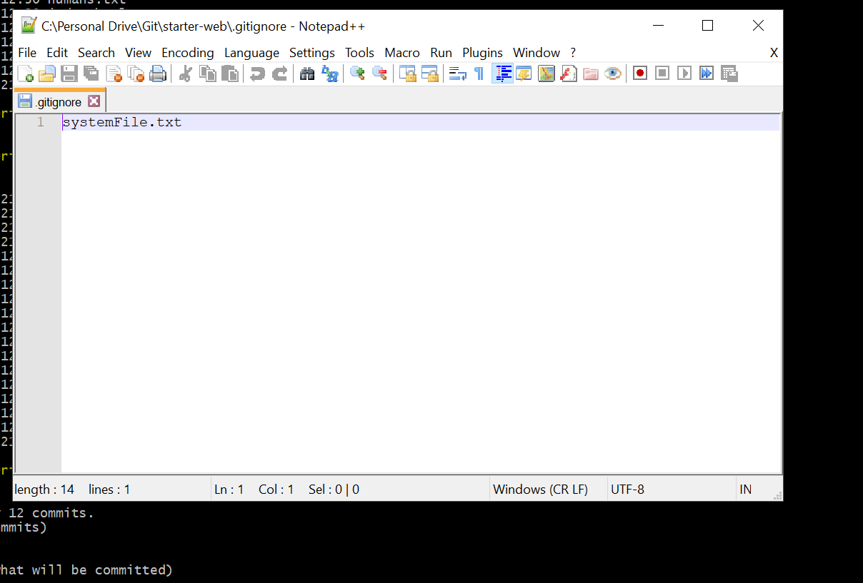

Then check for presence of .gitignore. Then add this file to git.

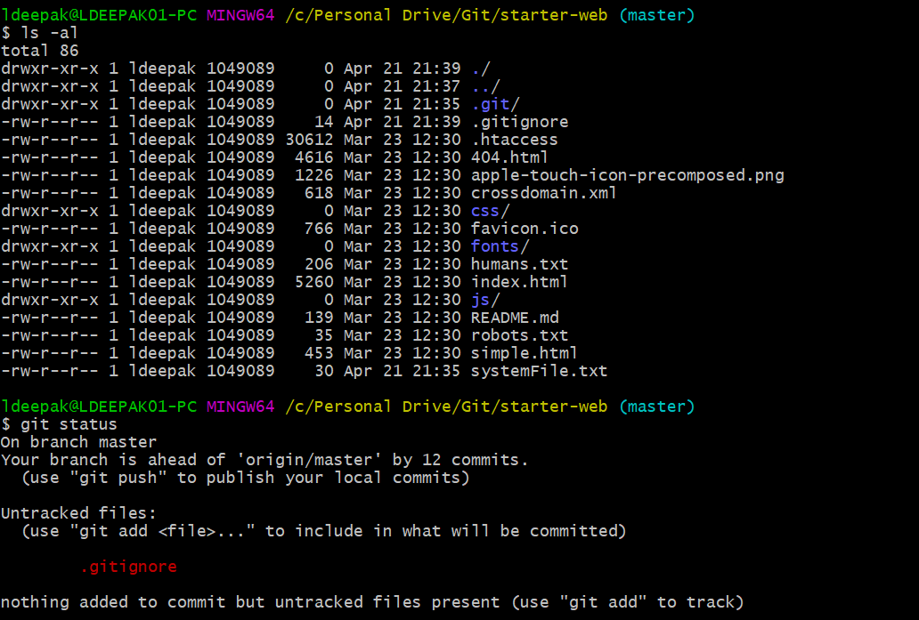

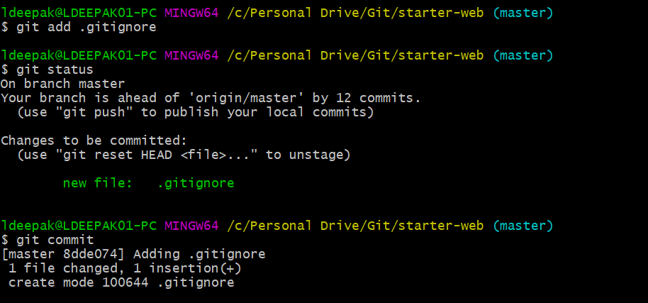

Create another file ‘access.log’ and exclude the file using .gitignore.

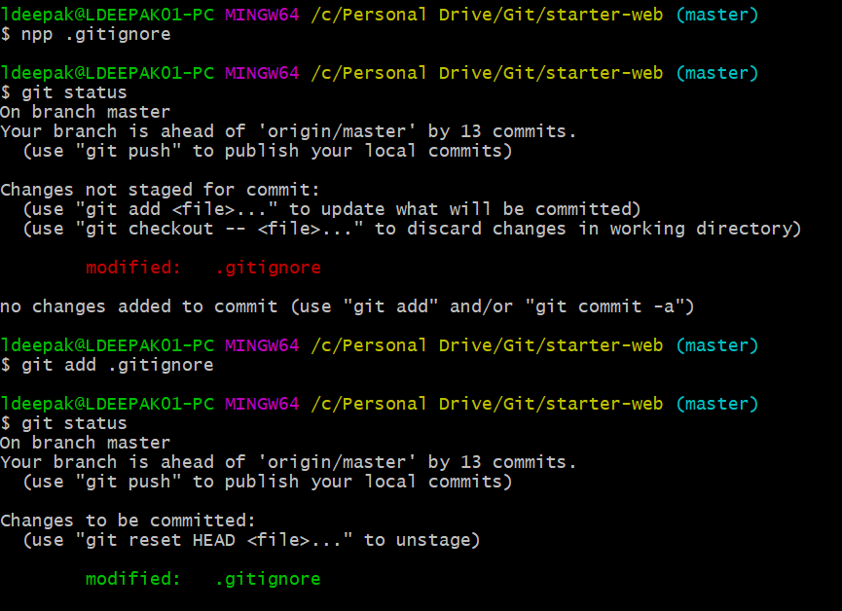

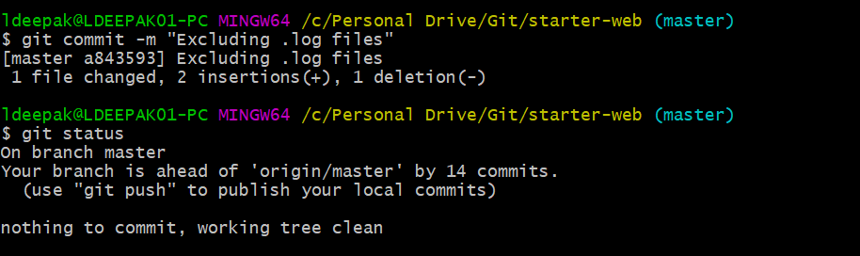

**PUSHING CHANGES FROM MASTER(LOCAL REPO.) TO ORIGIN/MASTER(REMOTE REPO.)**

Do git status

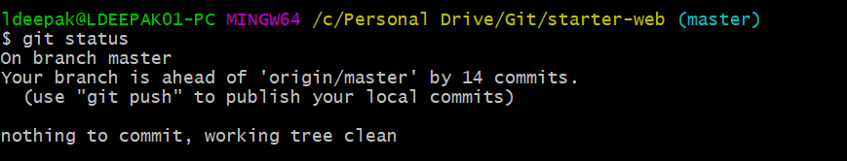

Do git pull.

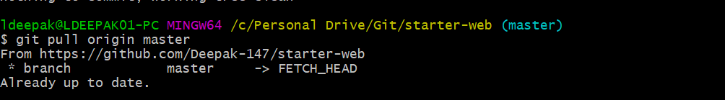

Do git push.

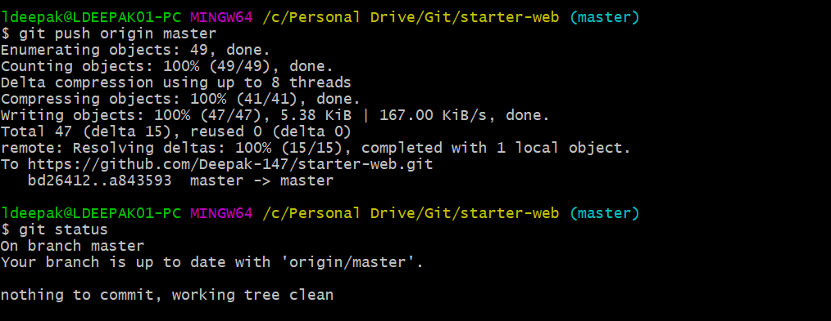

**VISUAL MERGE AND DIFF TOOL SETUP AND CONFIG**

Download and Install p4merge from Perforce.

Edit PATH environment variable to add location of p4merge executable.

Configure it with git bash.

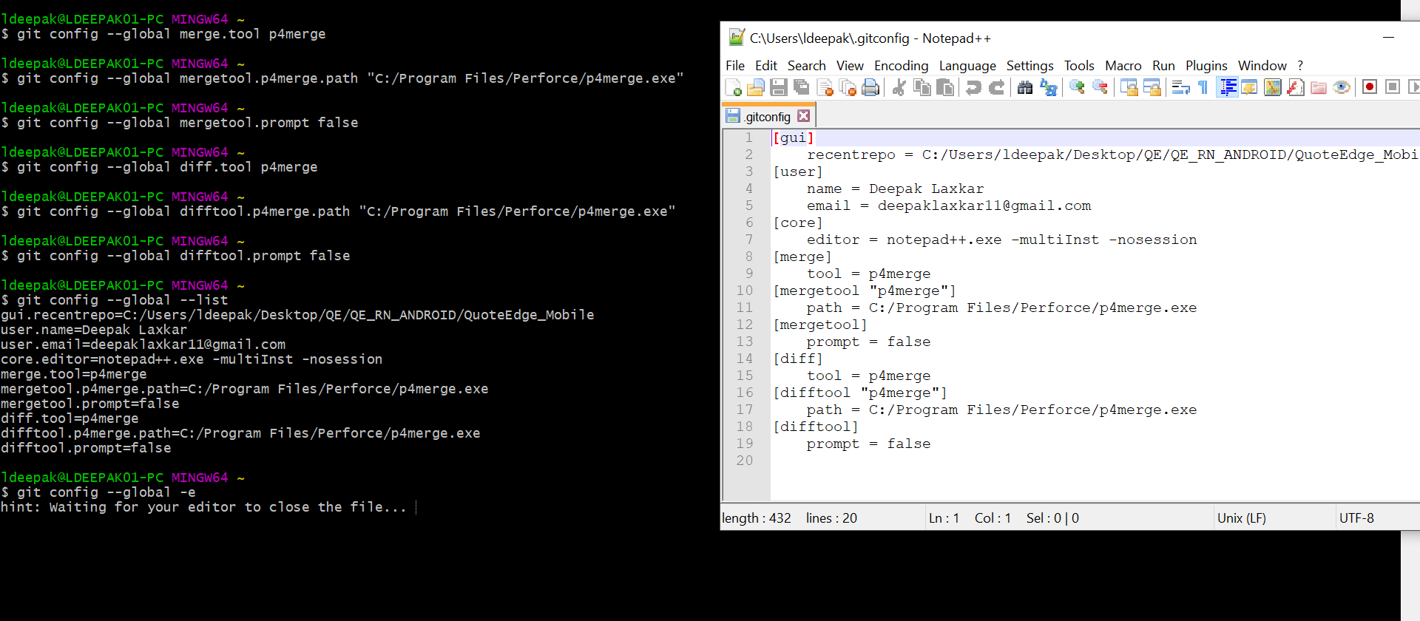

Remove the already existing README.md file.

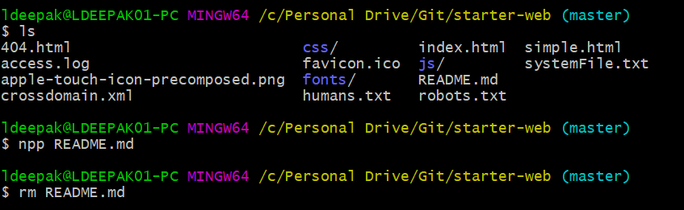

Create a new README.md file

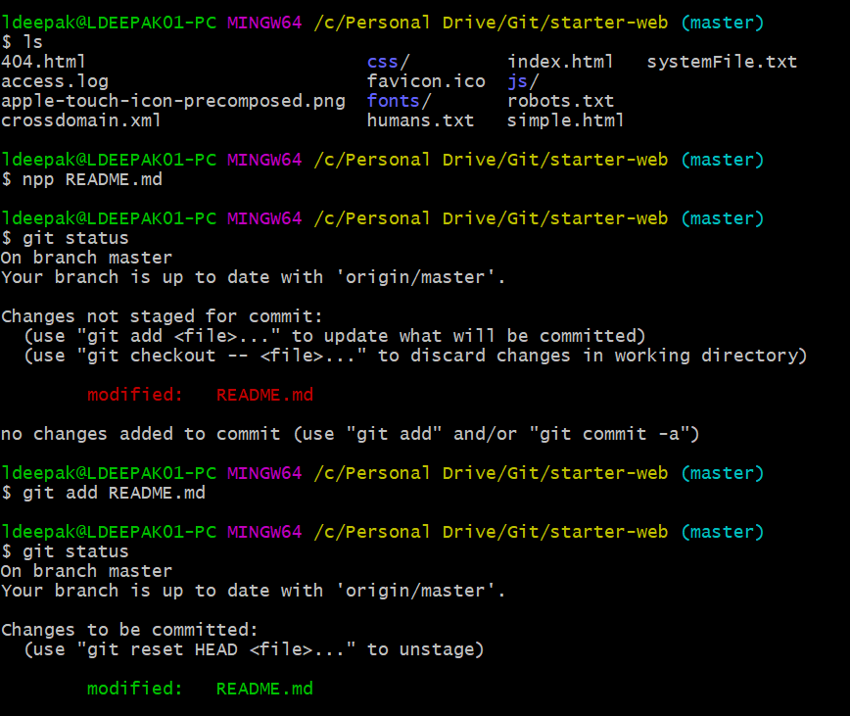

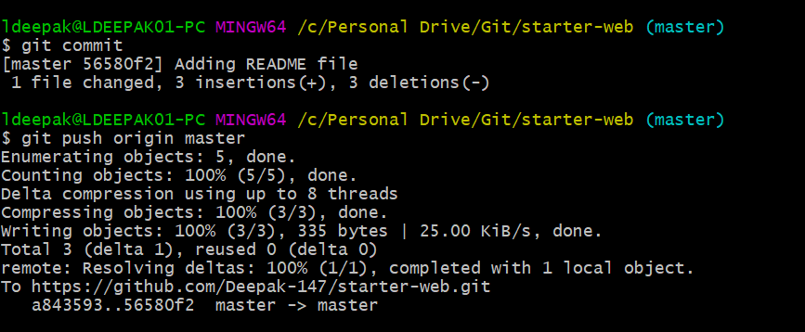

Edit the README.md file to add a new section.

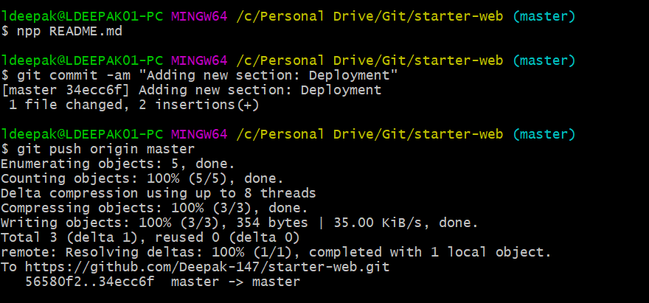

Edit the README.md file to add description.

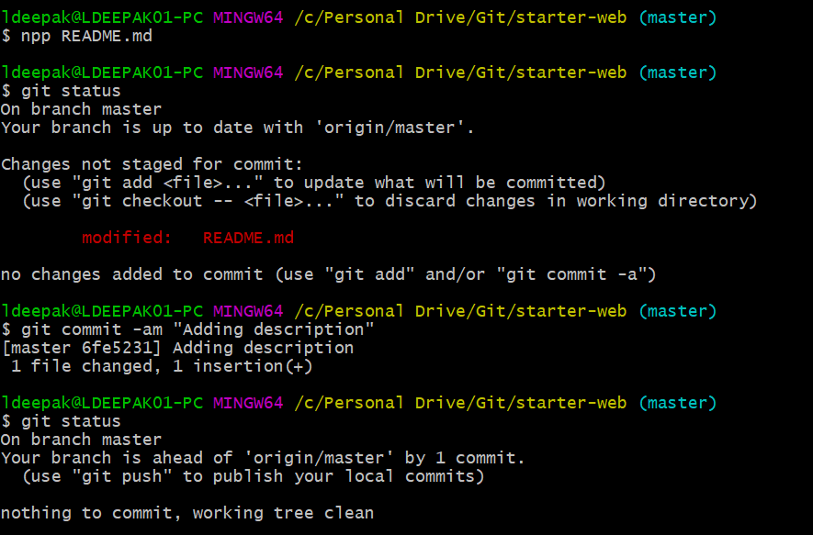

Edit the README.md file and add the introduction text.

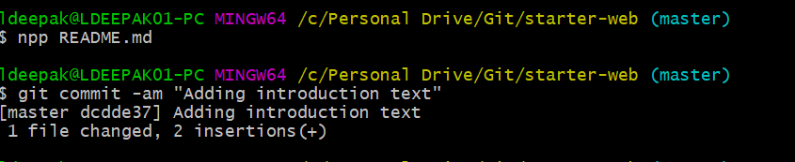

So far, we have made 2 commits since our last push. Now again edit README.md file and add text for purpose section. This time we add the files to staging area and not commit it. So our README.md file is present in three phases:

**Staging area**: README.md file containing text for purpose section

**Commit area(.git folder)**: README.md file containing text for description and introduction text.

**Remote Repo**: README.md file since last push.

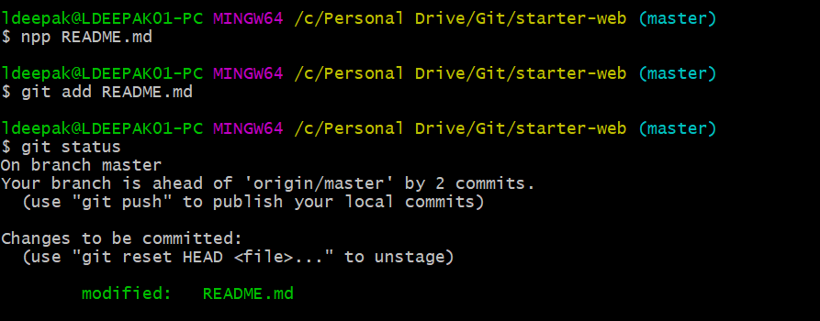

Now again edit README.md file to add text for deployment section.

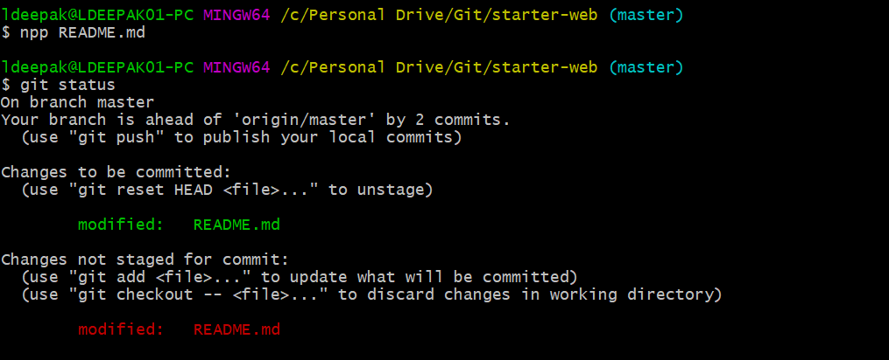

At this point we have our README.md file in all 4 phases of git:

**Working Directory:** README.md file containing text for deployment section.

**Staging area**: README.md file containing text for purpose section.

**Repository(.git folder)**: README.md file containing text for description and introduction text. Committed files.

**Remote Repo**: README.md file since last push.

**Differences**

1. **Check the differences between working directory and staging area**

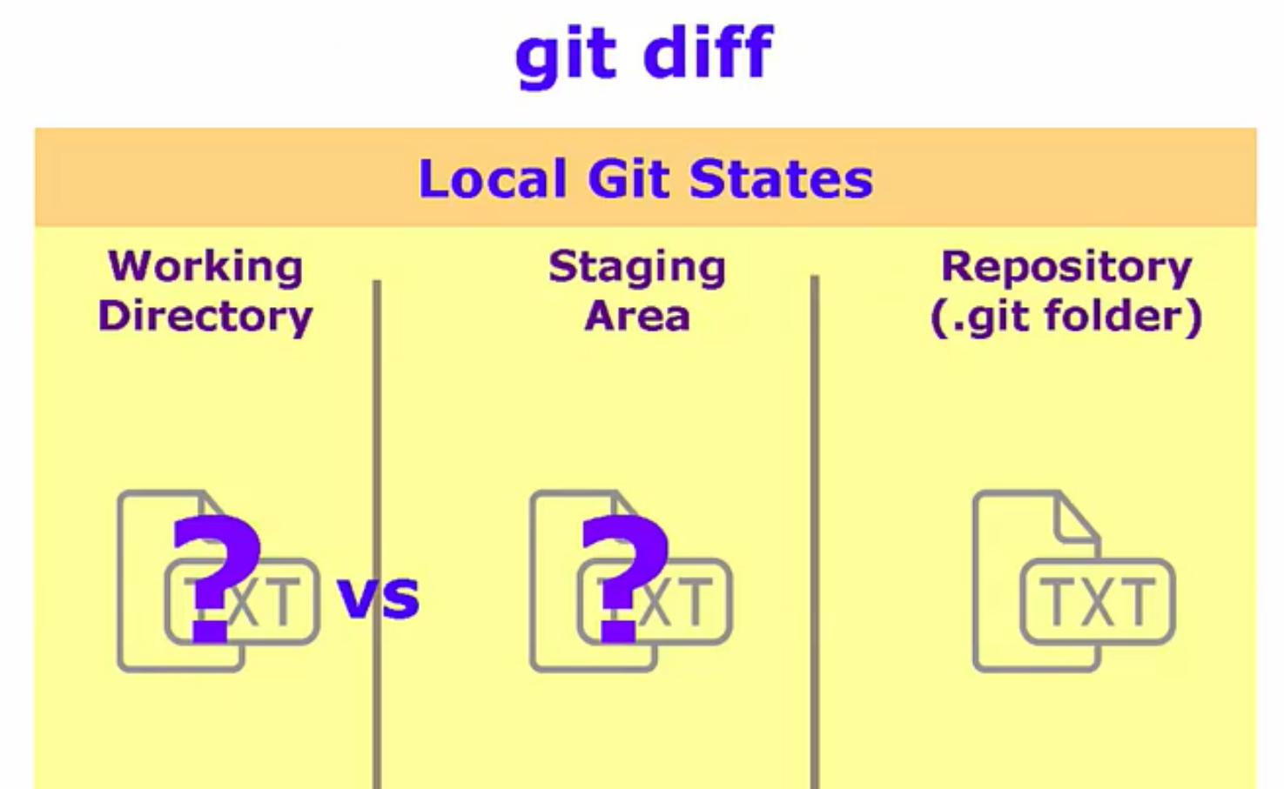

We do a **git diff** to see the differences between files present in working directory and staging area.

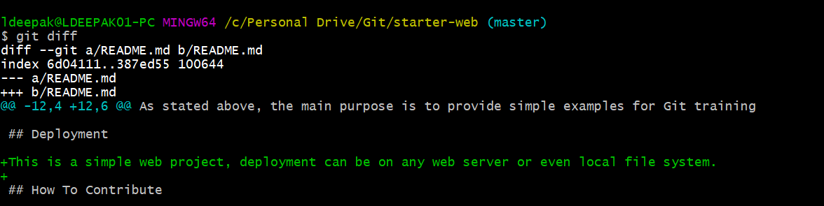

We can do **git difftool** and git will launch our visual difftool for us.



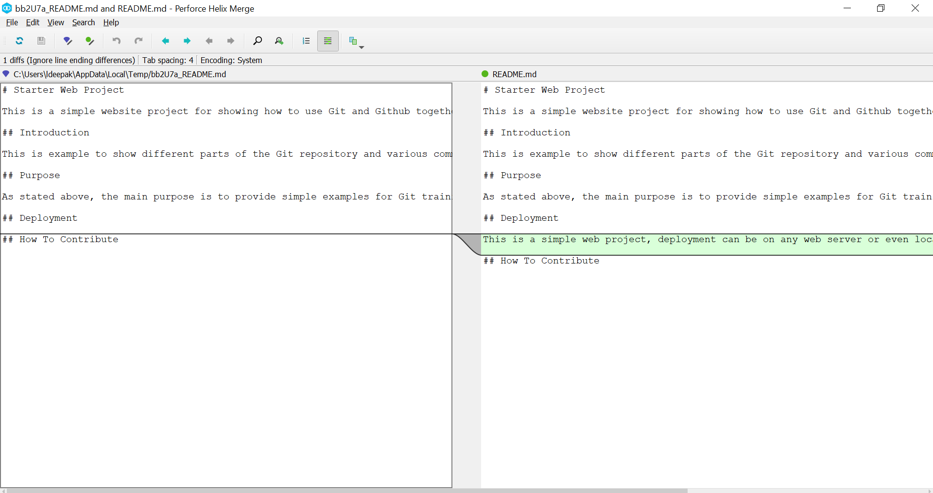

1. **Check the differences between working directory and Git repo(.git folder)**

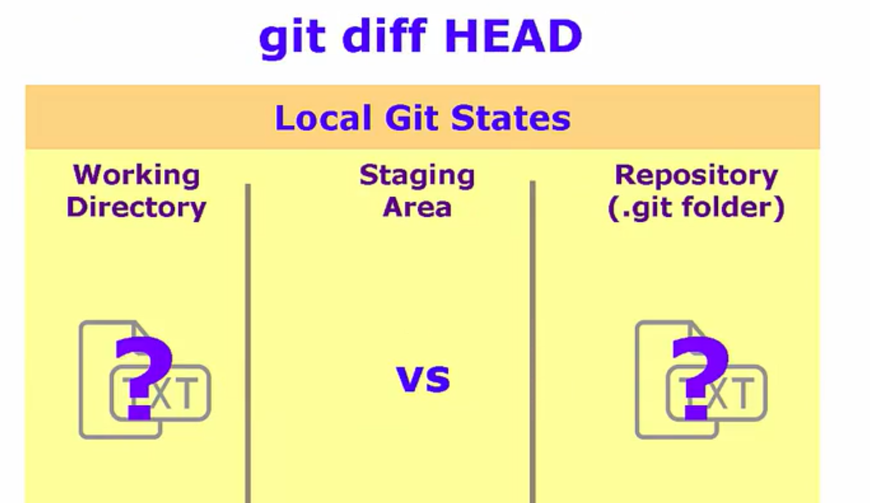

Do a **git diff HEAD** to see differences between working directory and last commit(.git folder)

HEAD means last commit on the current branch.

HEAD^ means commit before last commit.

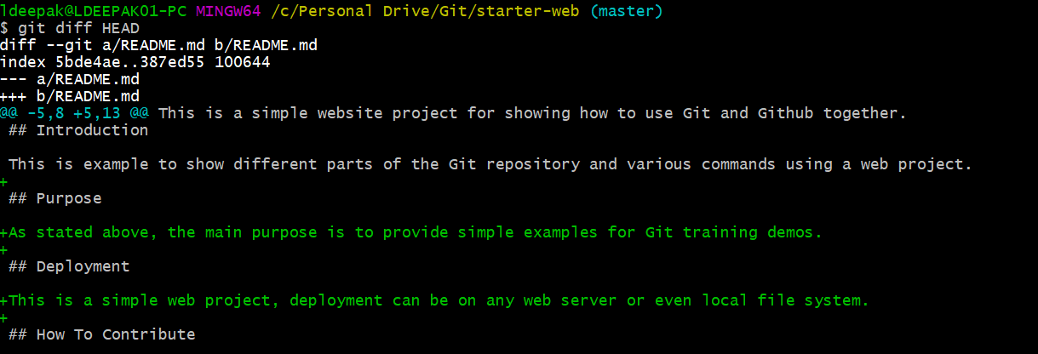

Lets visualize using p4merge difftool



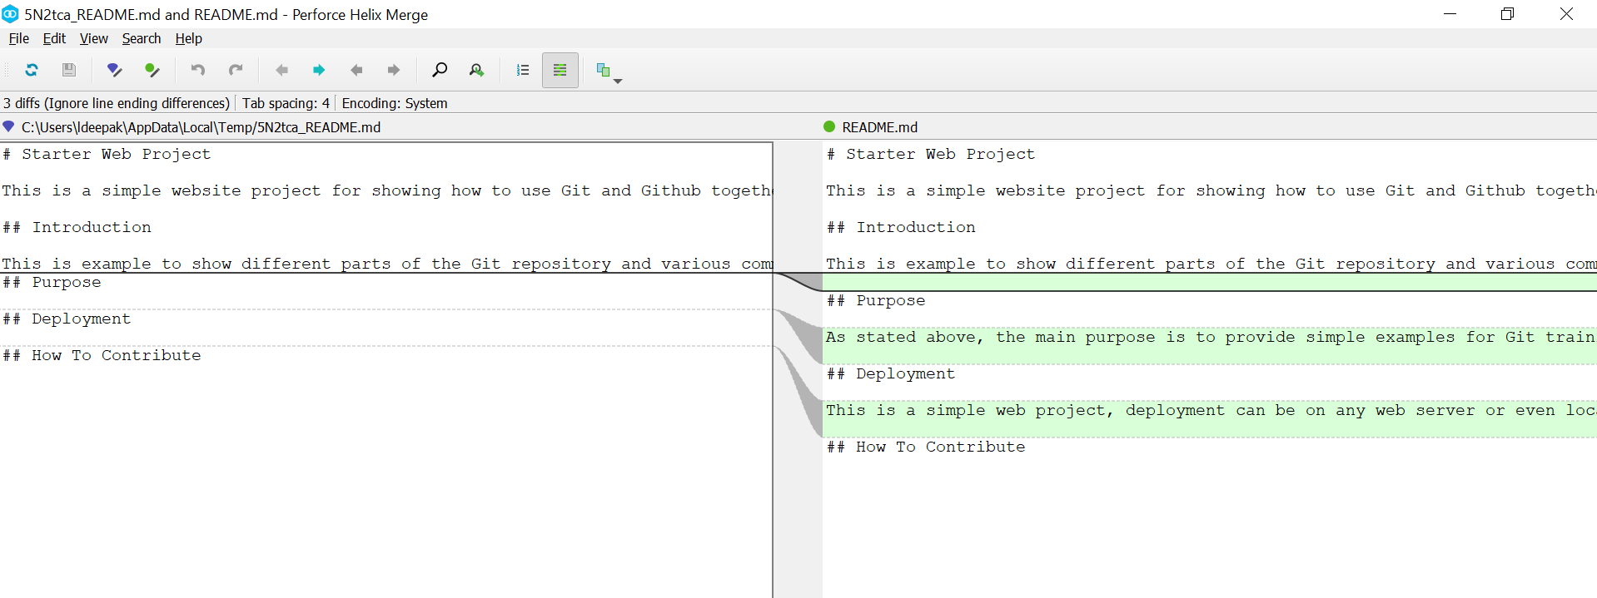

1. **Check the differences between staging area and Git Repo(.git folder)**

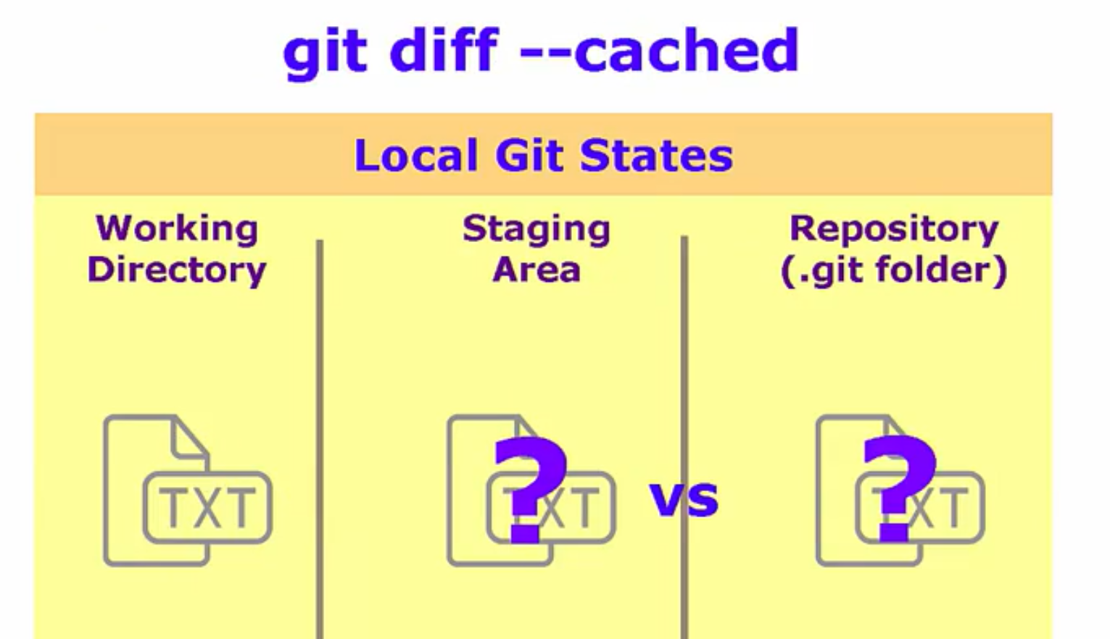

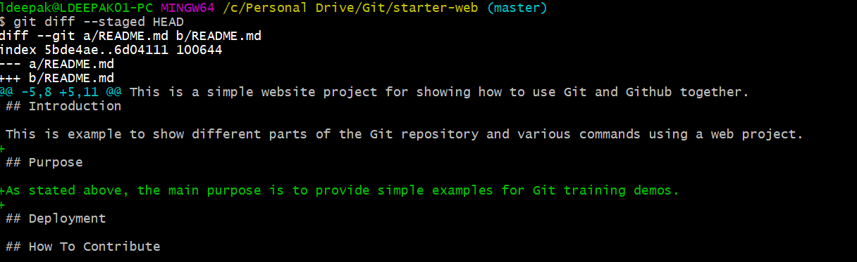

Lets see it visually



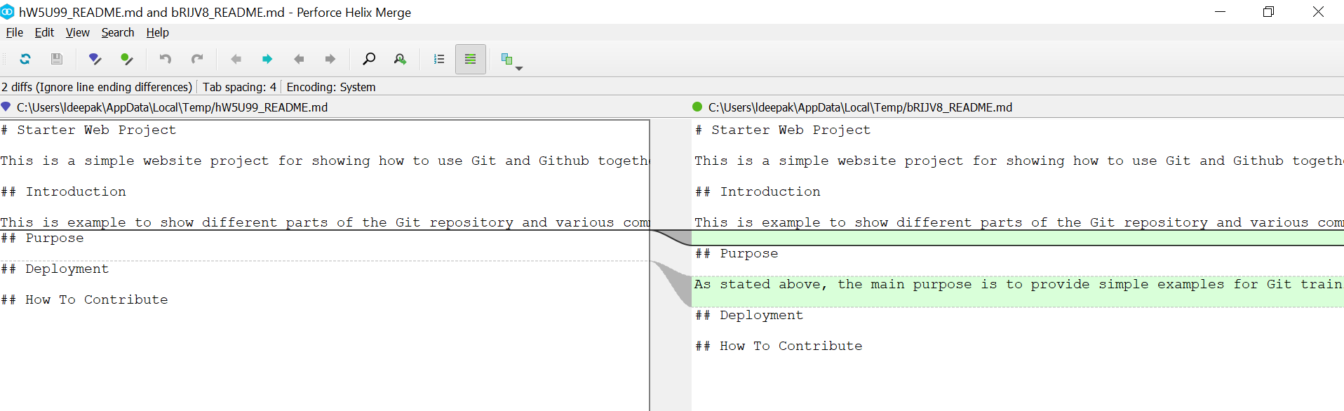

**Limiting the comparisons to just one file**

Modify another file and see the diff results.

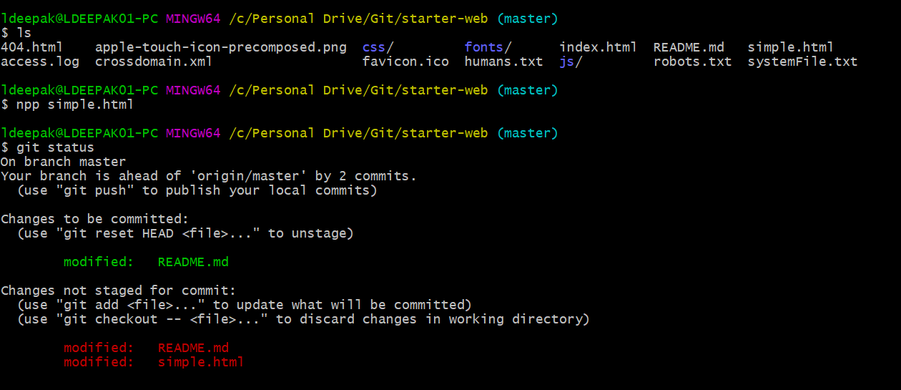

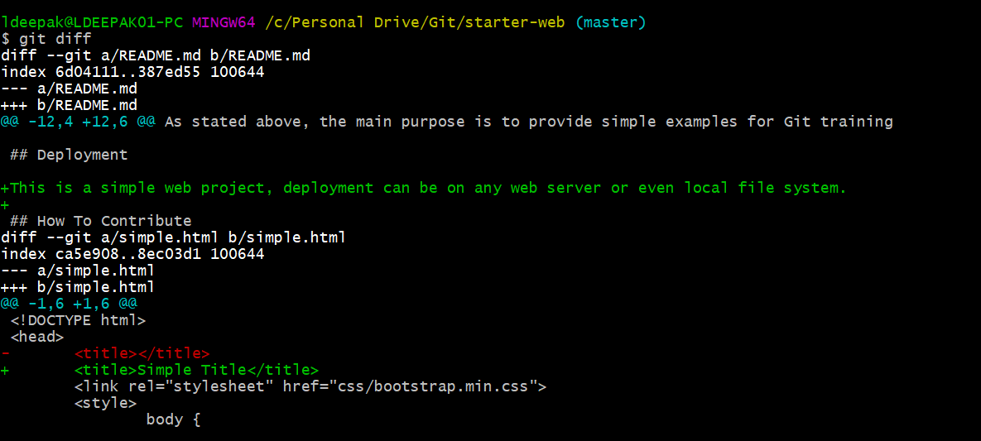

It shows differences in both the files. If we want to limit to just one file. Do **git diff -- <filepath>.** This shows on differences in README.md file.

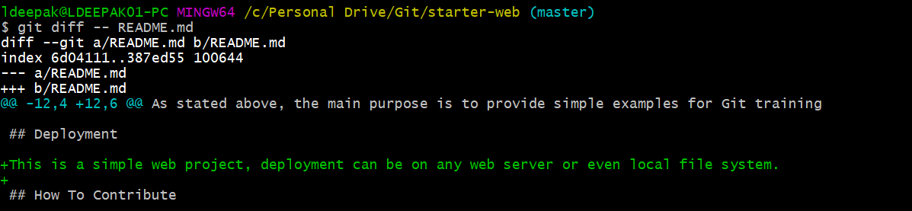

**Comparing between commits**

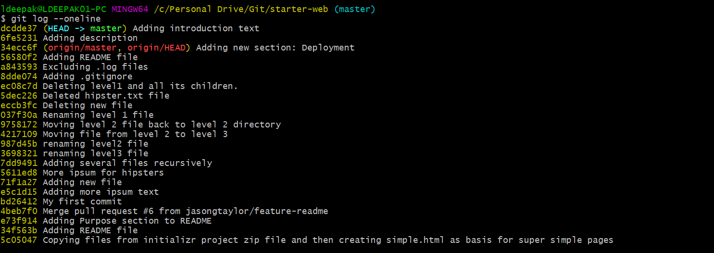

To see the differences between two random commits. Do **git diff <*commit id1*> <*commit id2*>**

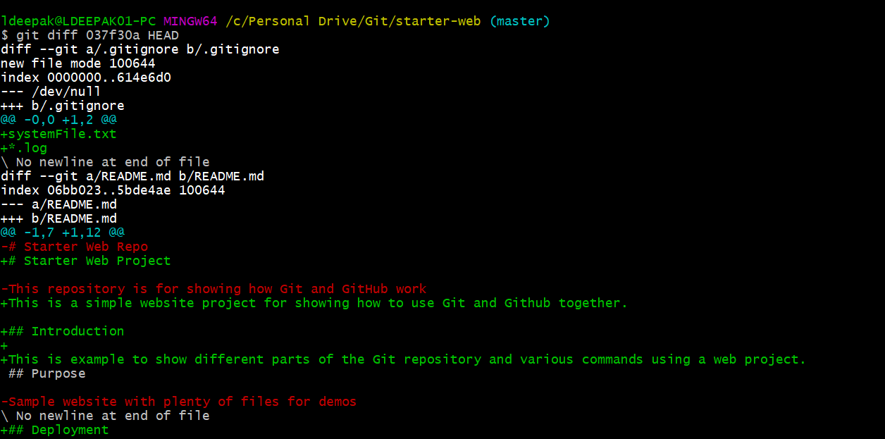

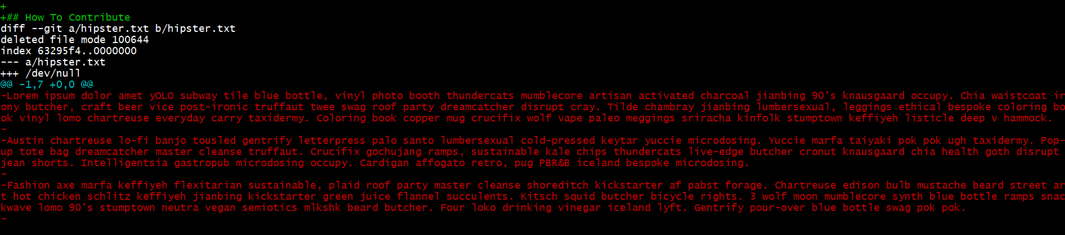We can visually see the differences using **git difftool <*commit id1*> <*commit id2*>**

**Differences between branches**

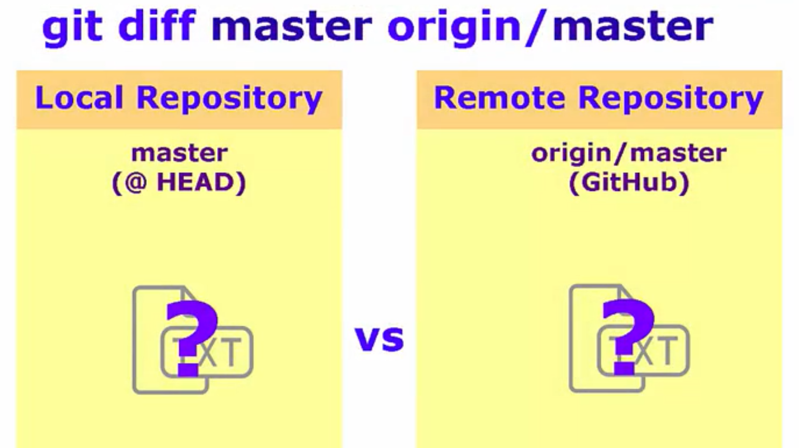

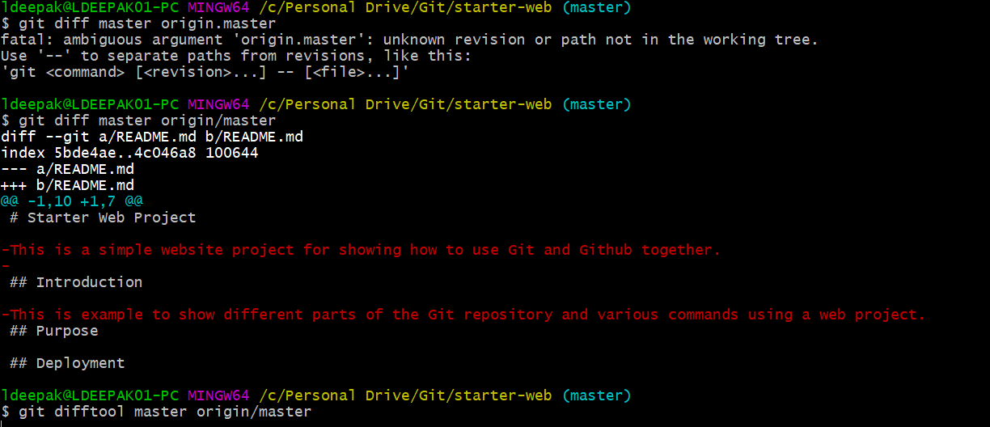

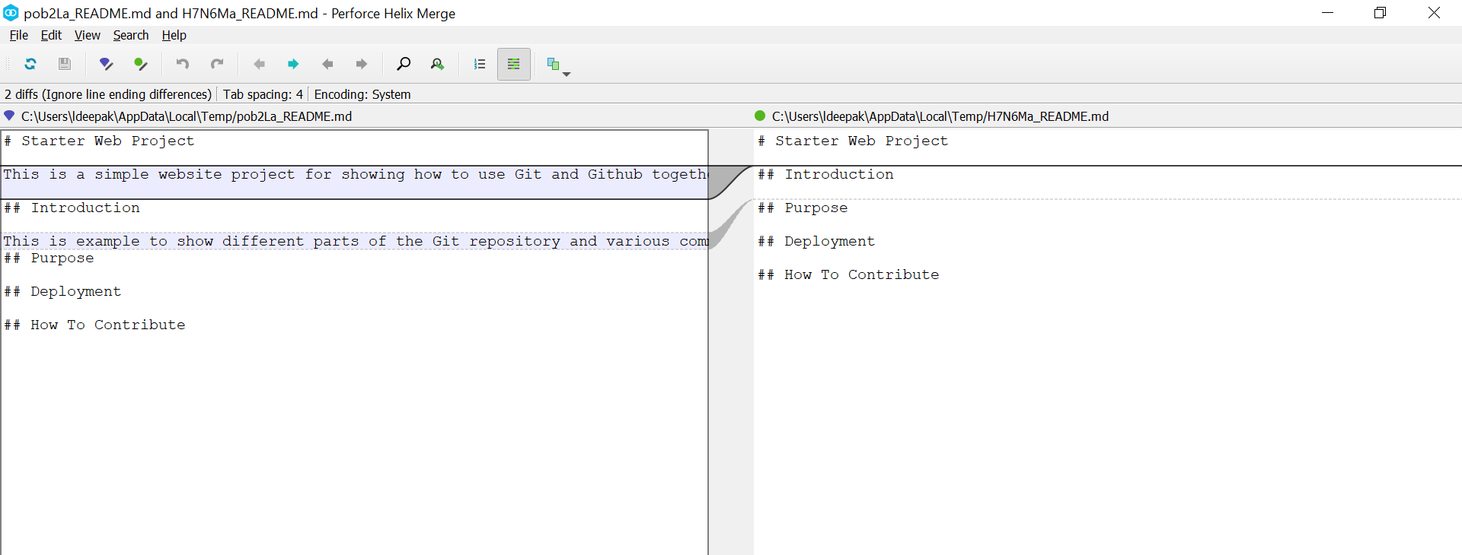

**BRANCHING AND MERGING**

**git branch:** List all local branches.

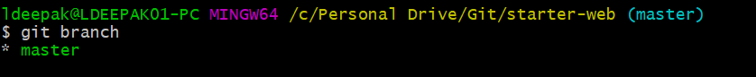

*next to a branch indicates the current branch.

**git branch -a:** Lists all local and all remote branches.

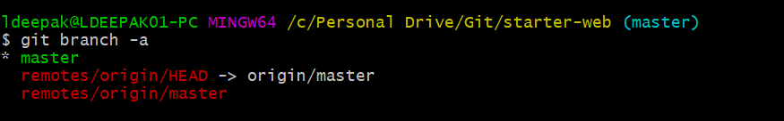

**git branch** **<*branchName*>**: Creates a new branch branchName.

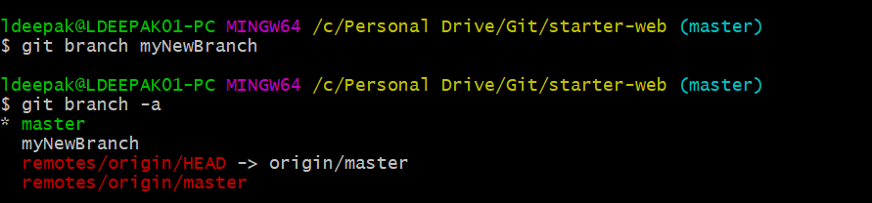’

**git checkout <*branchName*>**: Switches to the branch branchName.

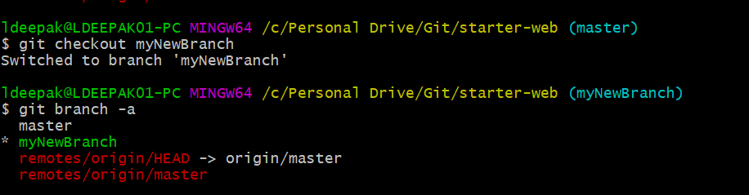

Switch again.

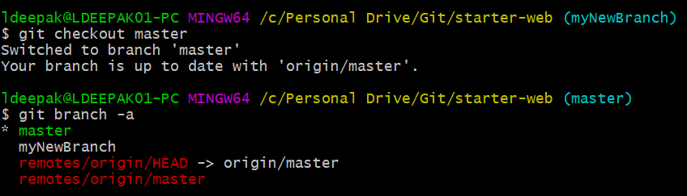’

**git branch -m <*oldName*> <*newName*>:** Renames branch oldName to newname.

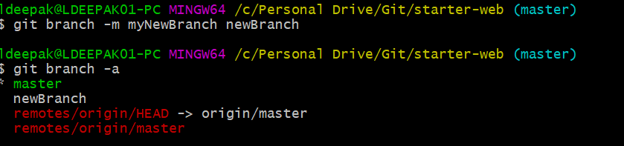

**git branch -d <*branchName*>:** Deletes the branch branchName.

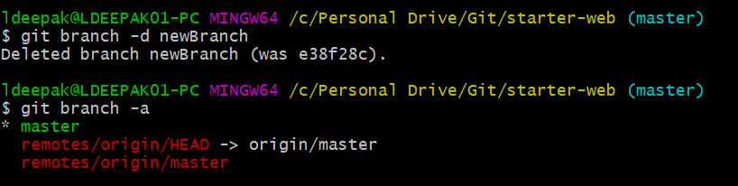

**git checkout -b <*branchName*>:** Creates the branch and switches to it.

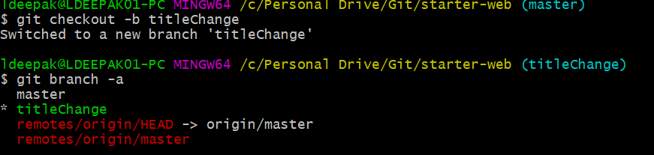

Now we will work on this branch and make changes to a file.

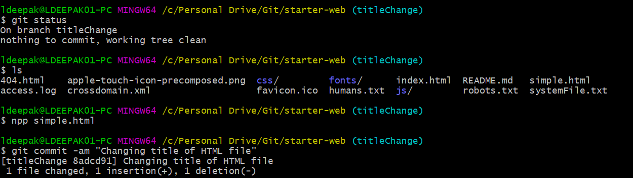

Now we need to make this change in master. So we switch to master and see the differences.

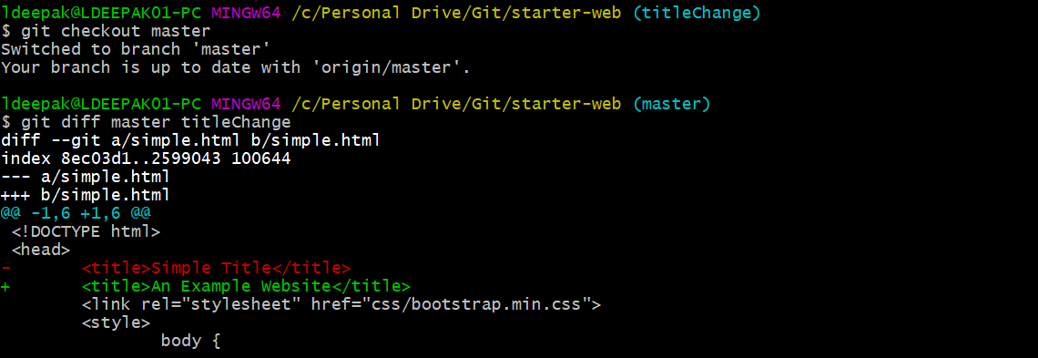

**git merge <*branchName*>:** Merges branchName with active branch.

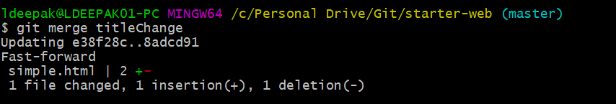

**1) Fast-Forward merges**

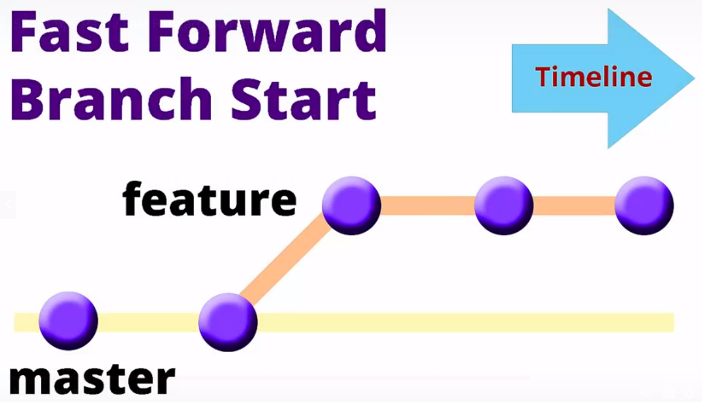

If there are no commits in master branch after branching, then git will place all commits on the master branch as if we never branched away.

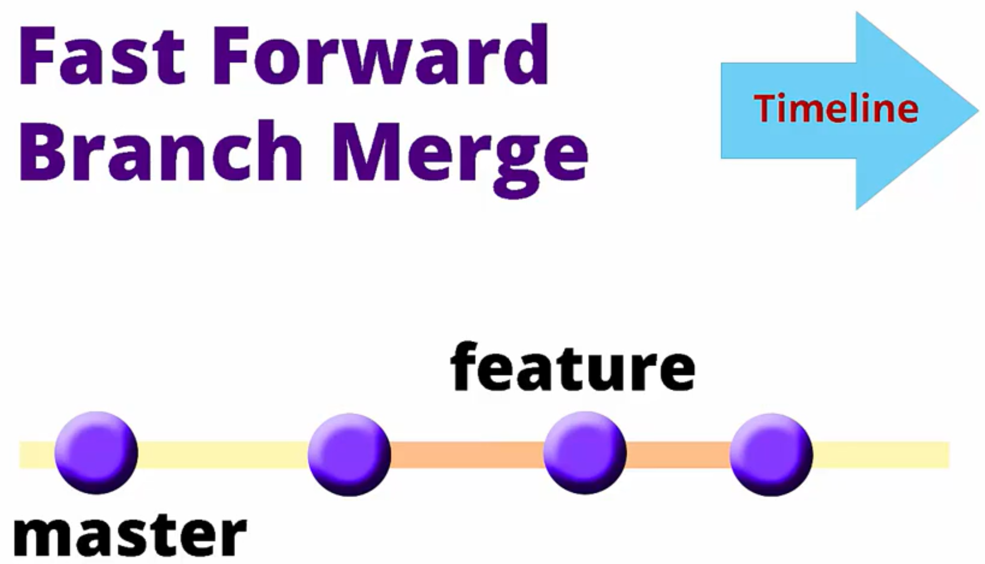 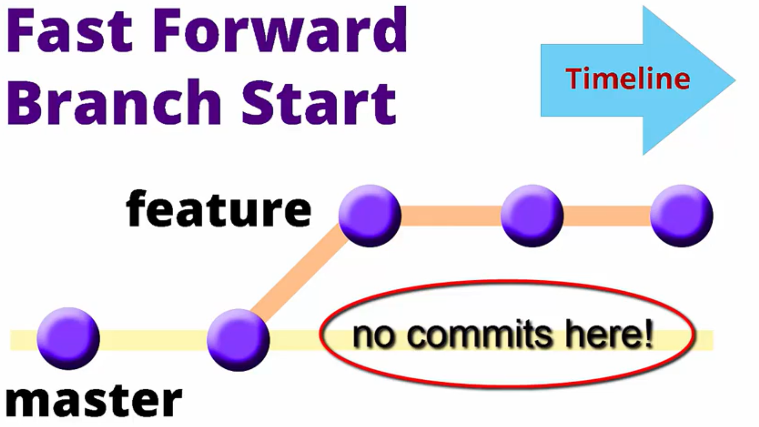

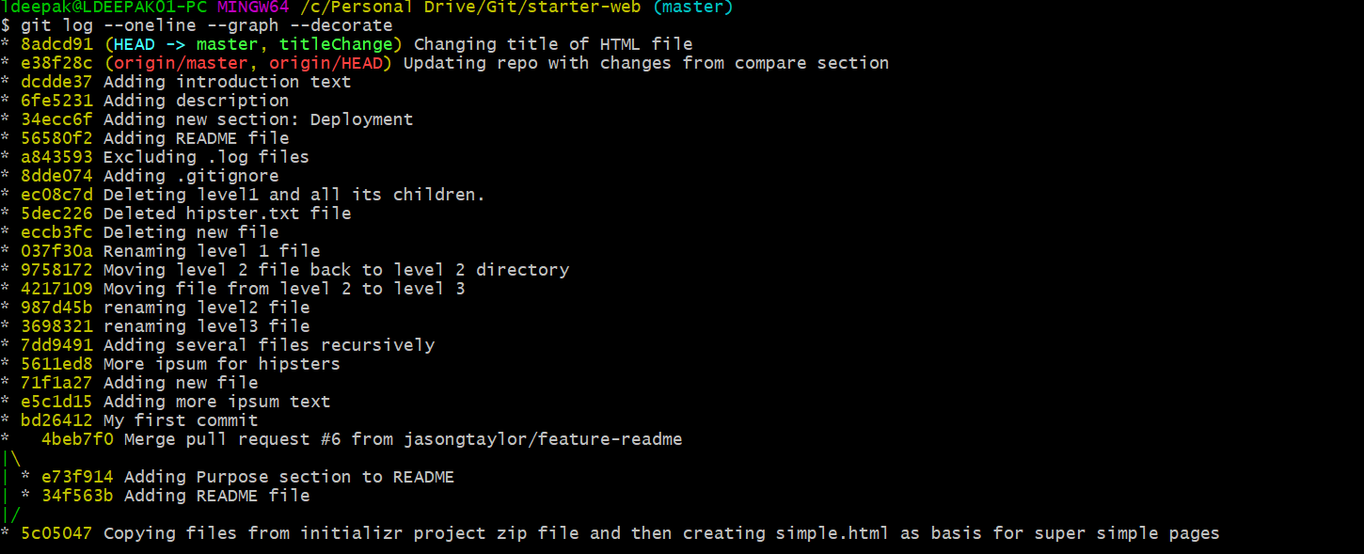

Since we have merged the changes, we no longer need the titleChange branch.

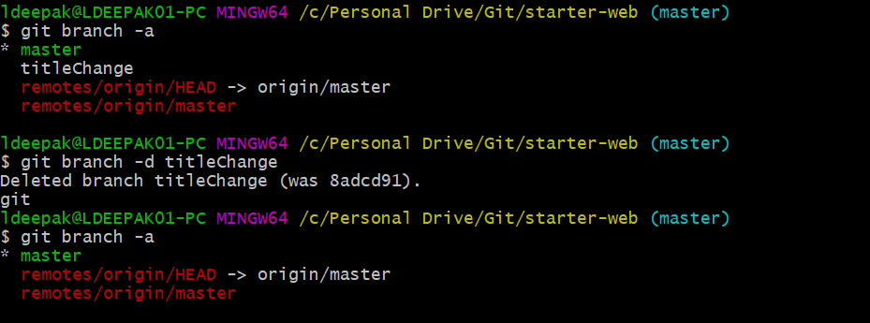

**2)** **Disable Fast Forward merges**

Now create another branch and do some changes to a file.

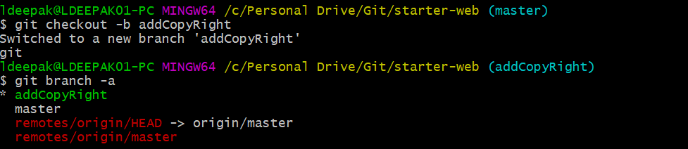

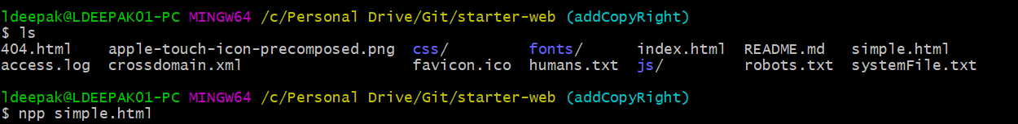

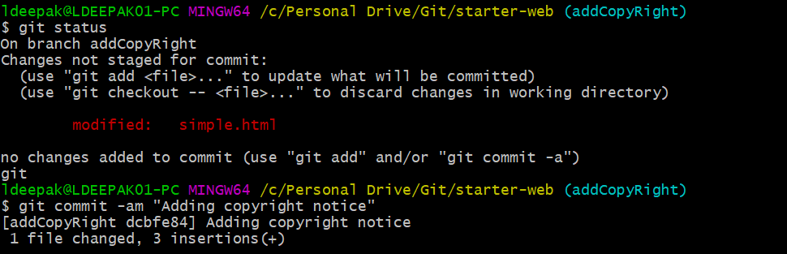

Edit README.txt and add copyright section with copyright notice.

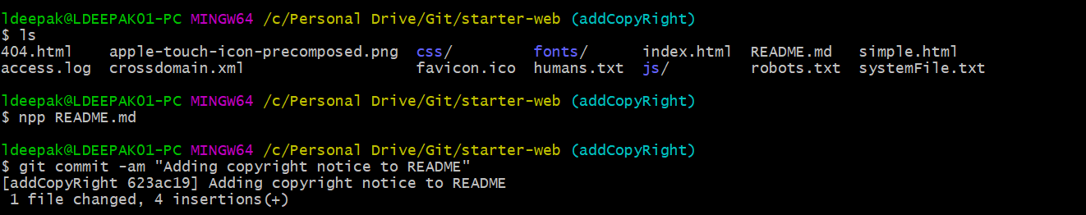

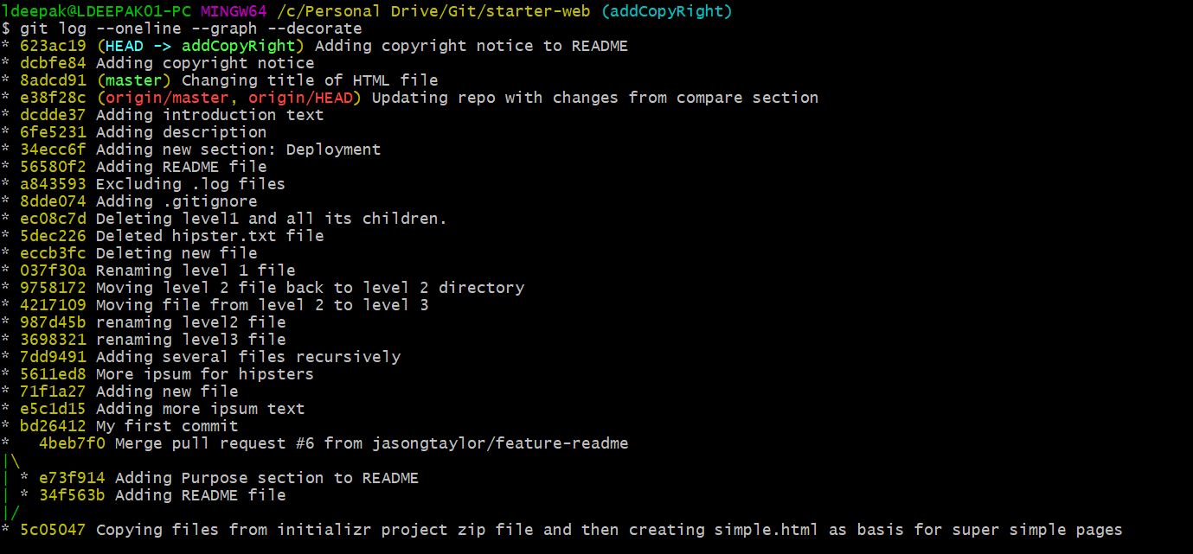

Now we need to integrate those changes to master branch.

Now we will disable Fast Forward merge just as an example in this case to demonstrate a merge commit.

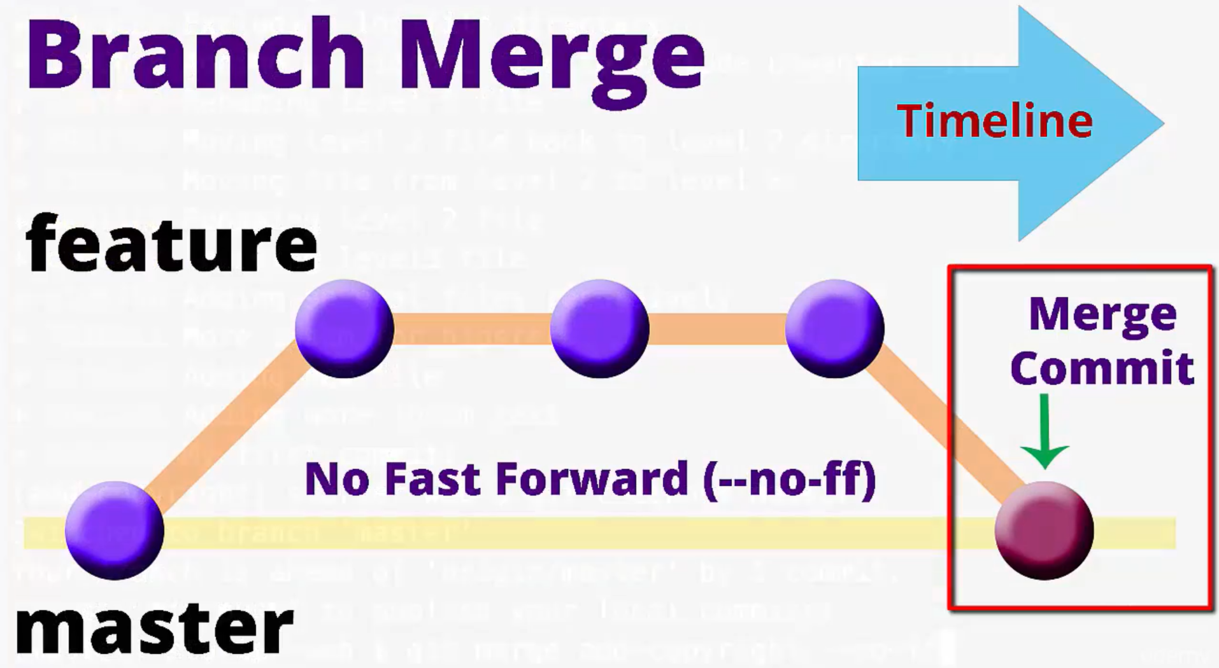

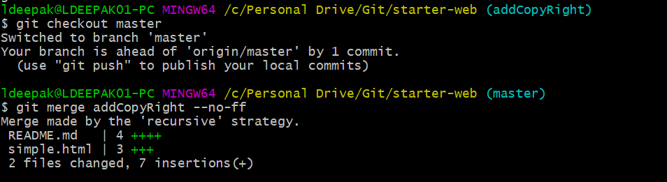

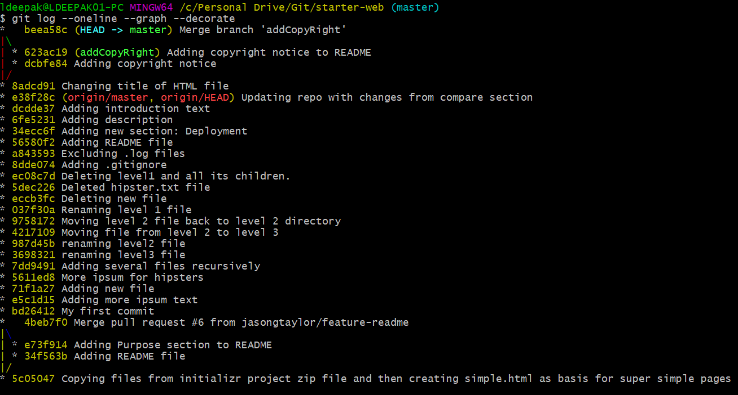

We can delete the branch now.

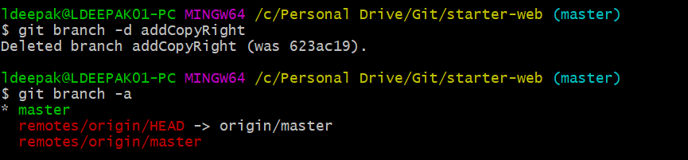

**3) Automatic Merges**

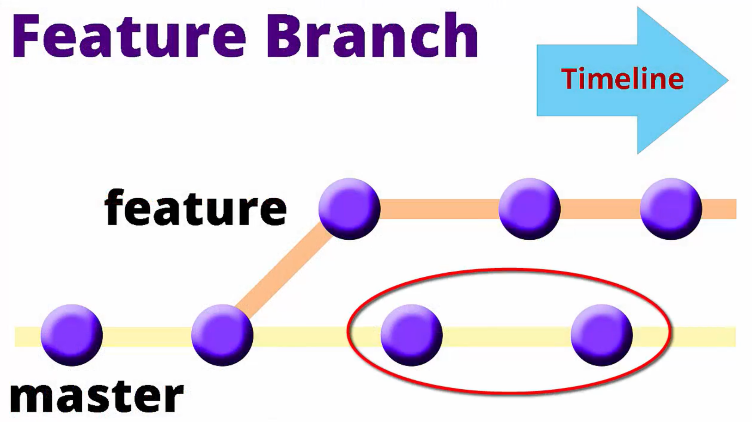

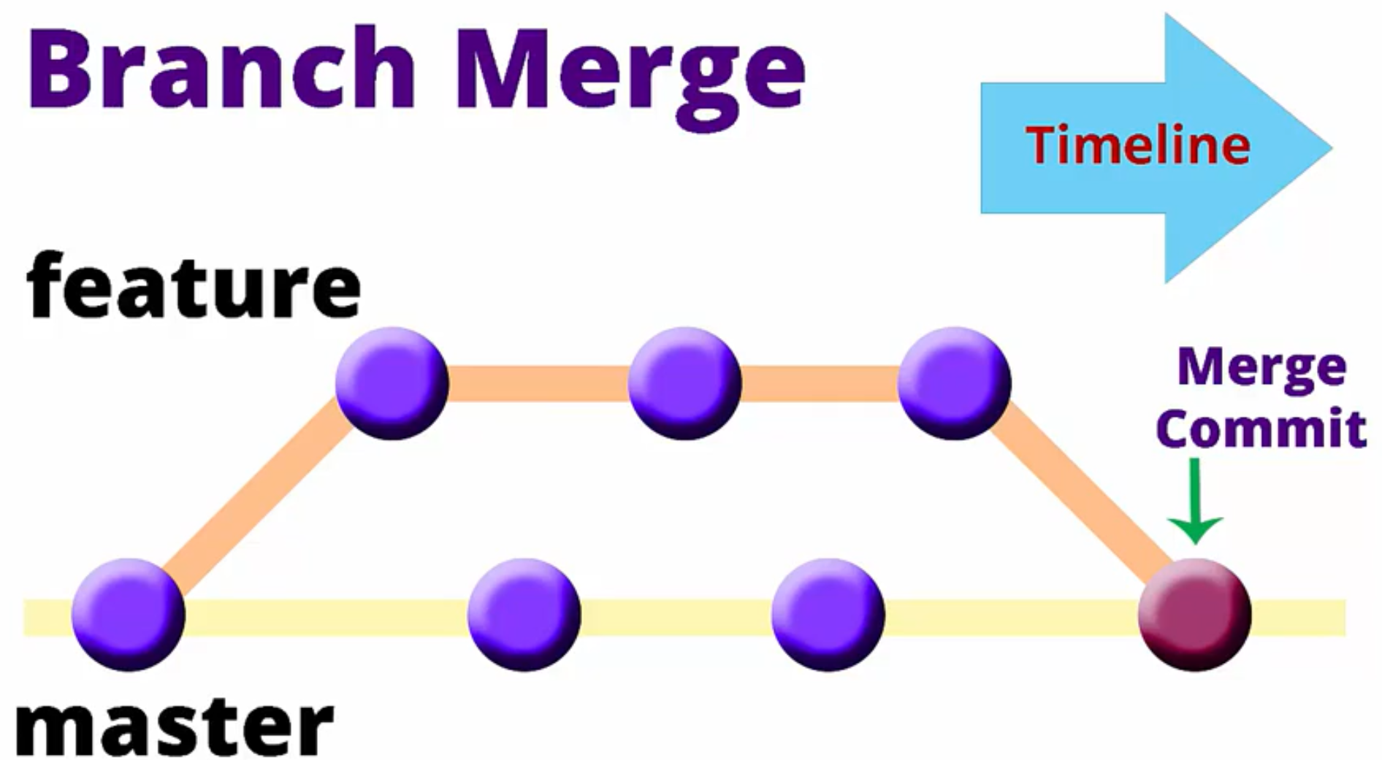

Let create a new branch and switch to it.

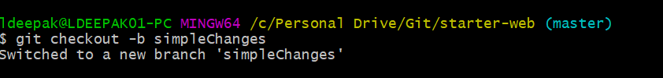

Make changes to a file.

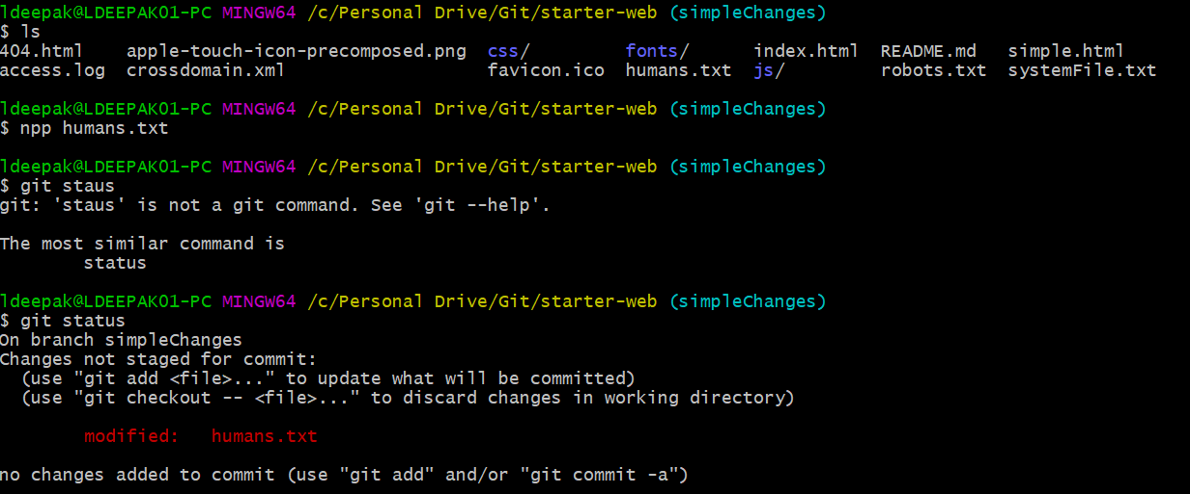

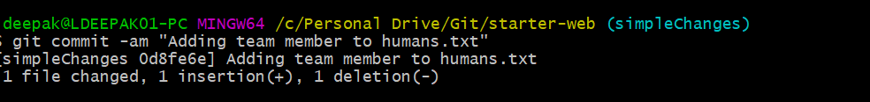

Now switch to master branch. Now before we merge changes from our new branch, we will make a new commit in master.

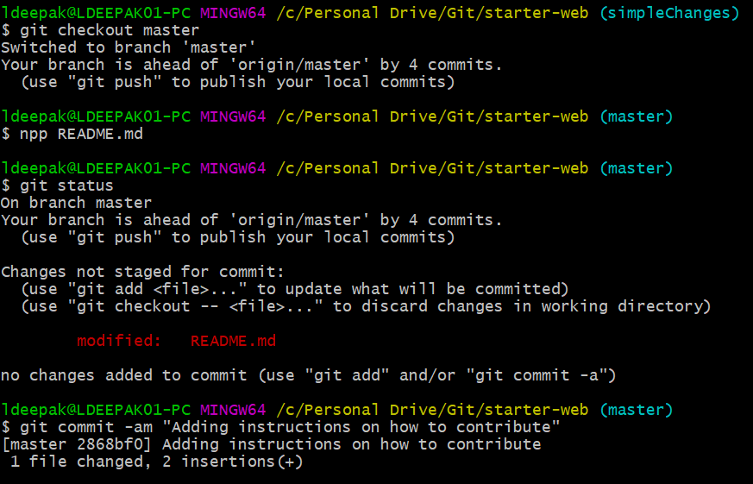

**git log --oneline --graph --decorate --all**: Shows commit history of all branches.

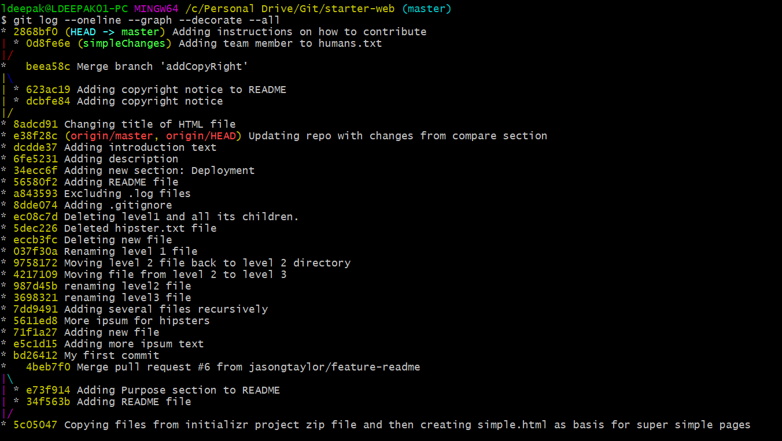

This clearly shows that we branched simpleChanges, made commit to it. But before merging the branch back, another commit to master.

Now we will merge.

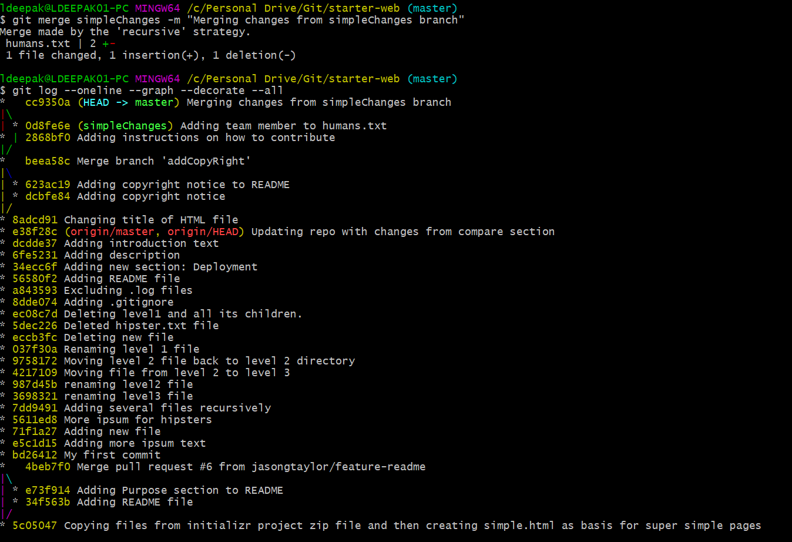

We can now delete simpleChanges branch.



**4) Merge Conflicts and resolution**

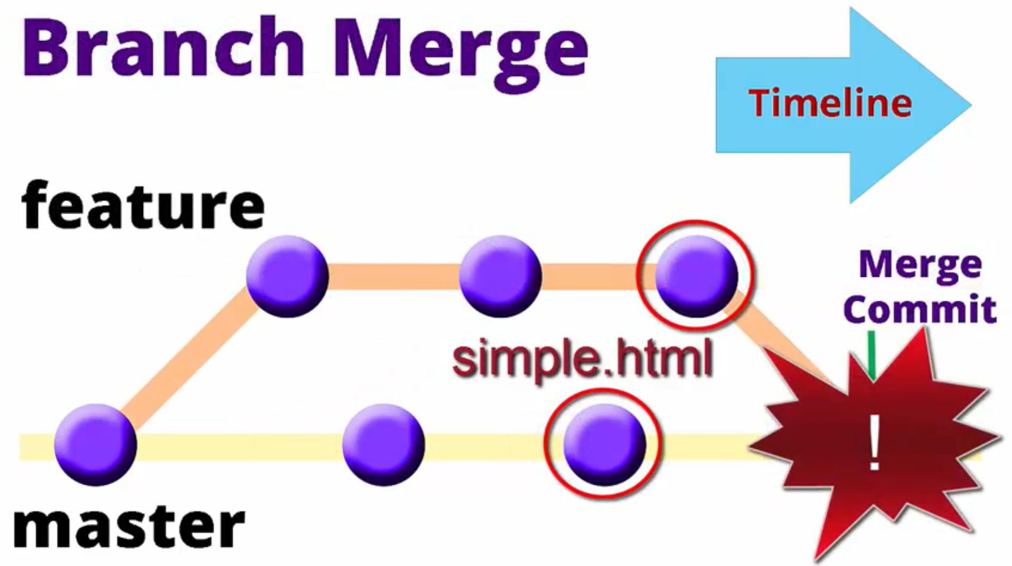

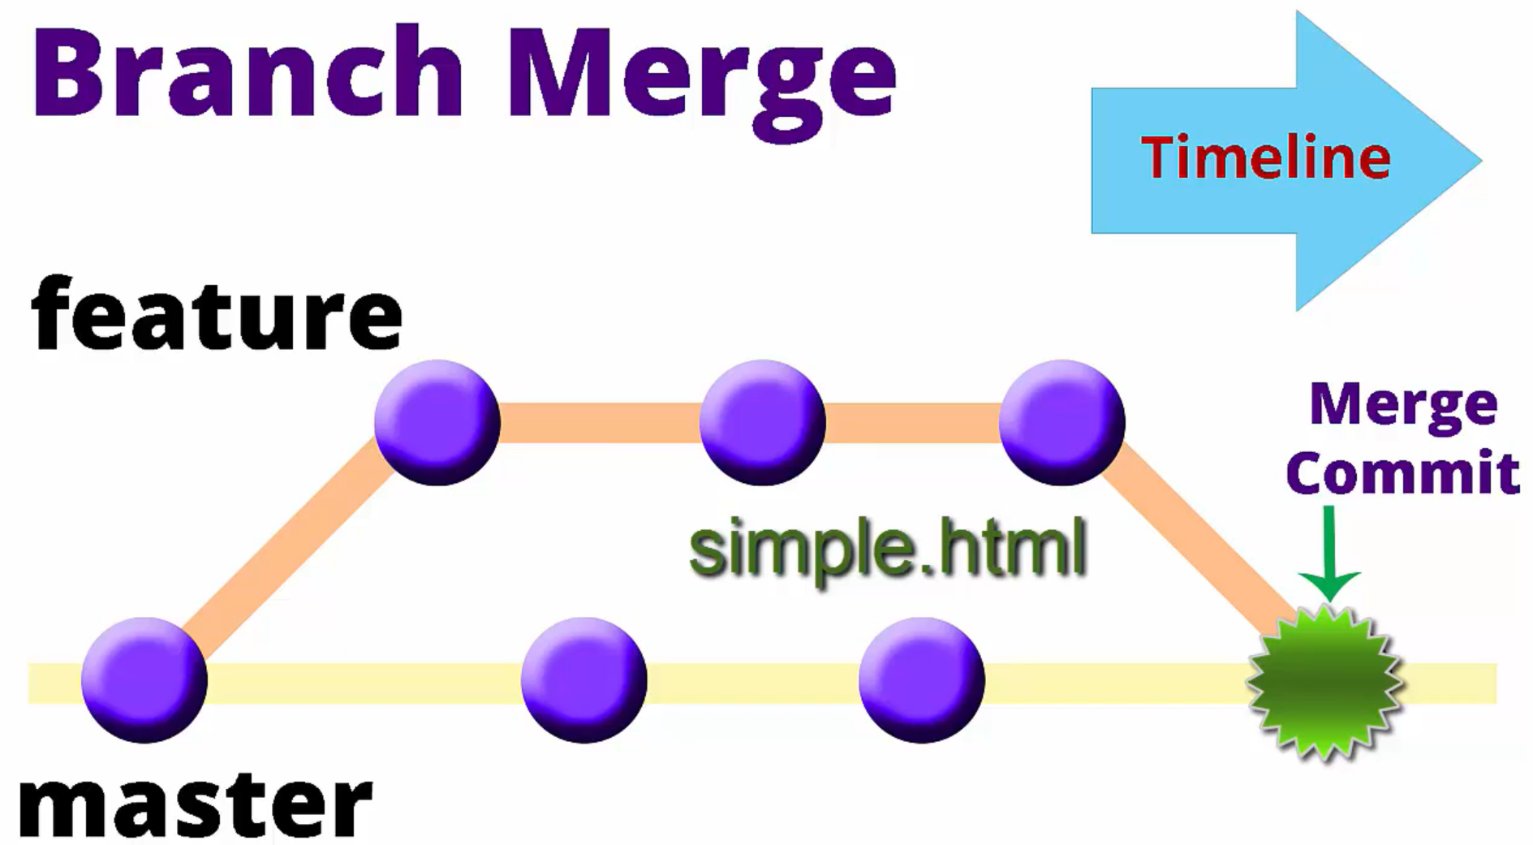

This situation could arise when several developers work on same file in different branches.

We will create a new branch and make changes to the file.

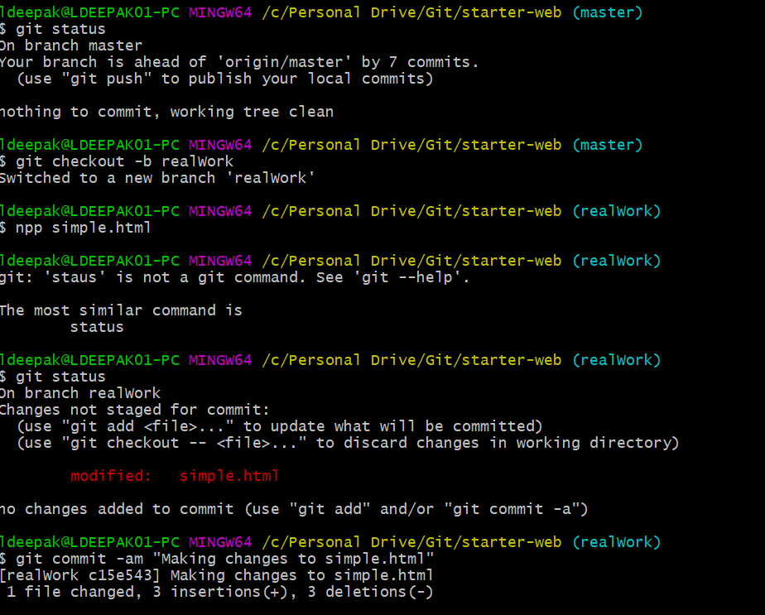

Now switch back to master and edit the same file.

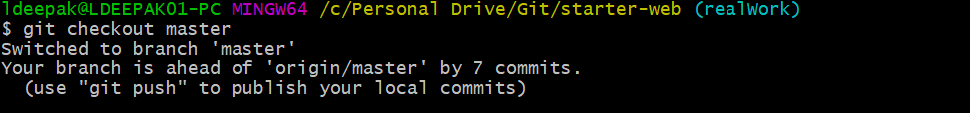

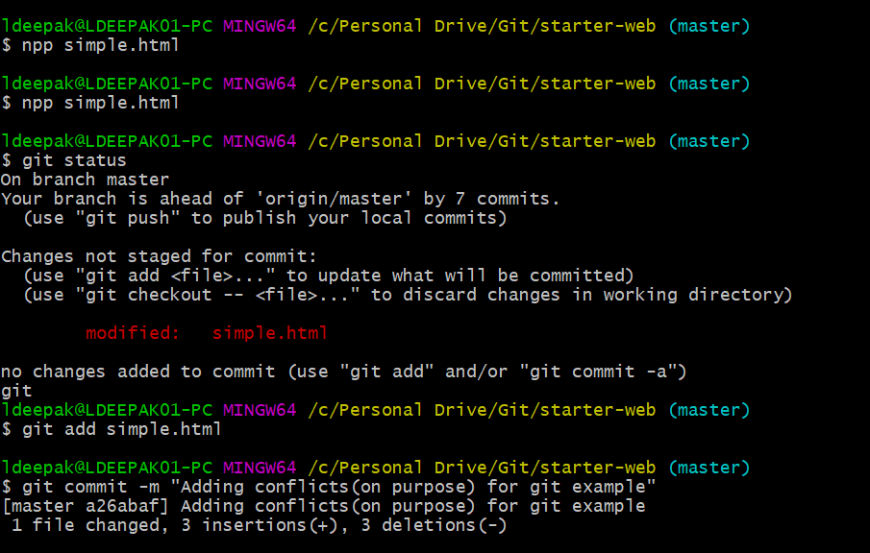

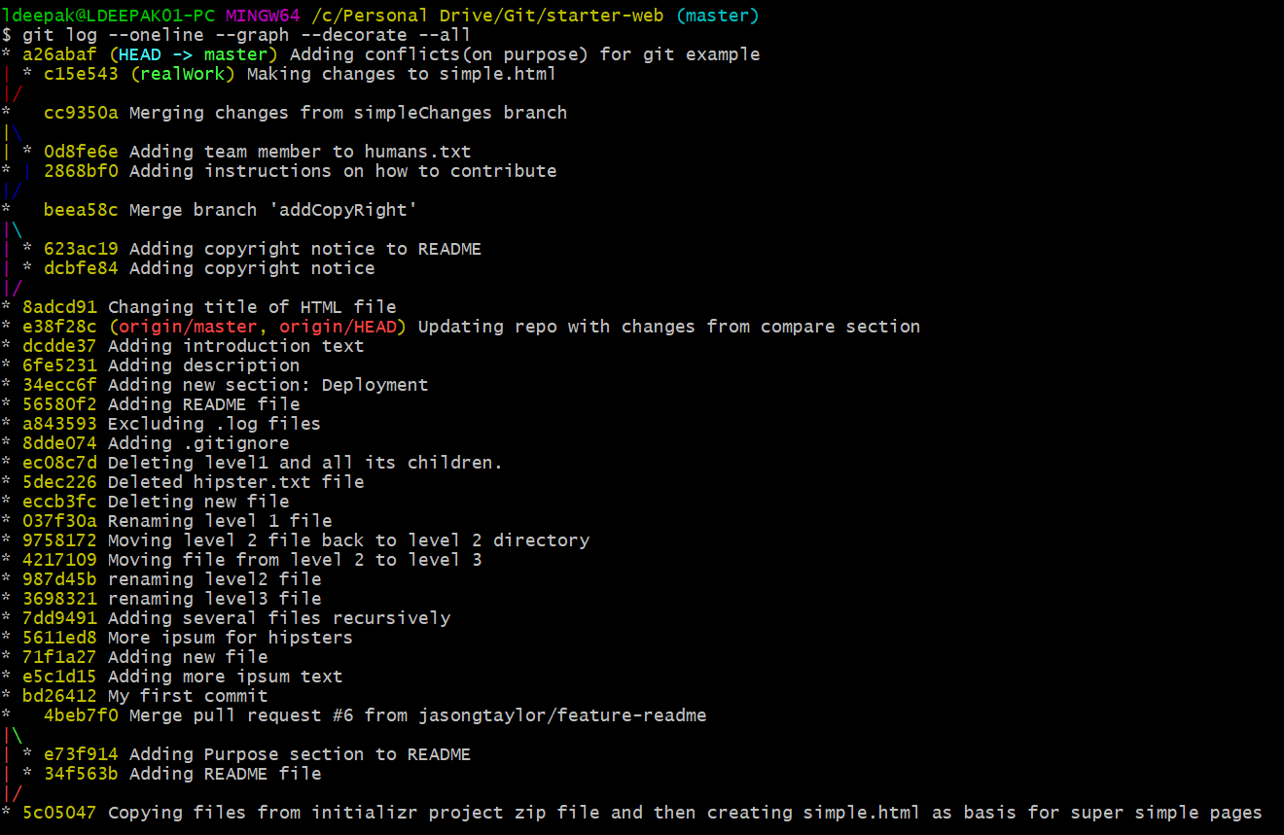

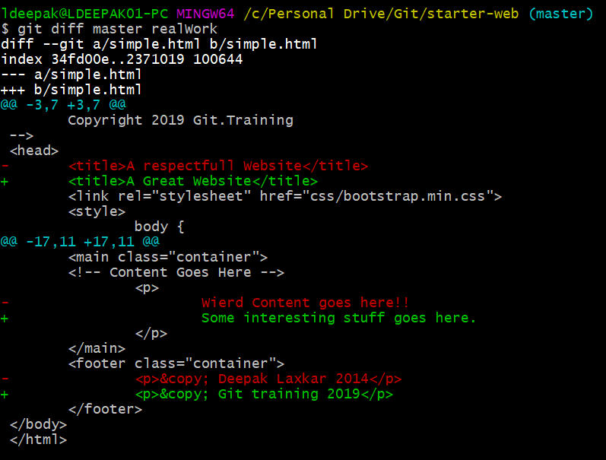

See it visually.



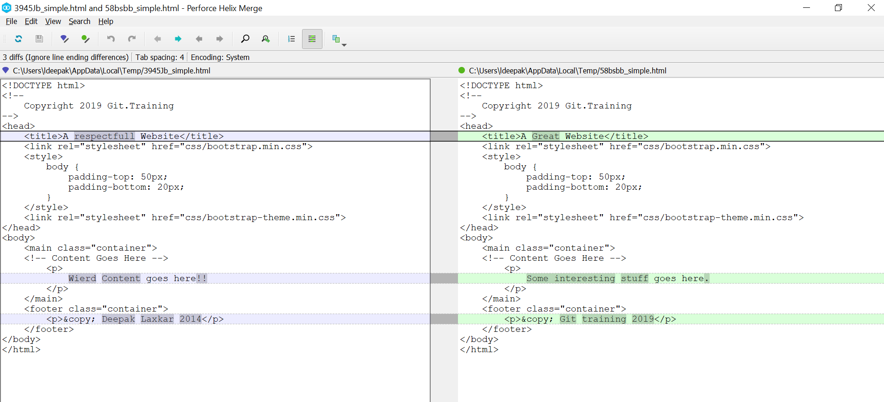

Now let’s try to merge. It will result in conflict.

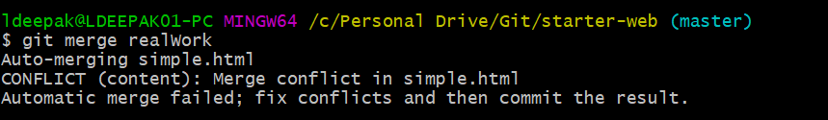

Now we must resolve these merge conflicts. We can either do this manually by opening each file and taking the required changes, or we can use our visual merge and diff tool.

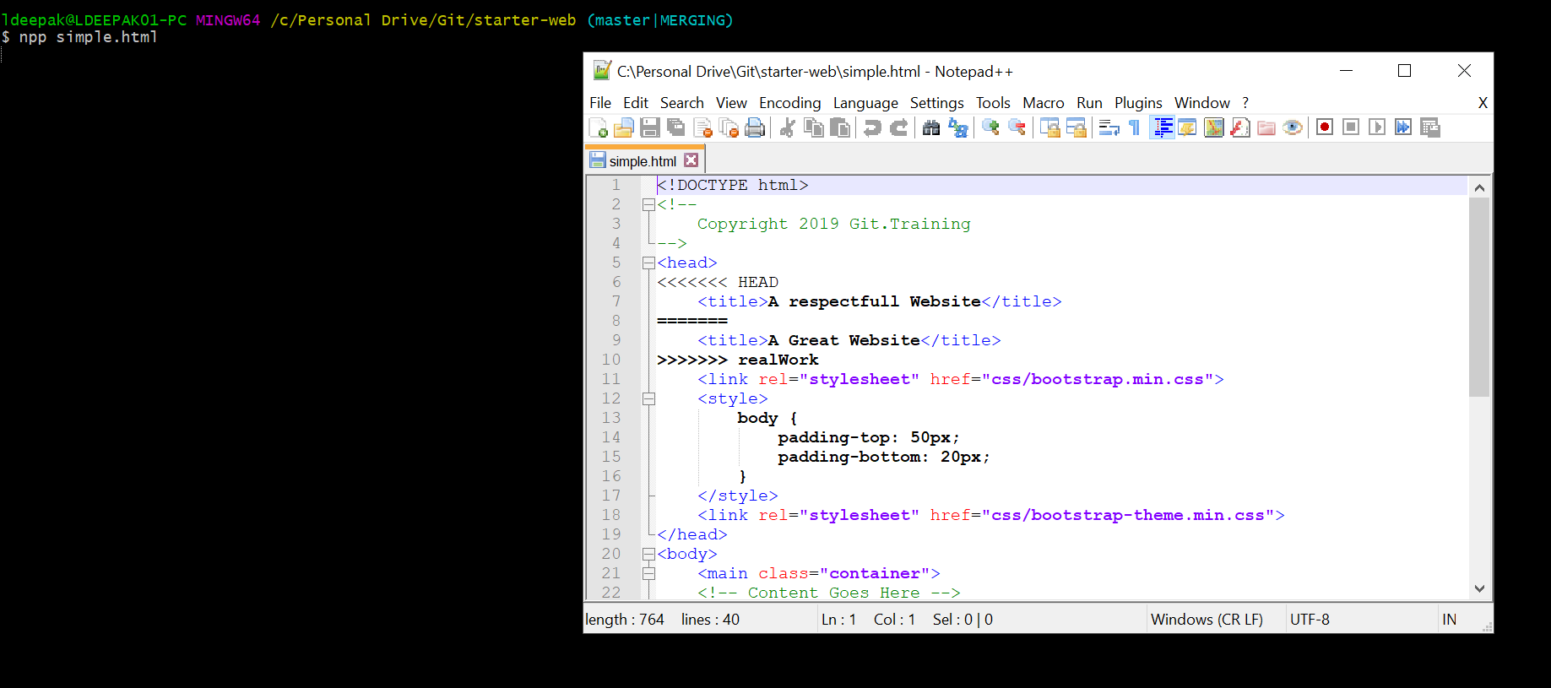

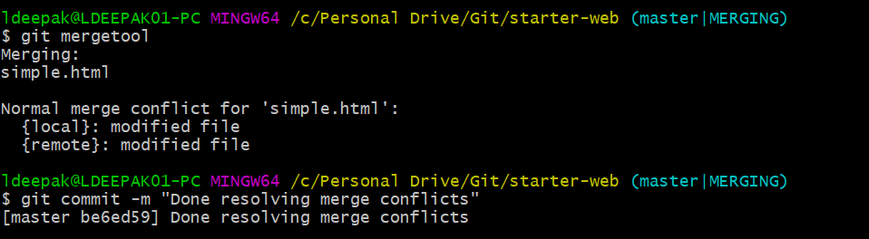

Opens p4merge tool to resolve the conflicts. Select the changes you want and then save and close.

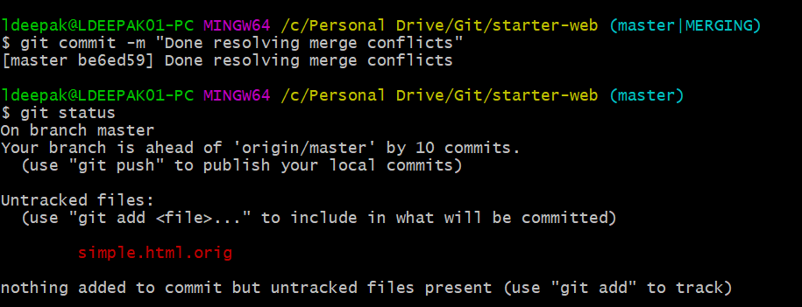

Git keeps original files in case we want to revert. We can ignore these files.

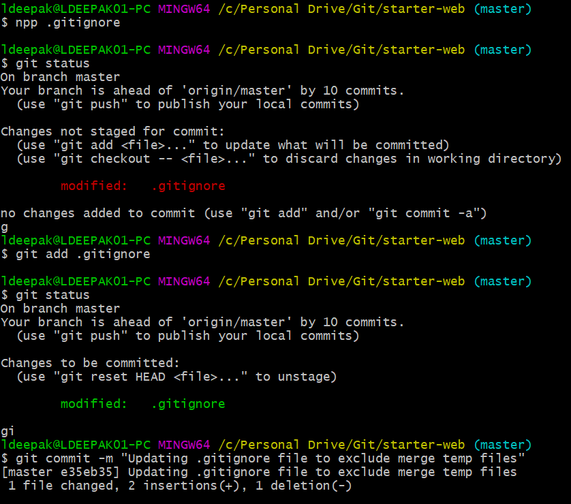

Since we have merged the changes, we can delete the realWork branch.

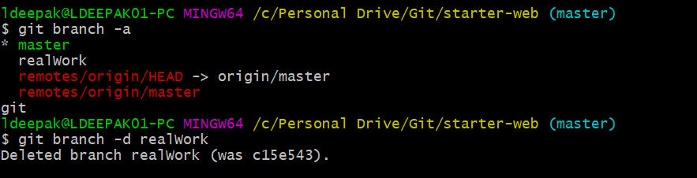

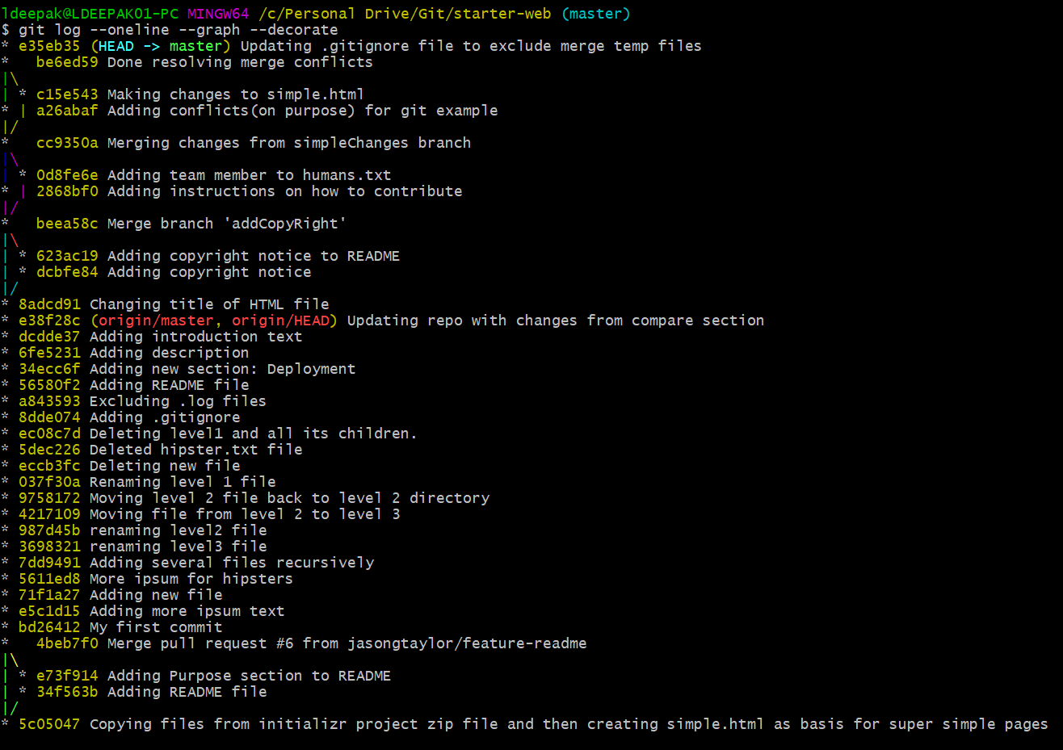

Finally let’s push our changes to GitHub.

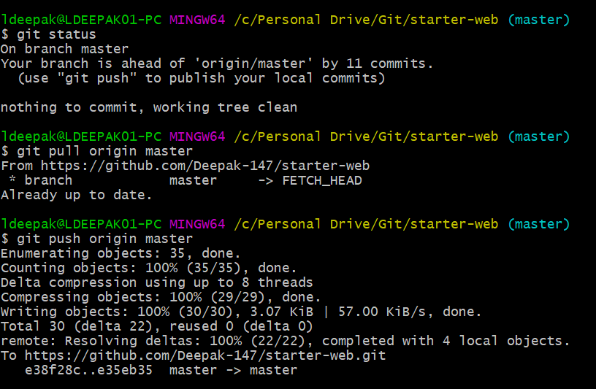

**REBASING**

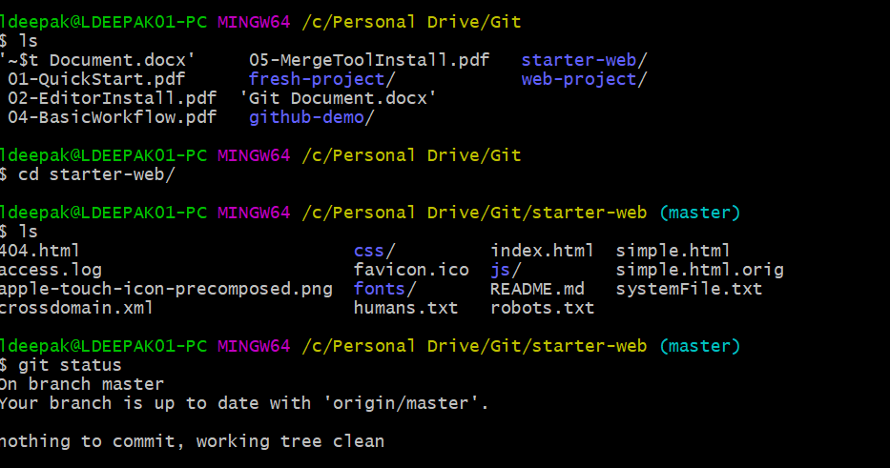

Create a new branch myFeature and do a commit.

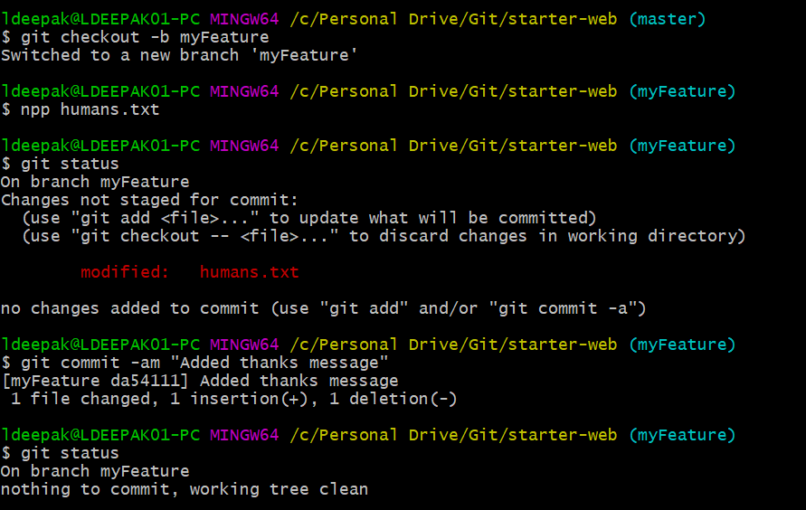

Now switch to master and do a commit.

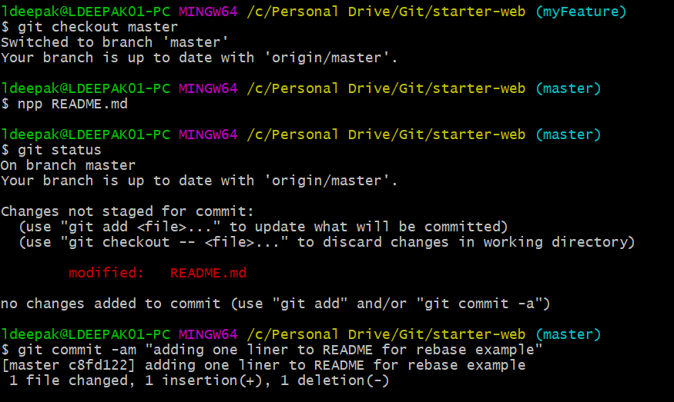

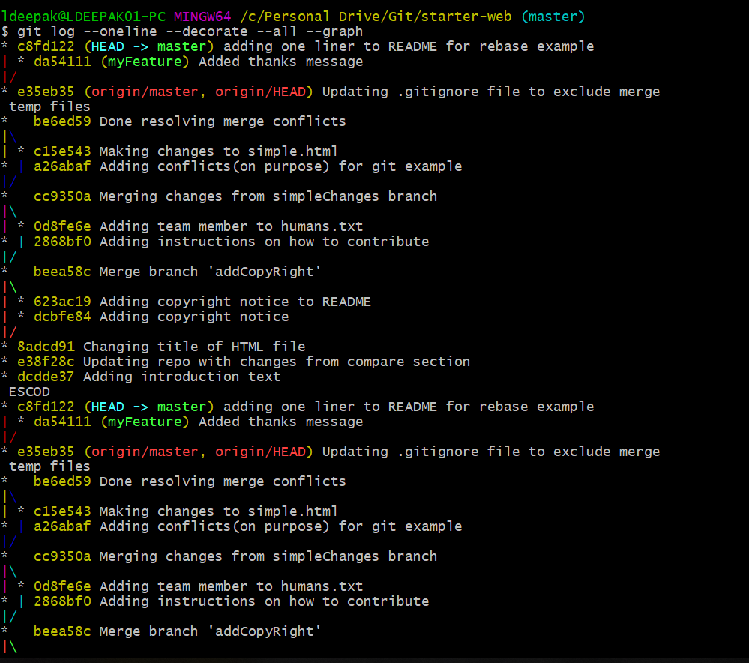

Add your changes in other branch on top of master branch.

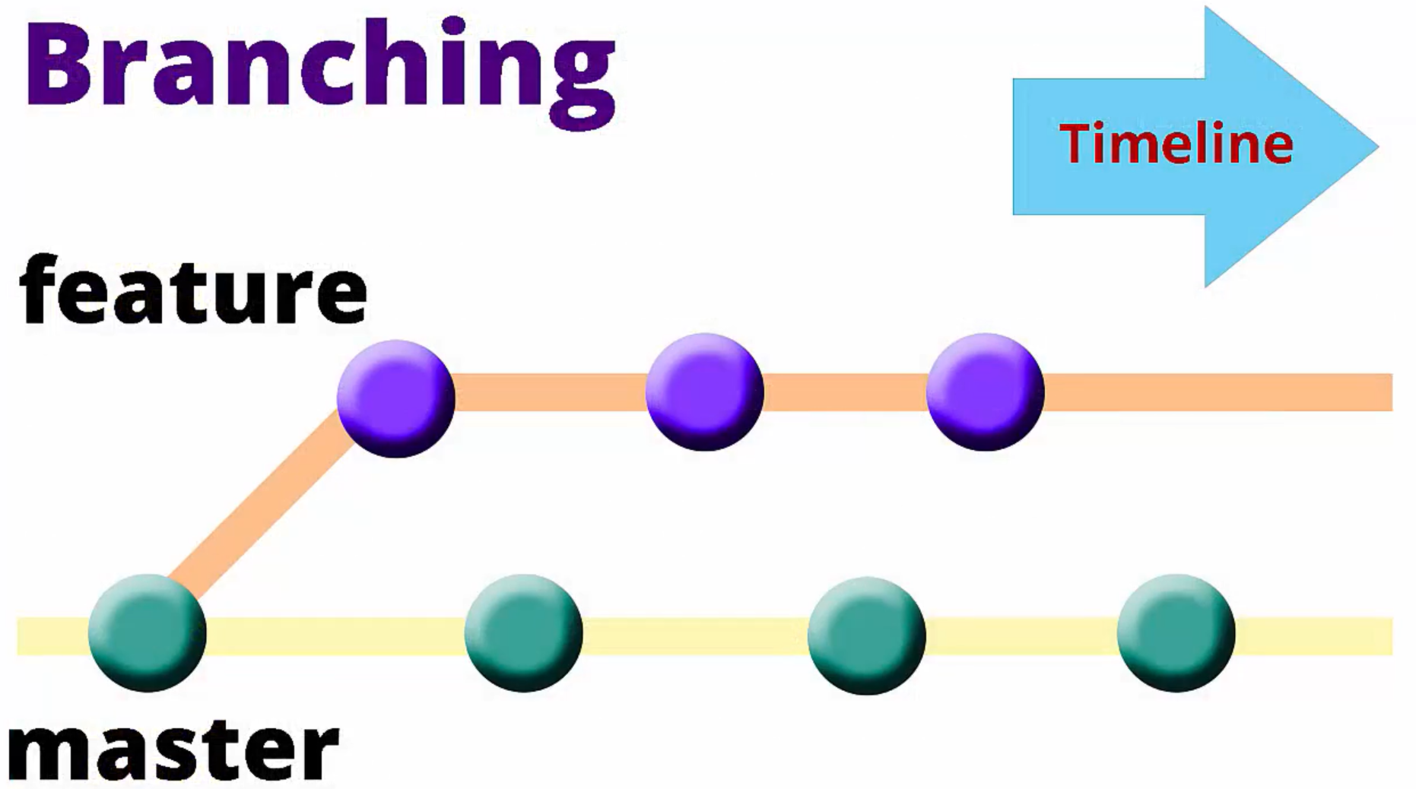

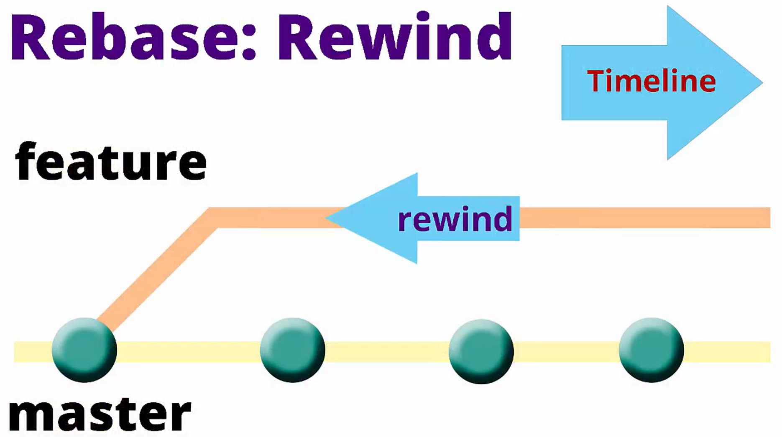

Rewind the changes that happened on myFeature branch, and playback on master branch.

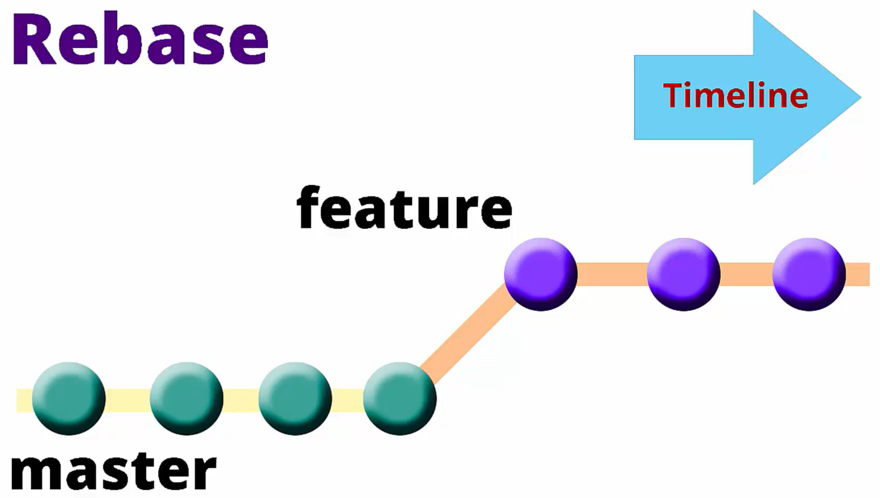

Now we switch to myFeature branch and do a rebase to master.

**git rebase <*branch name to rebase*>**

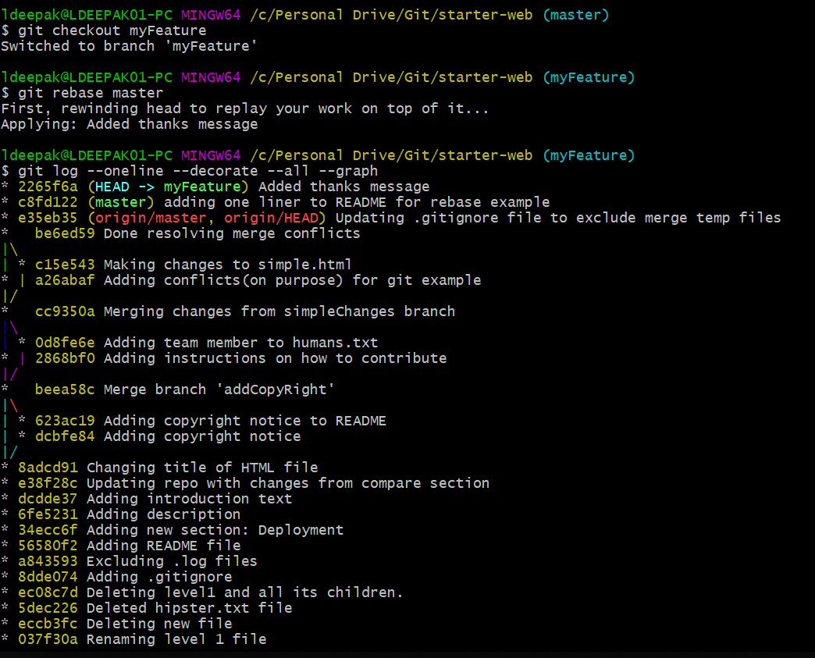

Now after the rebase we make one more commit in myFeature branch.

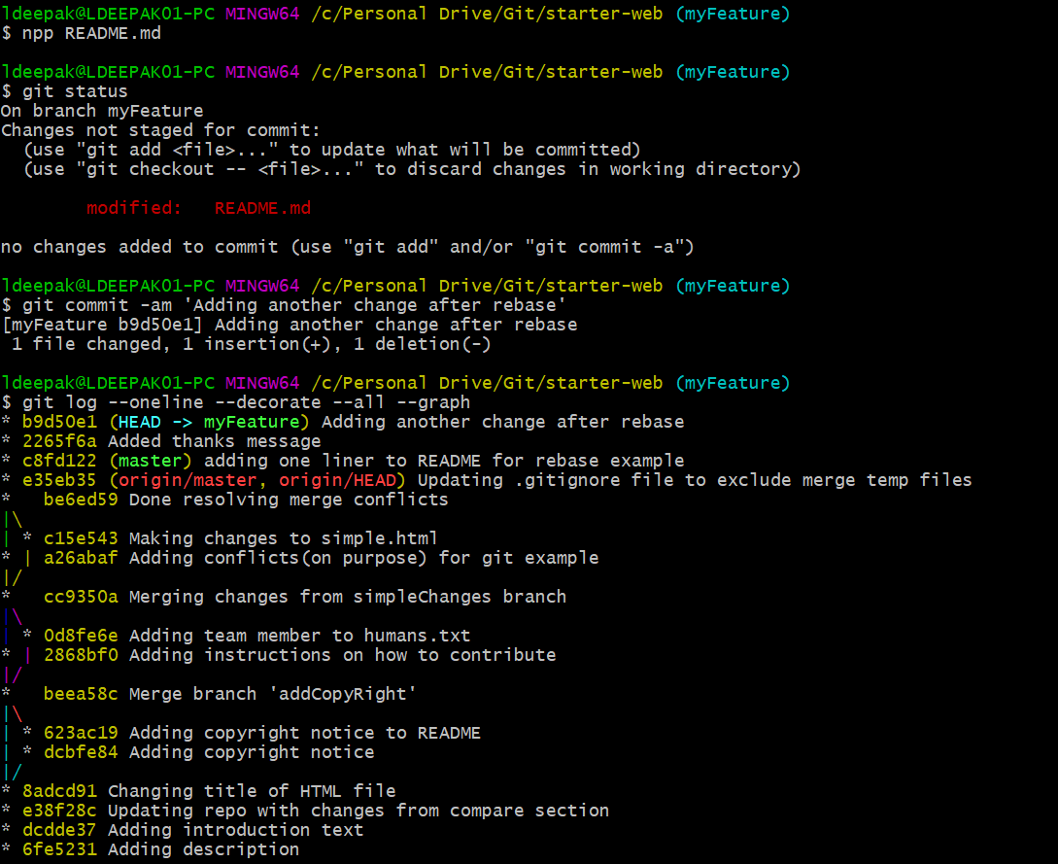

Now we switch to master and check for differences.  
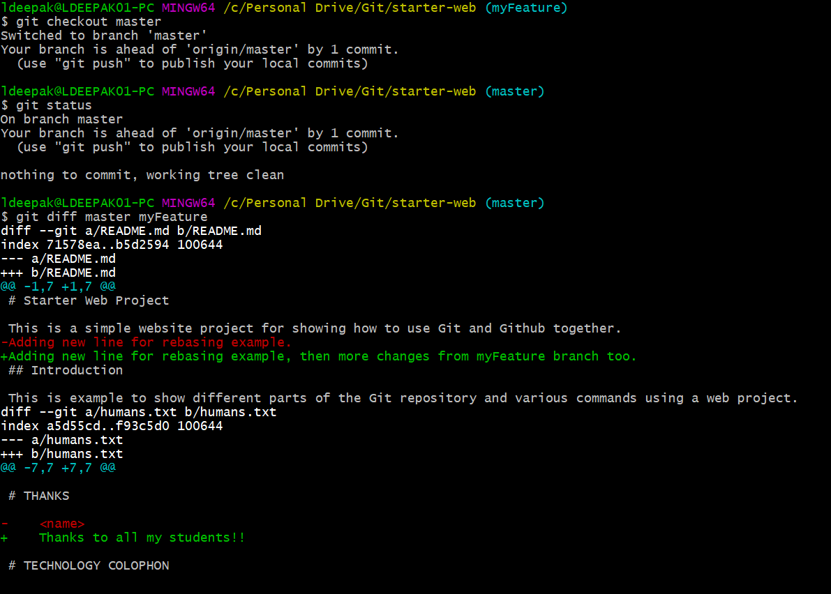

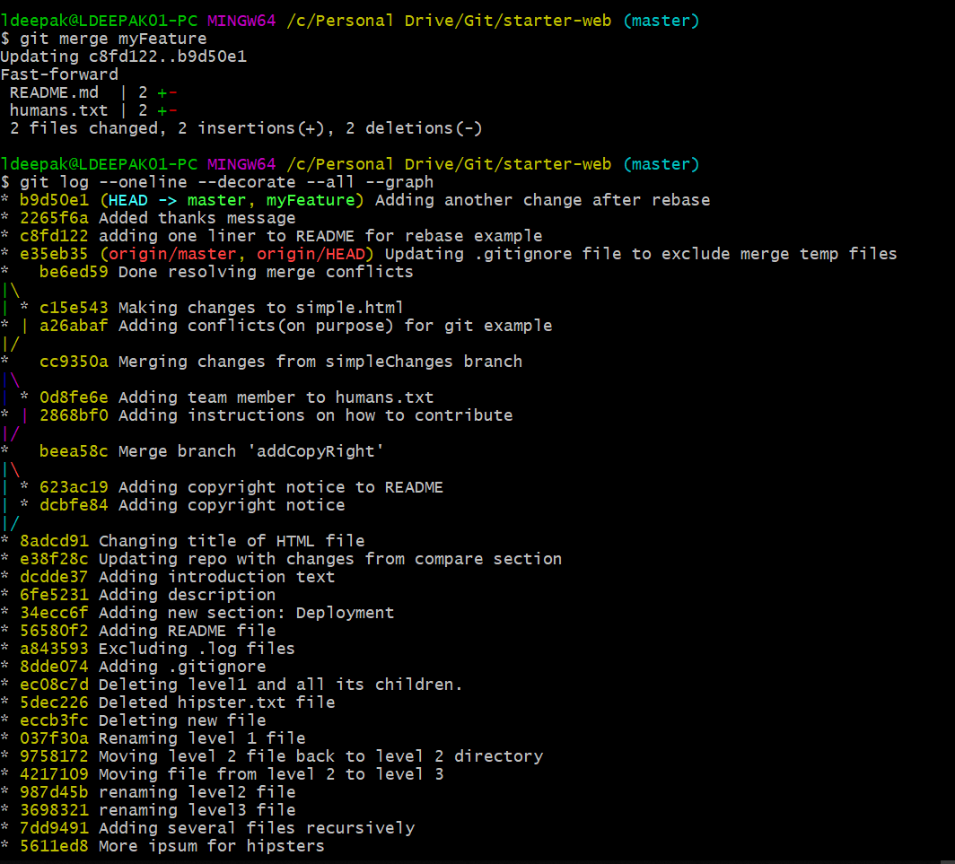

Now we delete the myFeature branch.

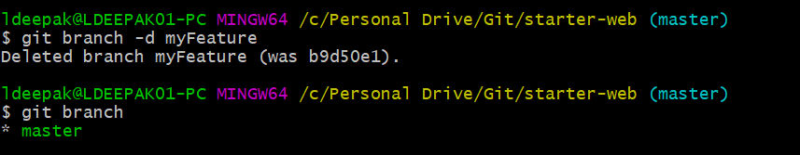

**REBASING CONFLICTS**

Now we make another change in master branch.

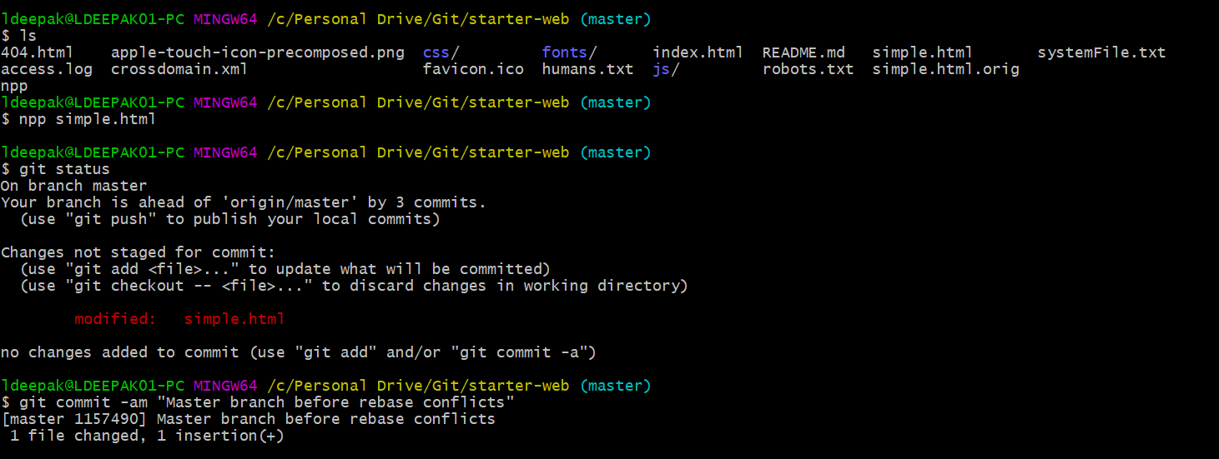

Now we create another branch bigTrouble and start to make some conflicting changes.

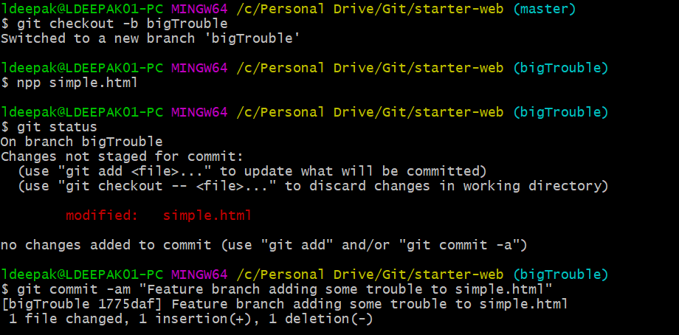

Now we switch to master and make some conflicting changes to same file.

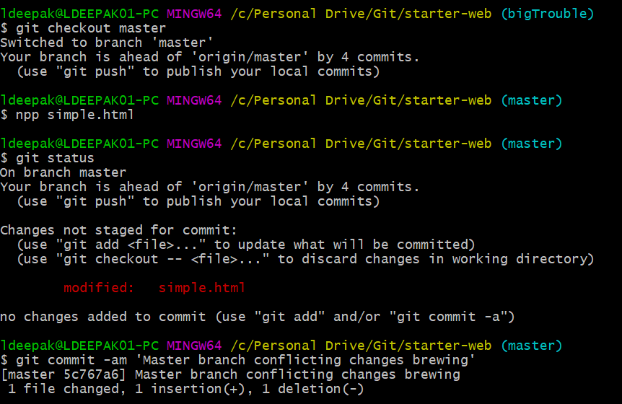

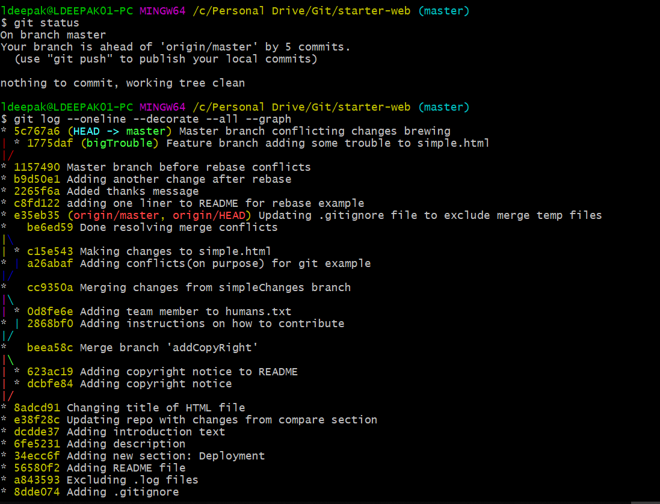

Now we switch to bigTrouble branch and try to rebase to master. This will result in conflict.

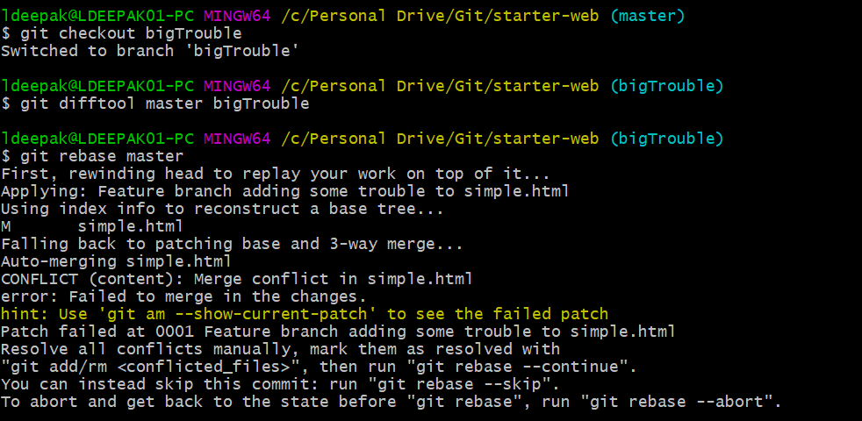

**ABORT REBASE**

We can abort the rebase using **git rebase --abort**



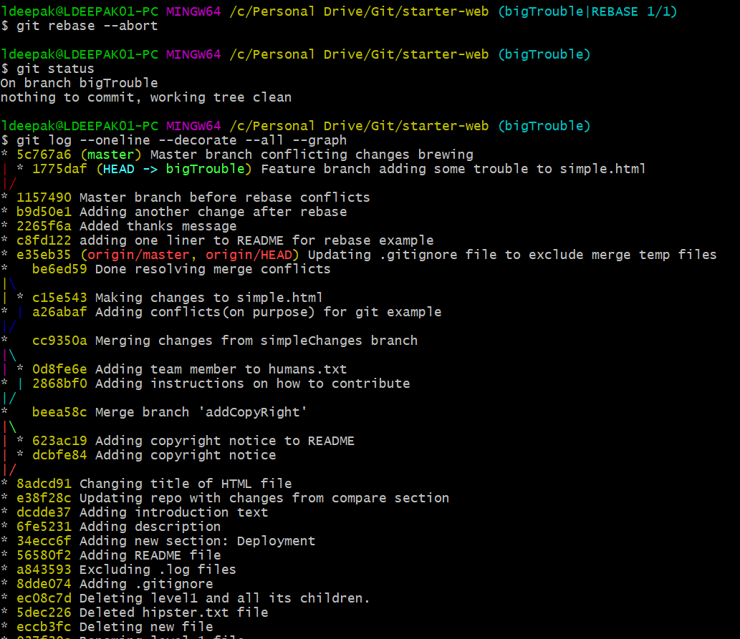

**REBASING CONFLICTS AND RESOLUTION**

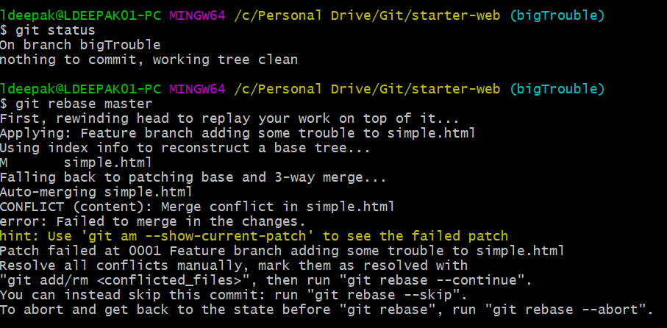

Use mergetool to resolve the conflicts.

After resolving the conflicts, git add the file, then do **git rebase --continue** to continue the rebase procedure.

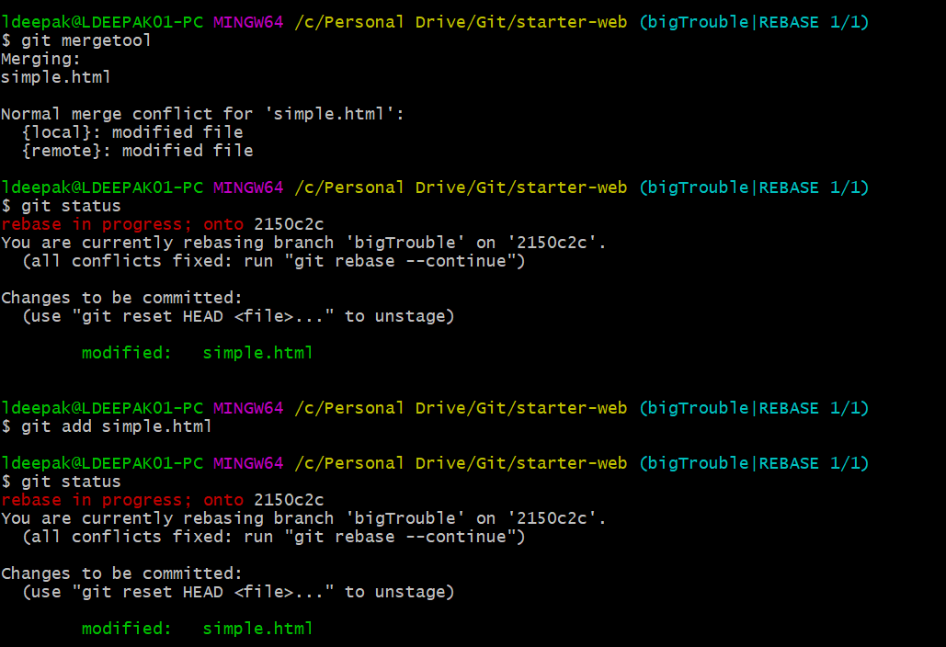

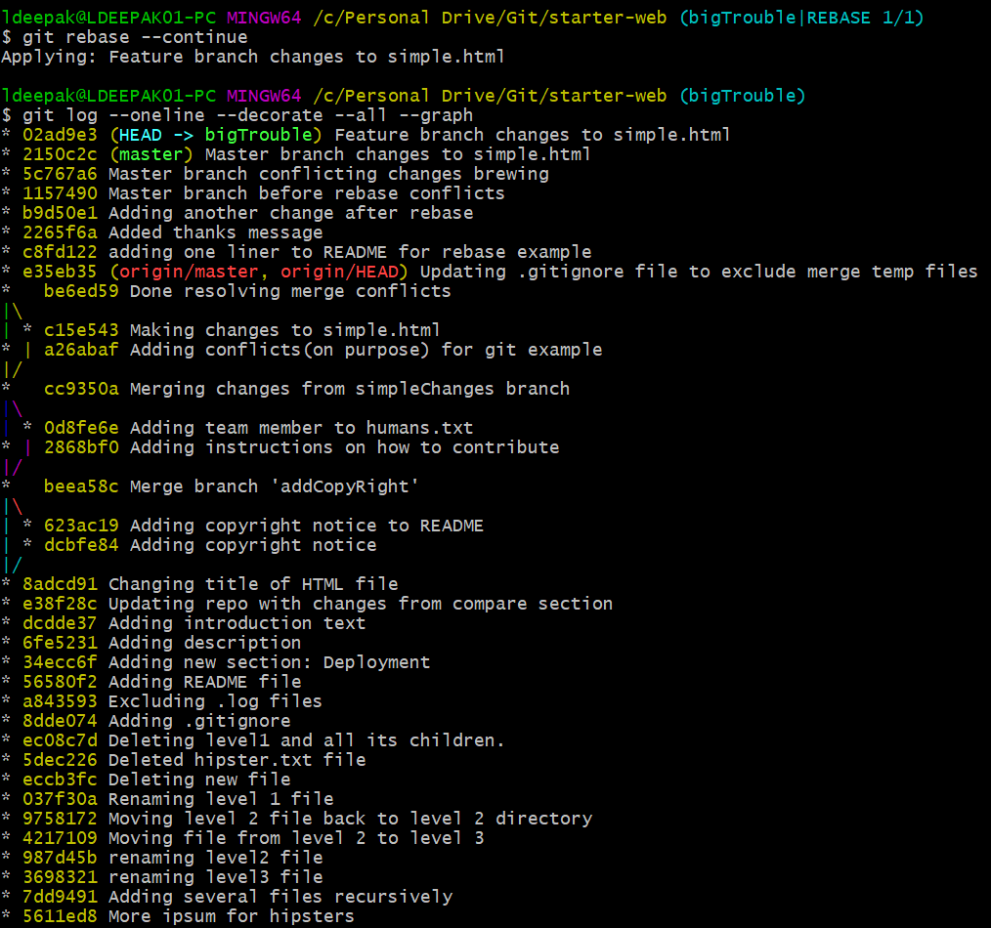

Now we make another change in simple.html file in bigTrouble branch

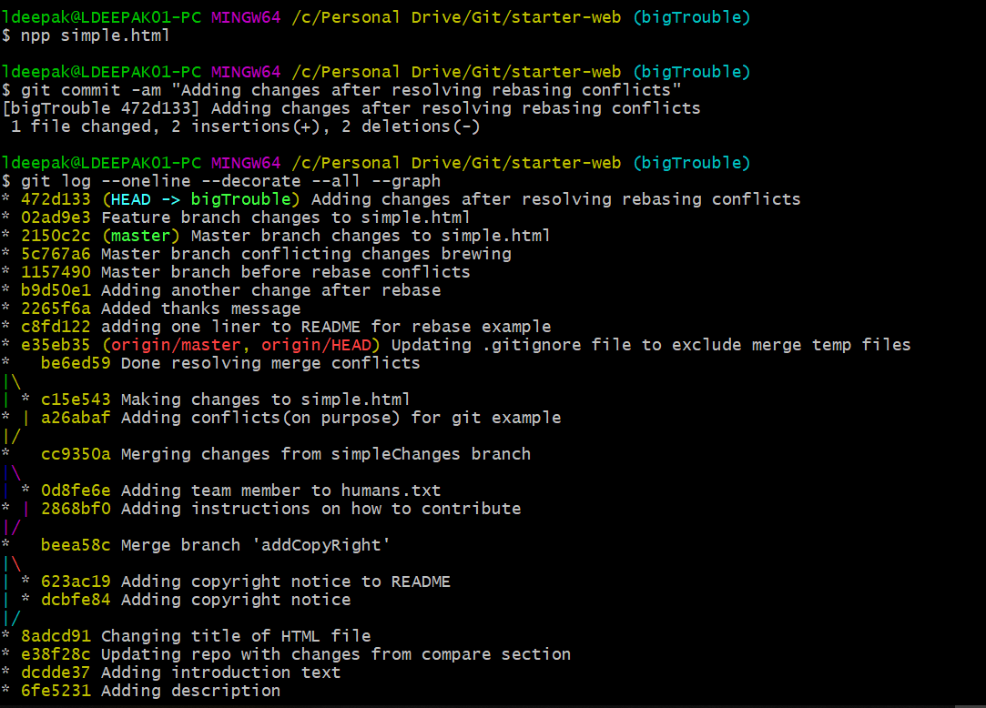

Now we integrate the changes into master

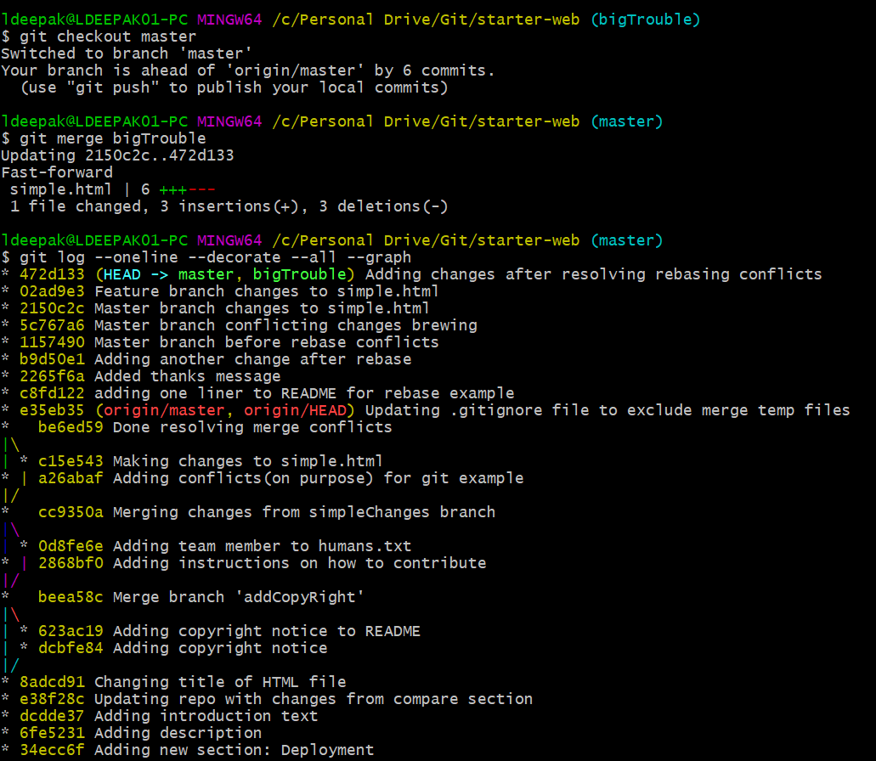

**REBASING REMOTE BRANCHES(GITHUB)**

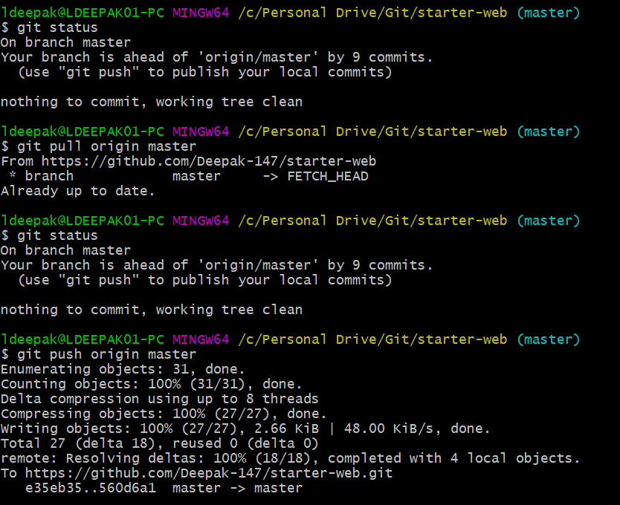

Now we make change to simple.html file and do a commit.

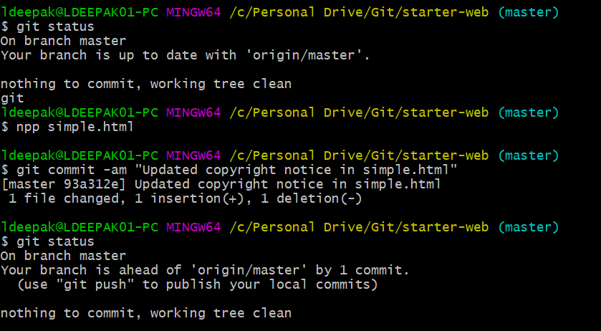

Now go to github.com and make changes to index.html and commit the changes. Now at this point both our master and origin master are each 1 commit ahead.

Now if we do git status, it tells that the master is ahead of origin master by 1 commit. But this is not the case. We need to update our references.

Doing **git fetch origin master** updates our references.

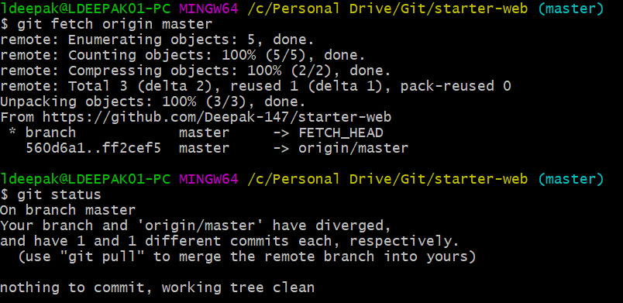

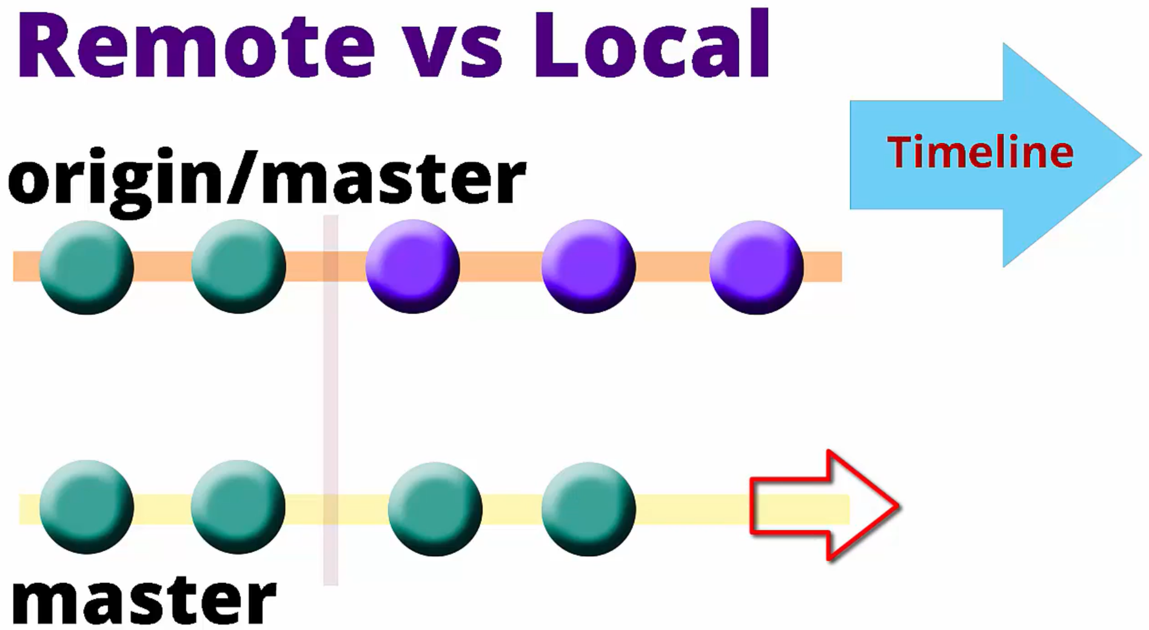

Now we want to keep our changes next the remote changes.

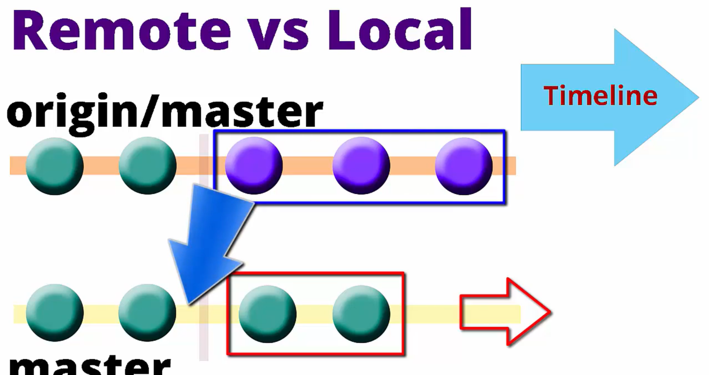

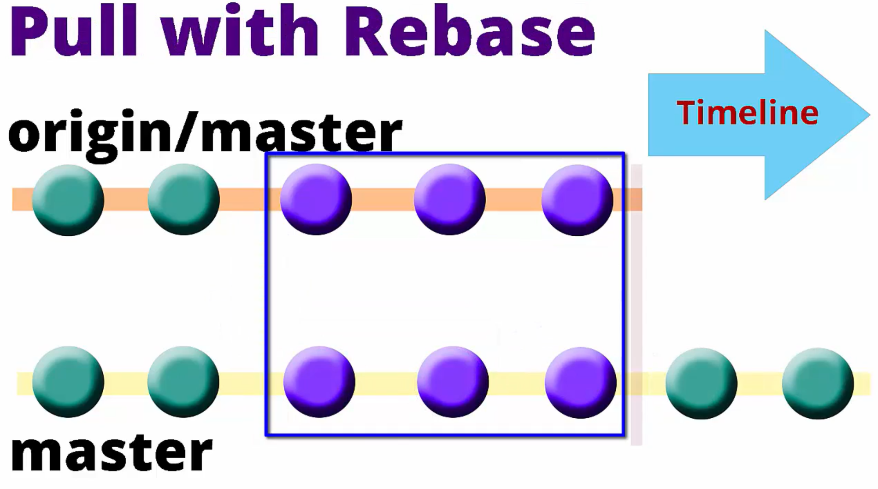

**git pull --rebase origin master**

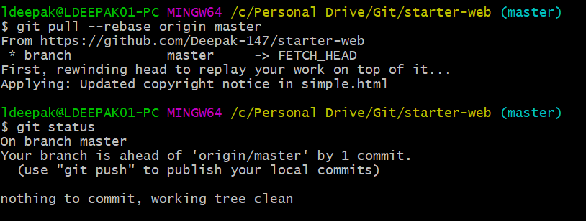

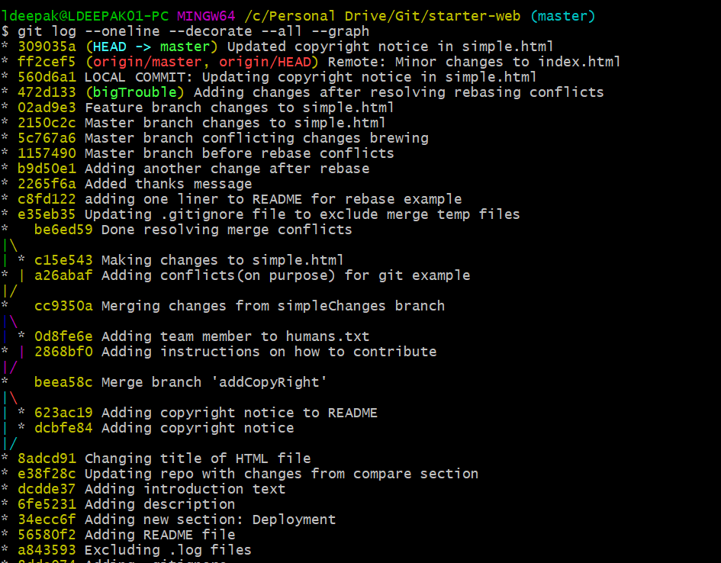

Cleanup

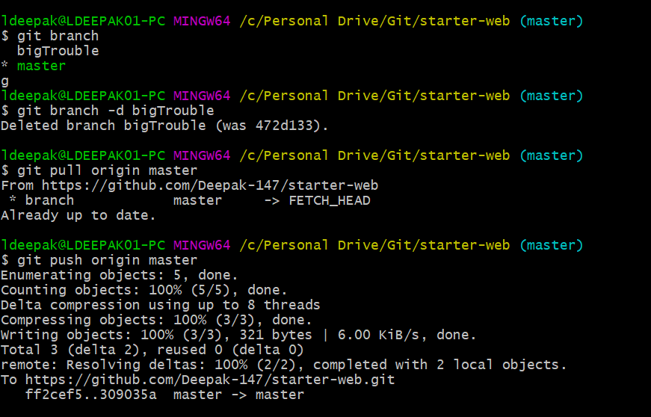

**STASHING**

**Simple stashing example**

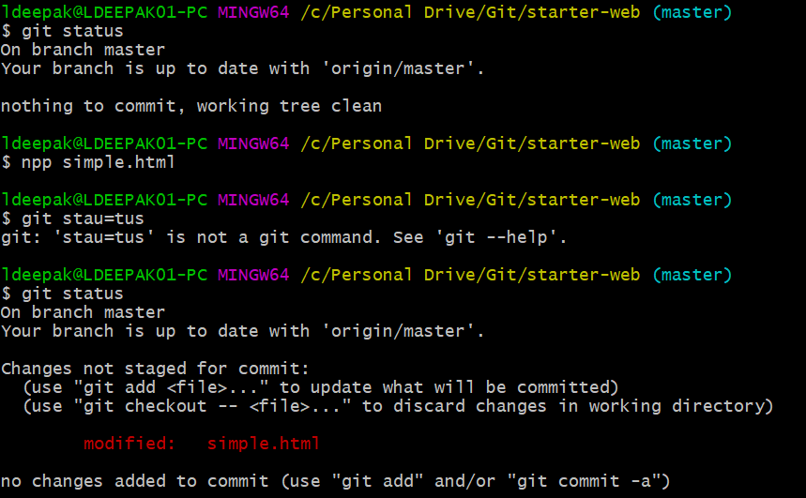

Now we don’t need to commit simple.html file now, this file is work in progress. Instead we want to commit another file. So, we need to stash away all the work in progress files and work on something else.

**git stash**: stashes and saves the current work.

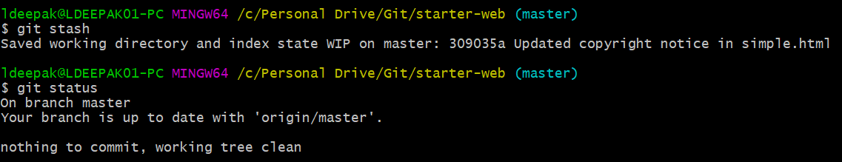

Now we can see that our working directory is clean.

We can continue working on some other file.

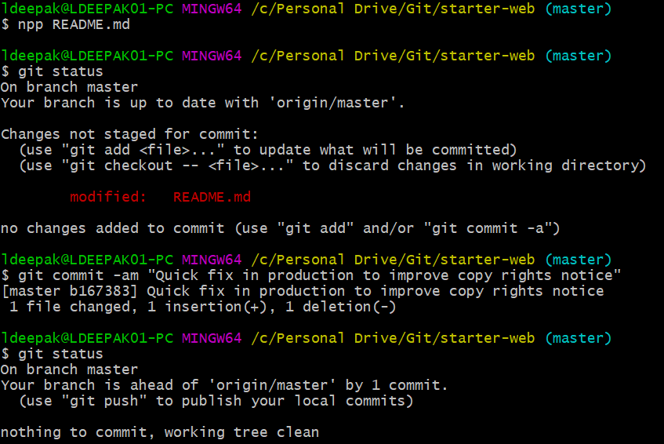

Now since we have done our high priority work, we can apply the stash back and continue working on it.

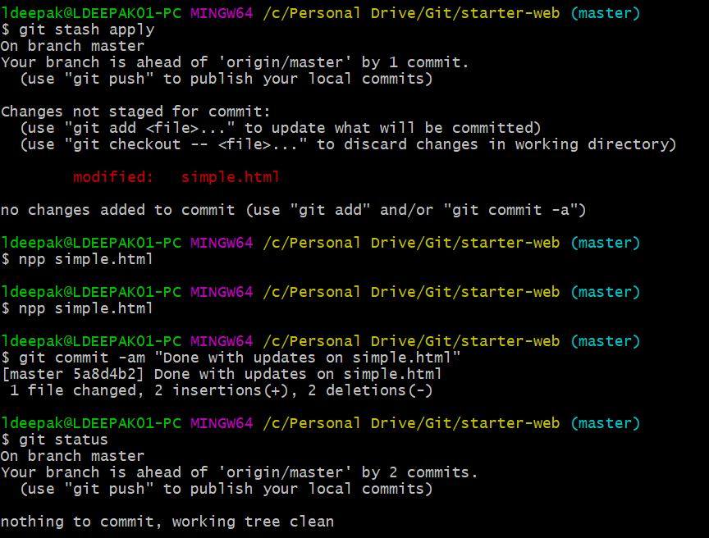

We can list the stashes using **git stash list** command. This will list all the stashes in order mentioning WIP(Work In Progress). We can drop the stash using **git stash drop,** if we don’t need that stash.

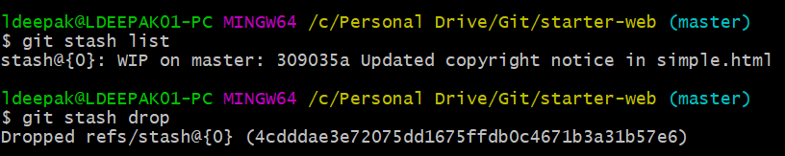

**Stashing untracked files**

By default, git stash command will only stash tracked files.

Doing **git ls-files** lists all tracked files.

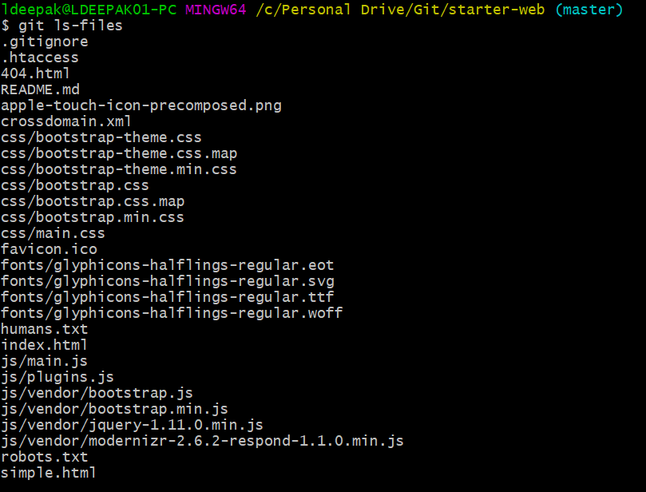

Now we will go ahead and modify an already existing file.

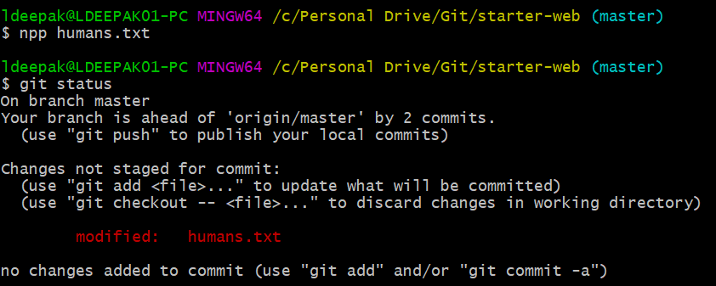

Now we create a new file and add some content to it. Git status shows modified files and untracked files.

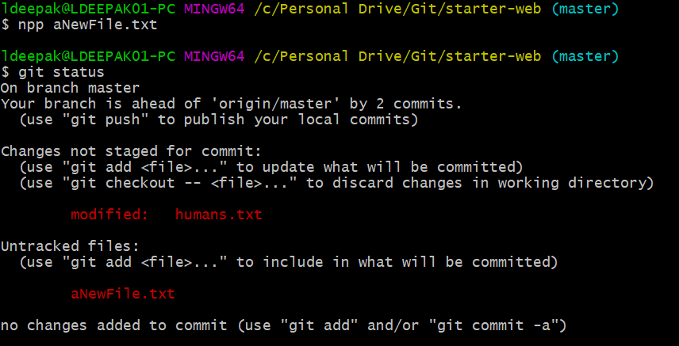

If we do a git stash, it will stash only modified files (tracked files) but leaves untracked files.

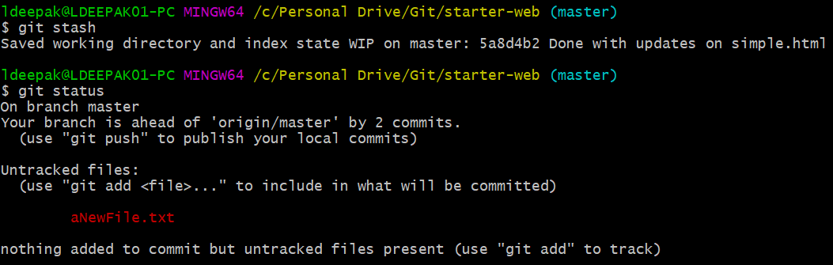

Here if we want to stash this untracked file also, then we can add this file(track this file) and then stash it. Or if don’t want to add it but still stash it then we can use **git stash -u** command.

Lets unstash it.

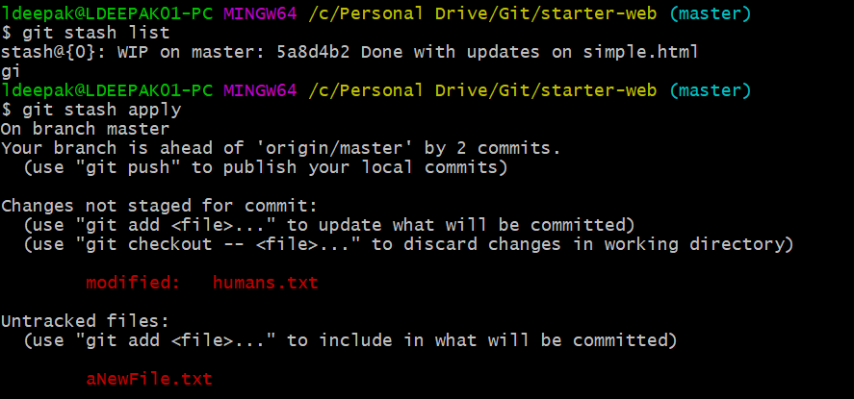

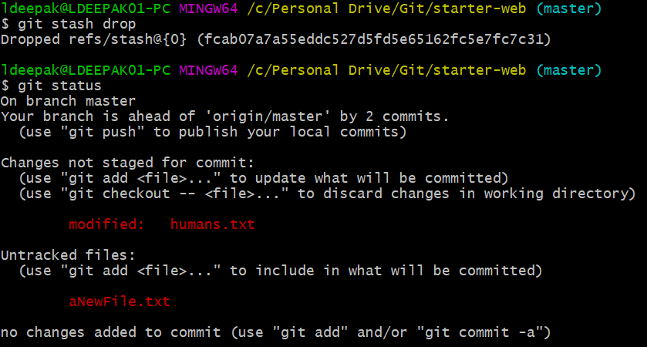

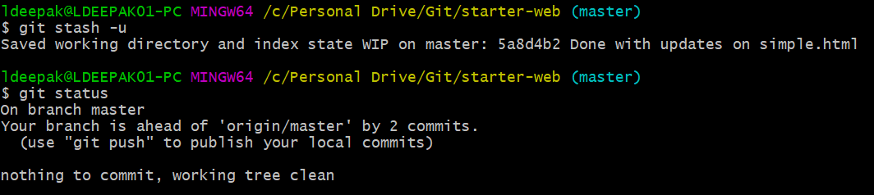

Now since our changes are stashed, we can work on other high priority tasks.

We can edit another file and make a commit.

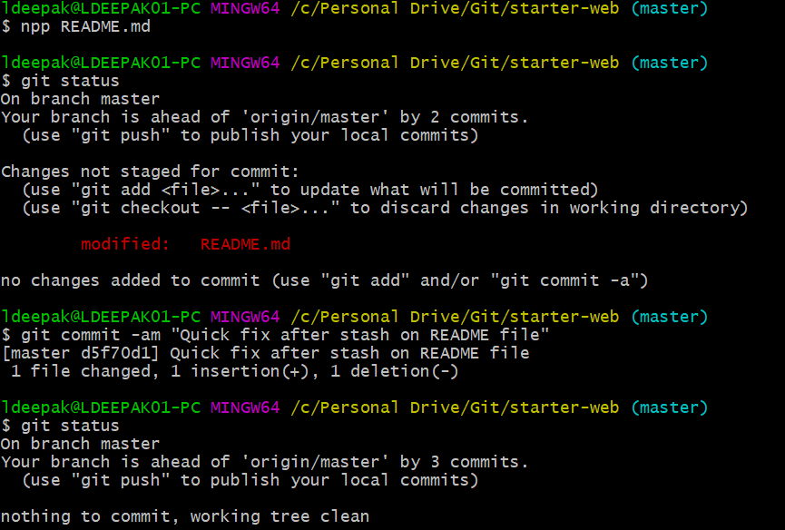

Now since our high priority task is done, we can continue with our stashed work.

We can apply and drop the stash in command using **git stash pop,** this is equivalent of doing a **git stash apply** and **git stash drop.**



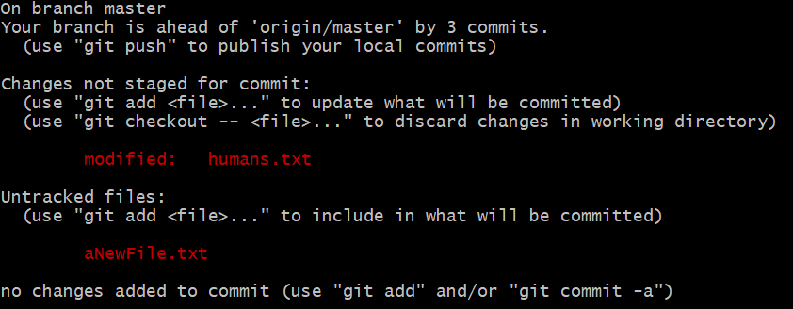

We can remove the untracked files if we want.

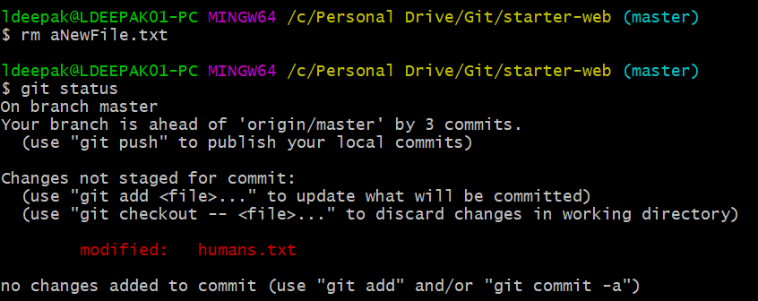

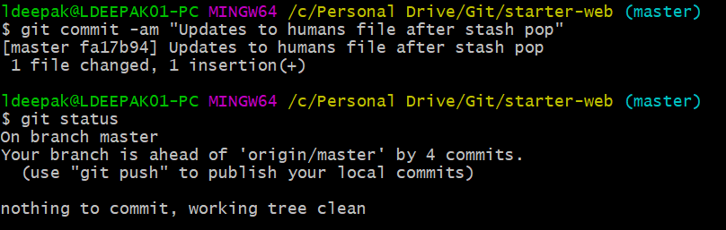

**Managing multiple stashes**

We can create multiple stashes using **git stash save.**

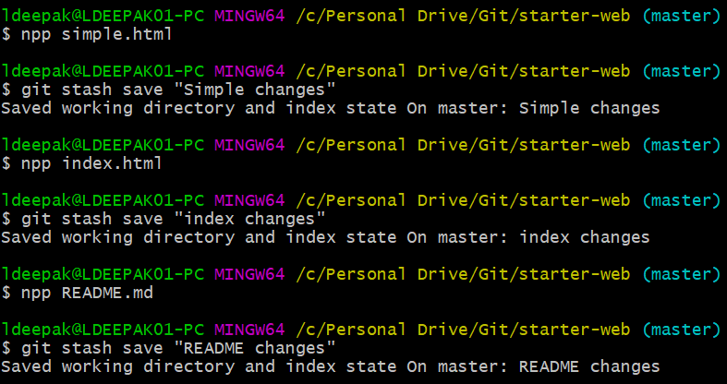

Now we can see the list of stashes, and we can choose the stash we want to apply. To view a specific stash, we do a **git stash show <*stash reference*>.** Also, we can apply a specific stash, using **git stash apply <*stash reference*>**

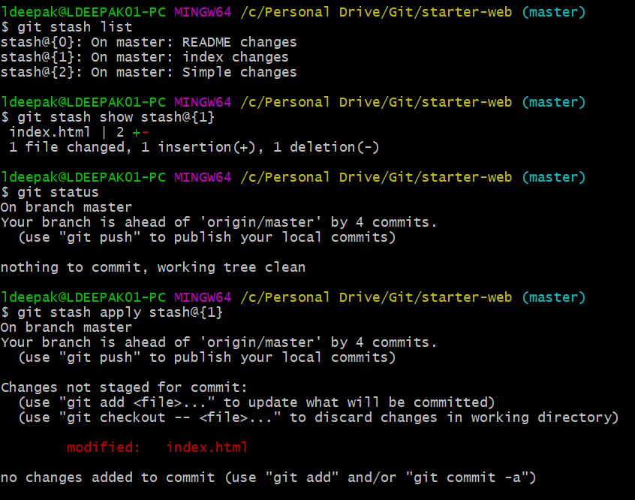

We can drop a specific stash using **git stash drop <*stash reference*>**

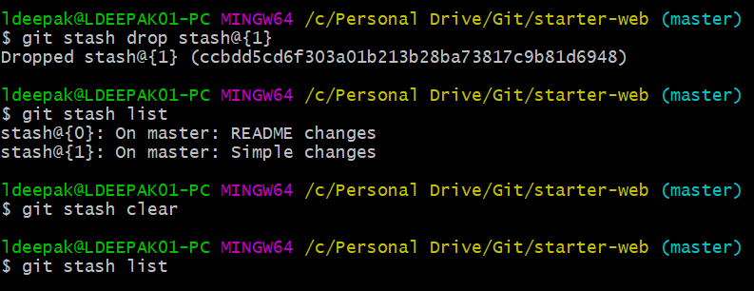

**Stashing stash to a branch**

We modify two other files and add index file to staging area.

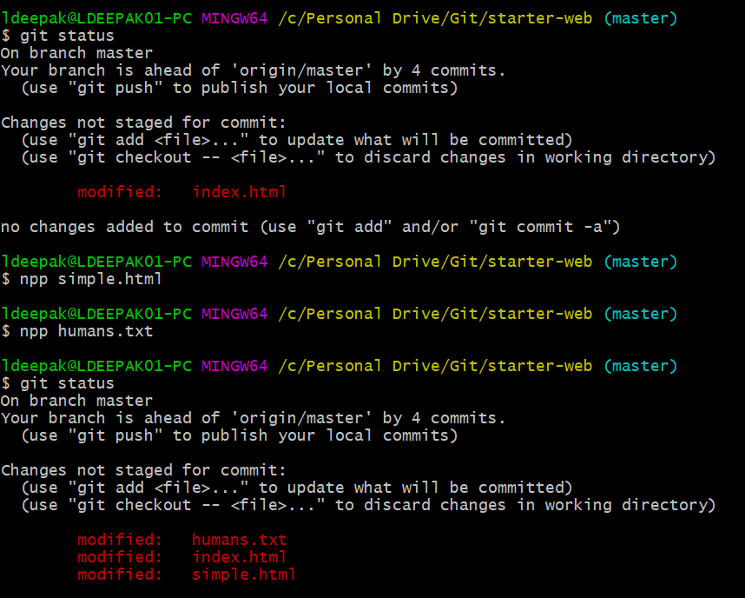

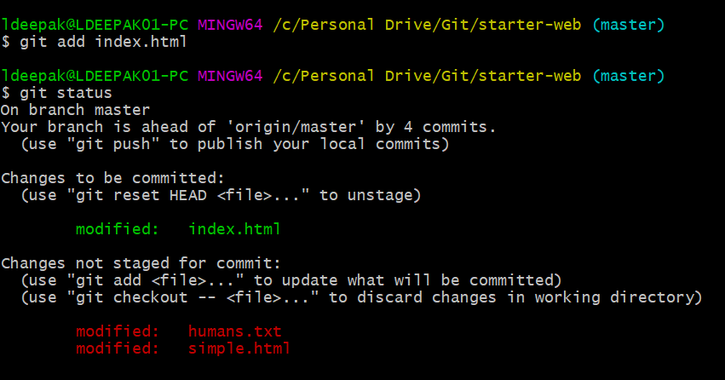

We create another file.

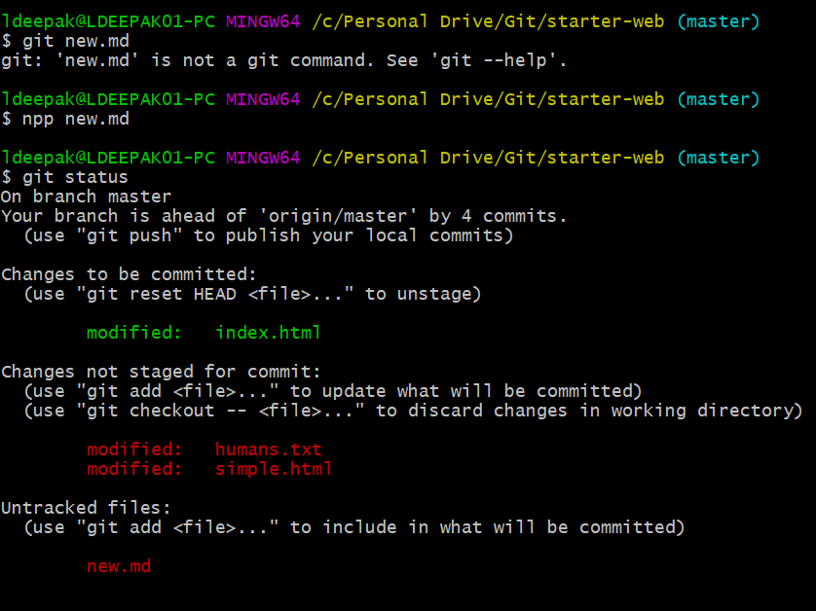

Now we decide that these changes belong to another branch. So, we stash and move them to another branch. Using **git stash branch <*branch name*>** command we create a new branch, apply the stash and then drop that stash.

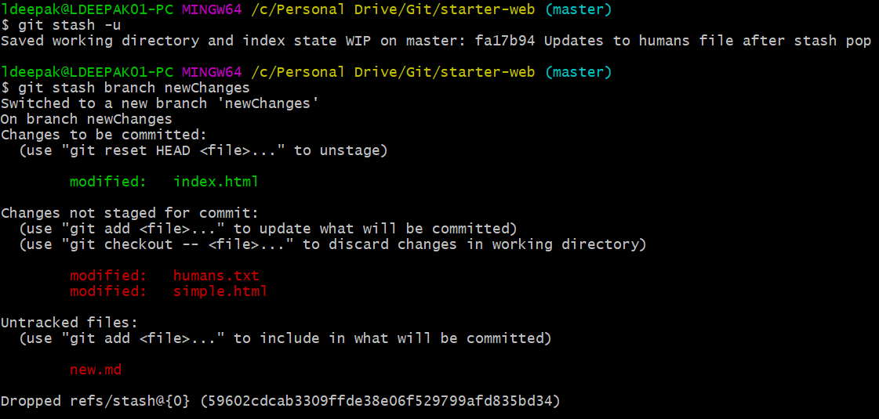

Now we make commit on our new branch. First, we decided to remove the new file.

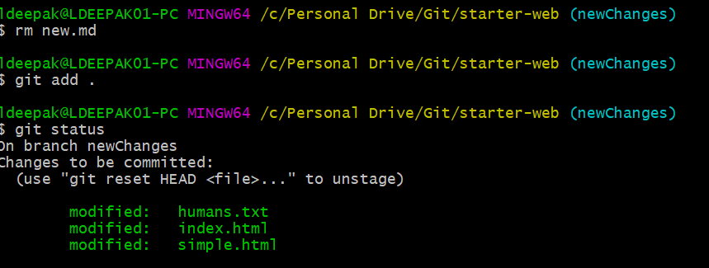

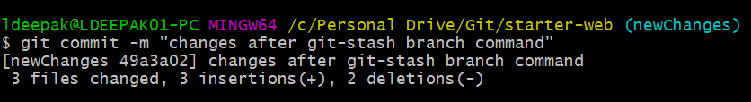

Now we switch to master and merge the two branches.

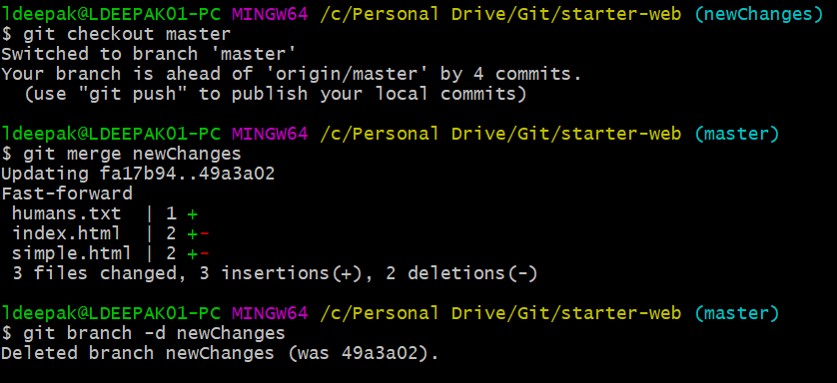

Cleanup

